**Shell Scripting FULL**

**deep@DESKTOP-JFJ21I5:~$ pwd**

**/home/deep**

**deep@DESKTOP-JFJ21I5:~$ pwd**

**/home/deep**

**deep@DESKTOP-JFJ21I5:~$ vi first.txt**

**deep@DESKTOP-JFJ21I5:~$ vi first.txt**

**deep@DESKTOP-JFJ21I5:~$ ls -l**

**total 122400**

**drwxr-xr-x 3 deep deep 4096 Feb 16 17:21 cloud**

**-rw-r--r-- 1 deep deep 574 Feb 16 17:31 cloud.tar.gz**

**drwxr-xr-x 2 deep deep 4096 Feb 17 04:57 day5**

**-rw-r--r-- 1 jethalal devops 12 Feb 16 08:55 demo-file.txt**

**drwxr-xr-x 2 deep deep 4096 Feb 16 09:12 devops.**

**-rw-r--r-- 1 deep deep 161 Feb 18 06:05 dynamic-pvc.yaml**

**-rw-r--r-- 1 deep deep 1223 Feb 17 04:21 file-sample_100kB.doc**

**-rw-r--r-- 1 deep deep 81 Feb 18 16:58 first.txt**

**-rw-r--r-- 1 deep deep 6 Feb 16 09:45 hello.txt**

**-rw-r--r-- 1 deep deep 3 Feb 18 04:45 kplabs.txt**

**-rw-r--r-- 1 deep deep 764 Feb 16 17:20 ldf.zip**

**drwxr-xr-x 3 deep deep 4096 Feb 16 17:32 linux_for_devops**

**-rw-r--r-- 1 deep deep 125267037 Feb 17 20:11 minikube-linux-amd64**

**-rw-r--r-- 1 deep deep 48 Feb 16 09:50 my-file.txt**

**-rw-r--r-- 1 deep deep 0 Feb 16 08:23 newfile.txt**

**-rw------- 1 deep deep 1086 Feb 16 12:46 nohup.out**

**-rw-r--r-- 1 deep deep 277 Feb 18 04:16 pod-volume.yaml**

**-rw-r--r-- 1 deep deep 196 Feb 18 05:09 pv.yaml**

**-rw-r--r-- 1 deep deep 278 Feb 18 05:16 pvc.yaml**

**lrwxrwxrwx 1 deep deep 44 Feb 16 09:38 softlink-file -> /home/deep/linux_for_devops/devops-file.txtr**

**deep@DESKTOP-JFJ21I5:~$ ls**

**cloud day5 devops. file-sample_100kB.doc hello.txt ldf.zip minikube-linux-amd64 newfile.txt pod-volume.yaml pvc.yaml**

**cloud.tar.gz demo-file.txt dynamic-pvc.yaml first.txt kplabs.txt linux_for_devops my-file.txt nohup.out pv.yaml softlink-file**

**deep@DESKTOP-JFJ21I5:~$ chmod 777 first.txt**

**deep@DESKTOP-JFJ21I5:~$ chmod +x first.txt**

**deep@DESKTOP-JFJ21I5:~$ ./first.txt**

**Hello world**

**This is our first shell script**

**this is awesome**

**deep@DESKTOP-JFJ21I5:~$ vi first.txt**

**deep@DESKTOP-JFJ21I5:~$ ./first.txt**

**Hello world**

**This is our first shell script**

**this is awesome**

**cloud day5 devops. file-sample_100kB.doc hello.txt ldf.zip minikube-linux-amd64**

**deep@DESKTOP-JFJ21I5:~$ mv first.txt first.sh**

**deep@DESKTOP-JFJ21I5:~$ ls**

**cloud day5 devops. file-sample_100kB.doc hello.txt ldf.zip minikube-linux-amd64 newfile.txt pod-volume.yaml pvc.yaml**

**cloud.tar.gz demo-file.txt dynamic-pvc.yaml first.sh kplabs.txt linux_for_devops my-file.txt nohup.out pv.yaml softlink-file**

**deep@DESKTOP-JFJ21I5:~$ vi first.sh**

**deep@DESKTOP-JFJ21I5:~$ ./first.sh**

**Hello world**

**This is our first shell script**

**Vi first.txt**

**#!/bin/bash**

**echo "Hllo world"**

**echo "this is our first shell script"**

**ls**

**pwd**

**sleep 10**

**deep@DESKTOP-JFJ21I5:~$ vi first.sh**

**deep@DESKTOP-JFJ21I5:~$ ./first.sh**

**Hello world**

**This is our first shell script**

**this is awesome**

**deep@DESKTOP-JFJ21I5:~$ which python3**

**/usr/bin/python3**

**deep@DESKTOP-JFJ21I5:~$**

**vi second.sh**

**#!/usr/bin/python3**

**print("Hello world form python program")**

**~ deep@DESKTOP-JFJ21I5:~$ vi second.sh**

**deep@DESKTOP-JFJ21I5:~$ ./second.sh**

**-bash: ./second.sh: Permission denied**

**deep@DESKTOP-JFJ21I5:~$ chmod +x second.sh**

**deep@DESKTOP-JFJ21I5:~$ ./second.sh**

**Hello world form python program**

**deep@DESKTOP-JFJ21I5:~$**

**./first.sh - . refer to current directory**

**deep@DESKTOP-JFJ21I5:~$ ./first.sh**

**Hello world**

**This is our first shell script**

**this is awesome**

**cloud demo-file.txt file-sample_100kB.doc hello.txt linux_for_devops newfile.txt pv.yaml softlink-file**

**cloud.tar.gz devops. first.sh kplabs.txt minikube-linux-amd64 nohup.out pvc.yaml**

**day5 dynamic-pvc.yaml first.txt ldf.zip my-file.txt pod-volume.yaml second.sh**

**/home/deep**

**^C**

**deep@DESKTOP-JFJ21I5:~$ pwd**

**/home/deep**

deep@DESKTOP-JFJ21I5:~$ **/home/deep/first.sh**

**Hello world**

**This is our first shell script**

**this is awesome**

**cloud demo-file.txt file-sample_100kB.doc hello.txt linux_for_devops newfile.txt pv.yaml softlink-file**

**cloud.tar.gz devops. first.sh kplabs.txt minikube-linux-amd64 nohup.out pvc.yaml**

**day5 dynamic-pvc.yaml first.txt ldf.zip my-file.txt pod-volume.yaml second.sh**

**/home/deep**

**$ It also working fine , . refer to present working directyr**

**. == /home/deep/first.sh**

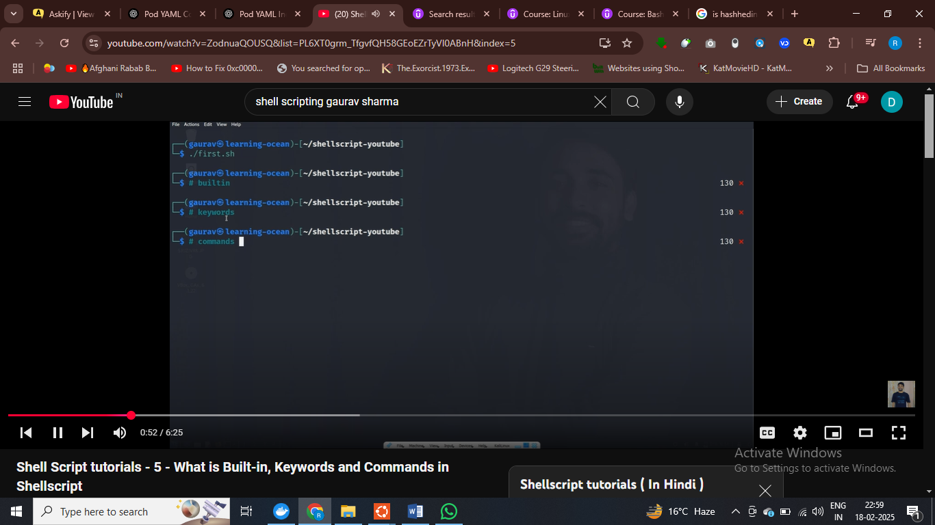

deep@DESKTOP-JFJ21I5:~$ type -a uptime

uptime is /usr/bin/uptime

uptime is /bin/uptime

deep@DESKTOP-JFJ21I5:~$ type -a echo

echo is a shell builtin

echo is /usr/bin/echo

echo is /bin/echo

deep@DESKTOP-JFJ21I5:~$ type -a pwd

pwd is a shell builtin

pwd is /usr/bin/pwd

pwd is /bin/pwd

deep@DESKTOP-JFJ21I5:~$ type -a if

if is a shell keyword

deep@DESKTOP-JFJ21I5:~$

**$ echo or pwd** is built in , inko turant execute akr dete hai linuyx

# BUILT IN OR KEYWORDS KA JYDA USE KARO ISME

Ctrl and ` to open terminal in vs code

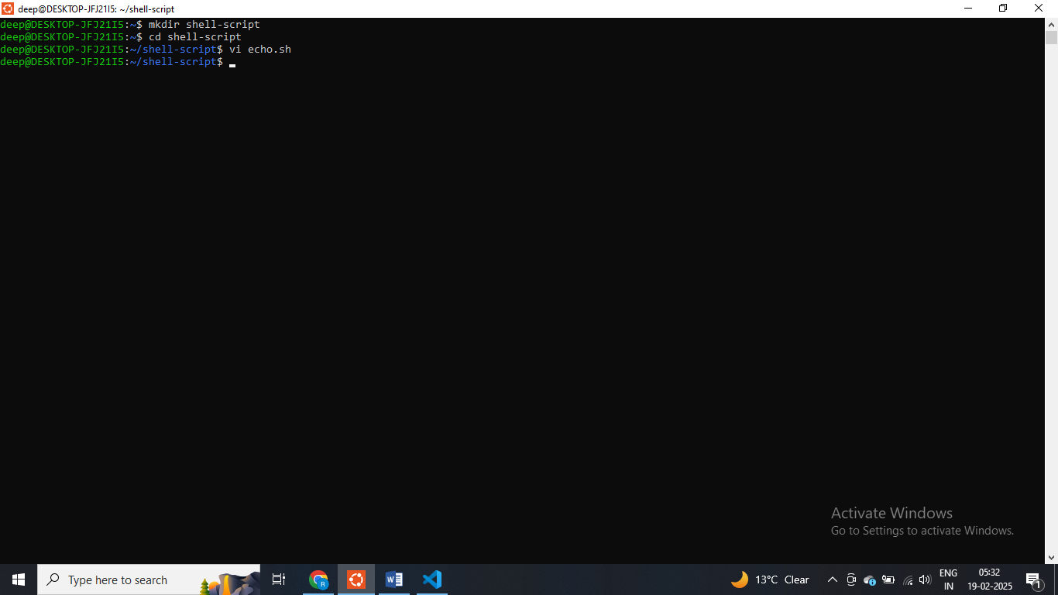

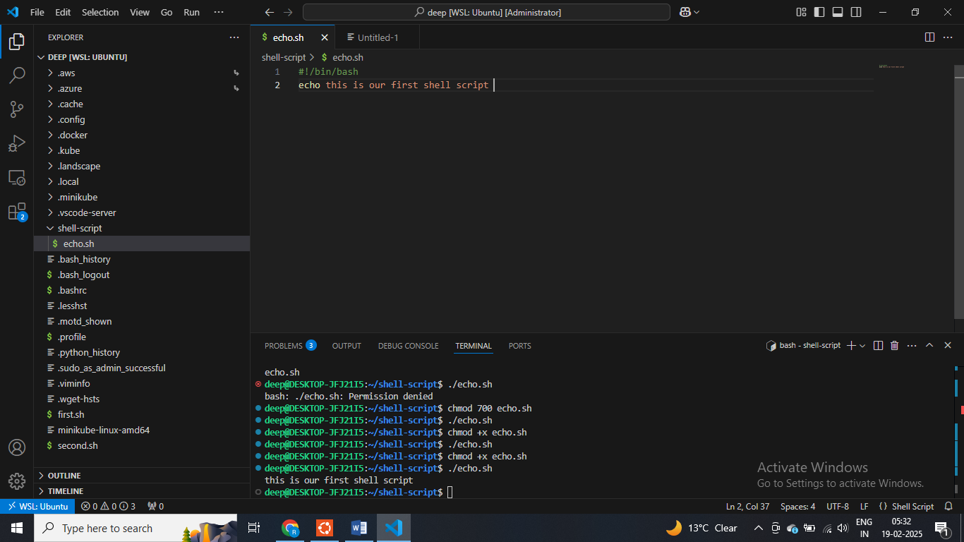

#!/bin/bash

echo "this is our first shell                        script"

**echo.sh**

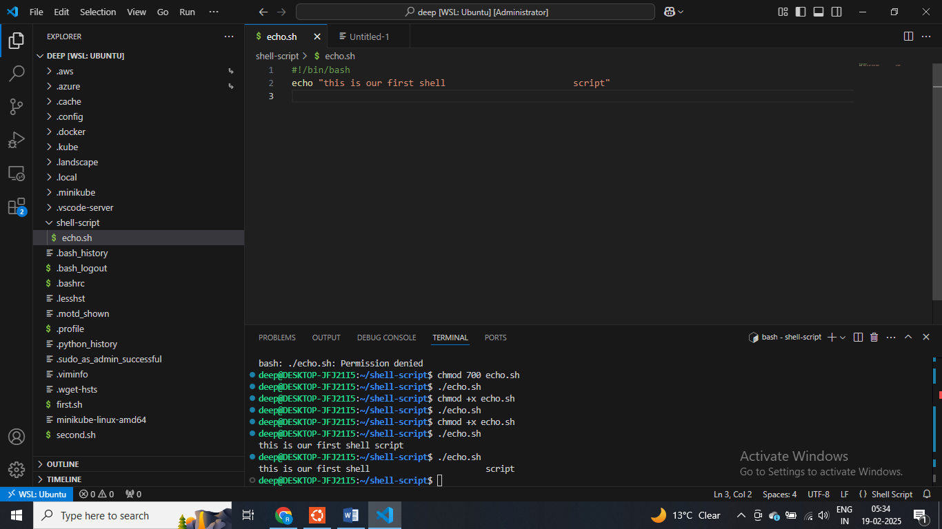

**deep@DESKTOP-JFJ21I5:~/shell-script$ man echo**

#!/bin/bash

echo "this is our first shell                        script"

echo -e "\033[0;32m success here"

echo -e "\033[0;31m failed message here"

echo -e "\033[0;33m warning message here"

**echo.sh**

**deep@DESKTOP-JFJ21I5:~/shell-script$ ./echo.sh**

**this is our first shell script**

**success here**

**failed message here**

**warning message here**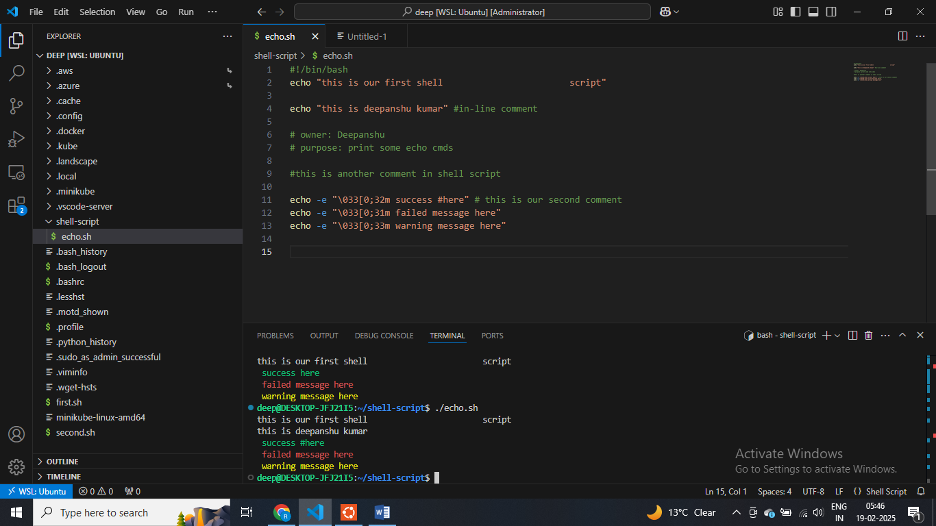

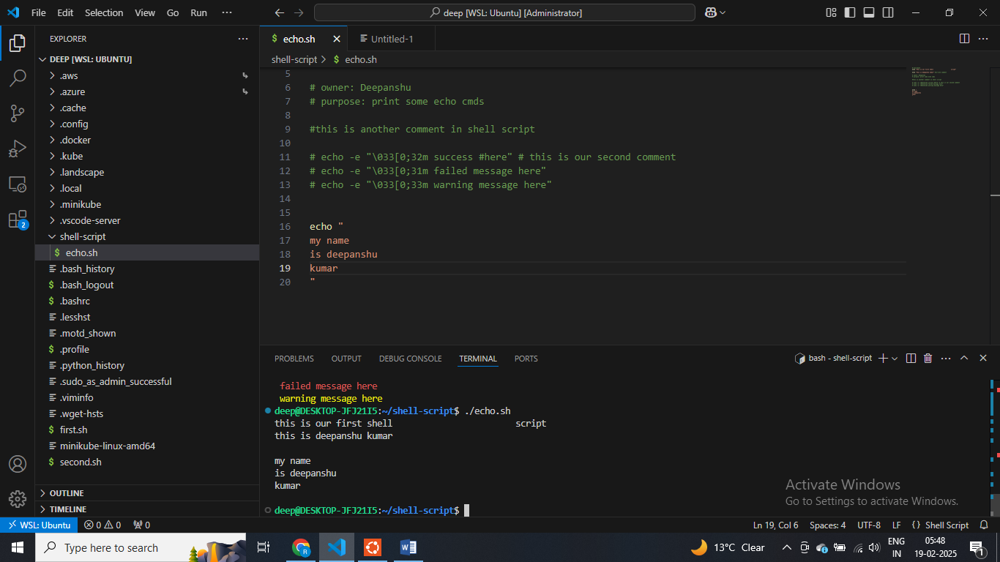

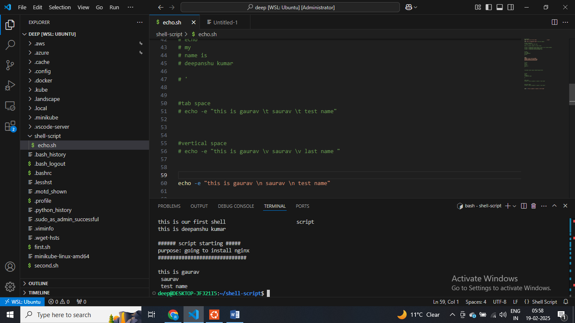

**Echo to print anything on terminal**

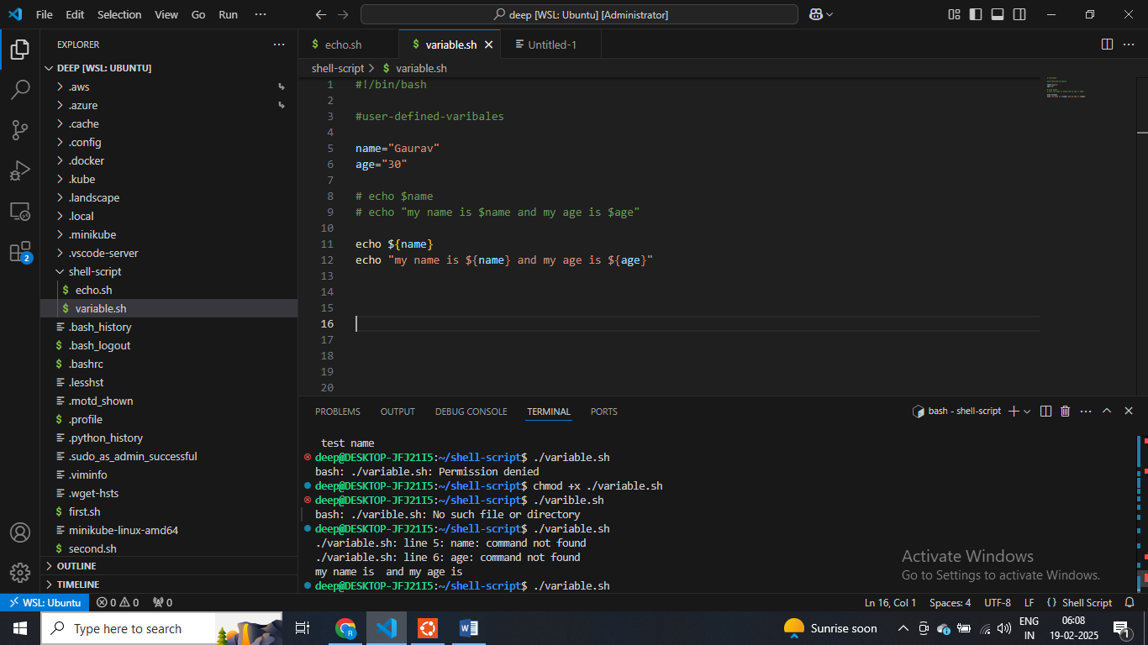

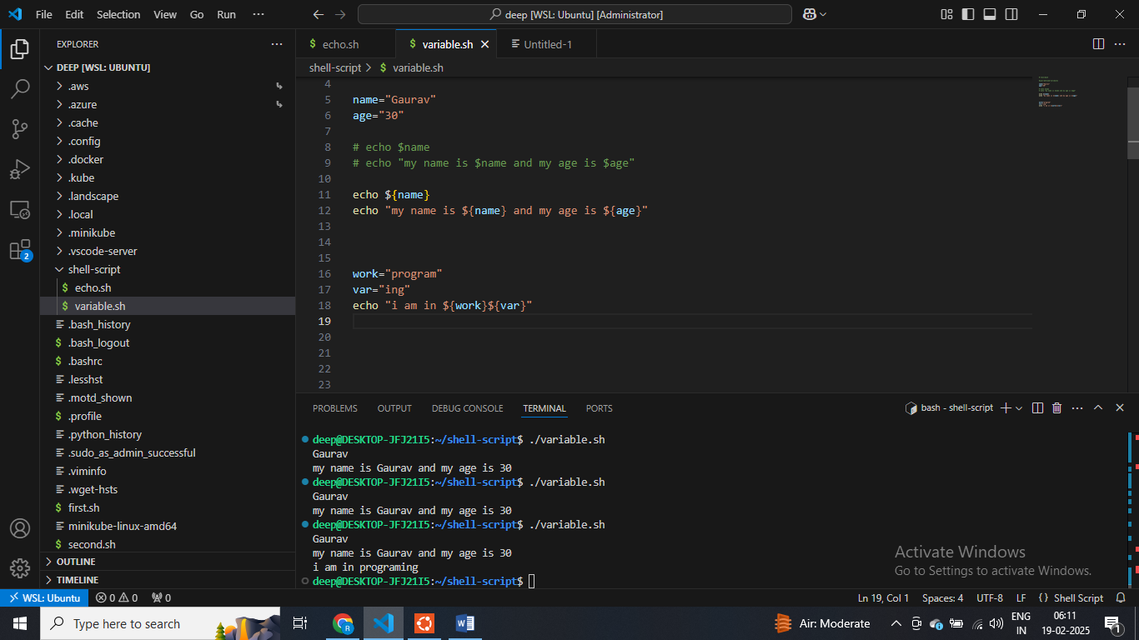

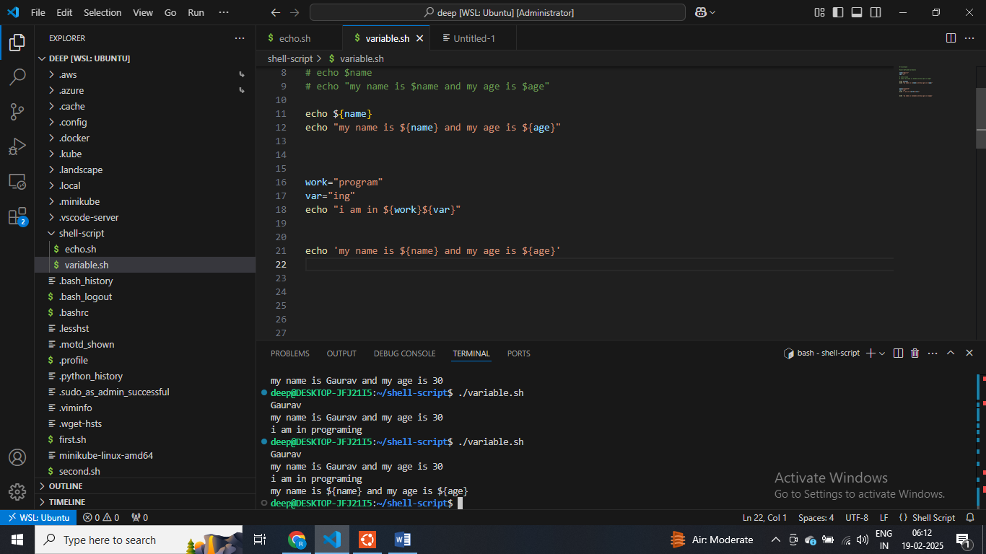

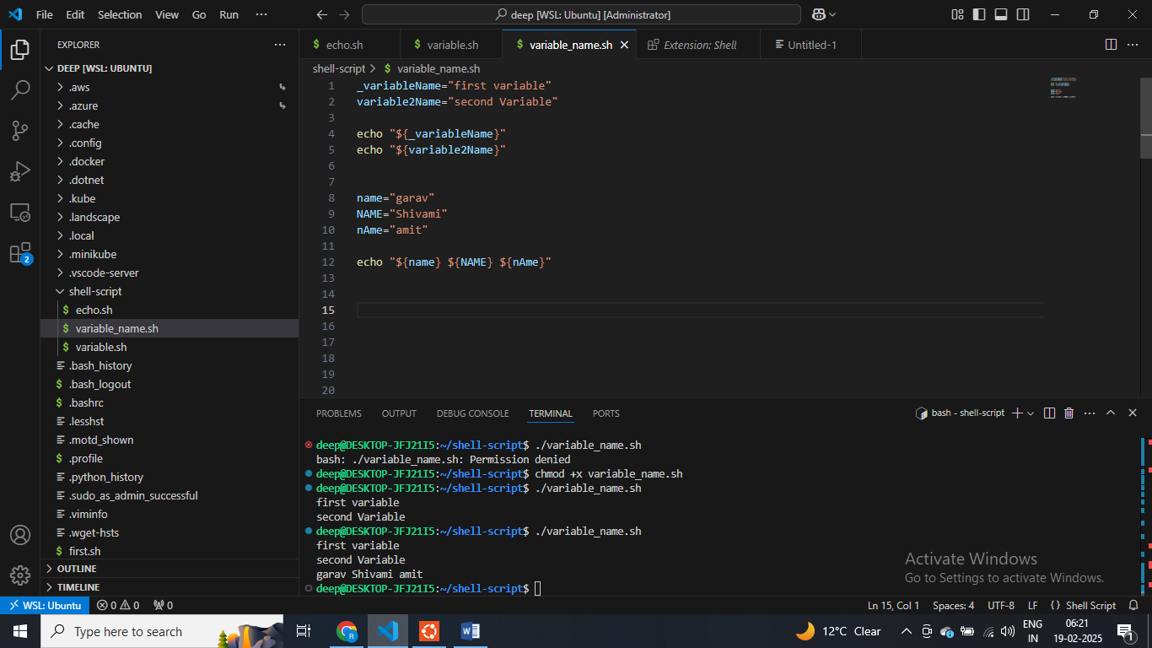

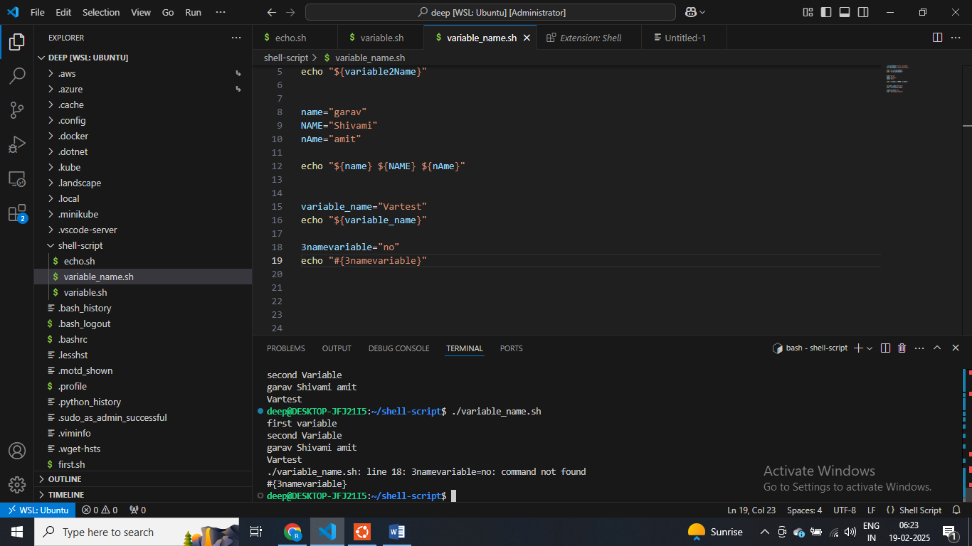

**$ is cmd line arguments**

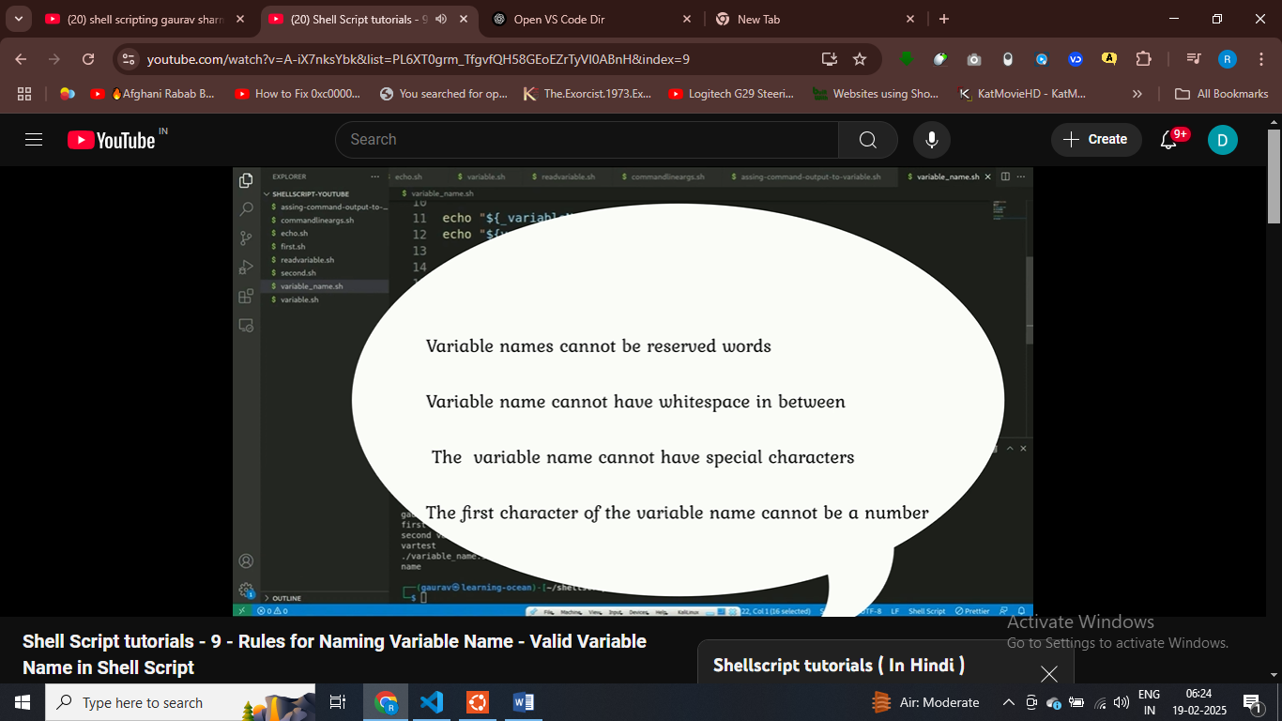

**deep@DESKTOP-JFJ21I5:~/shell-script$ env**

**SHELL=/bin/bash**

**WSL2_GUI_APPS_ENABLED=1**

**WSL_DISTRO_NAME=Ubuntu**

**NAME=DESKTOP-JFJ21I5**

**PWD=/home/deep/shell-script**

**$ these are system define varibel**

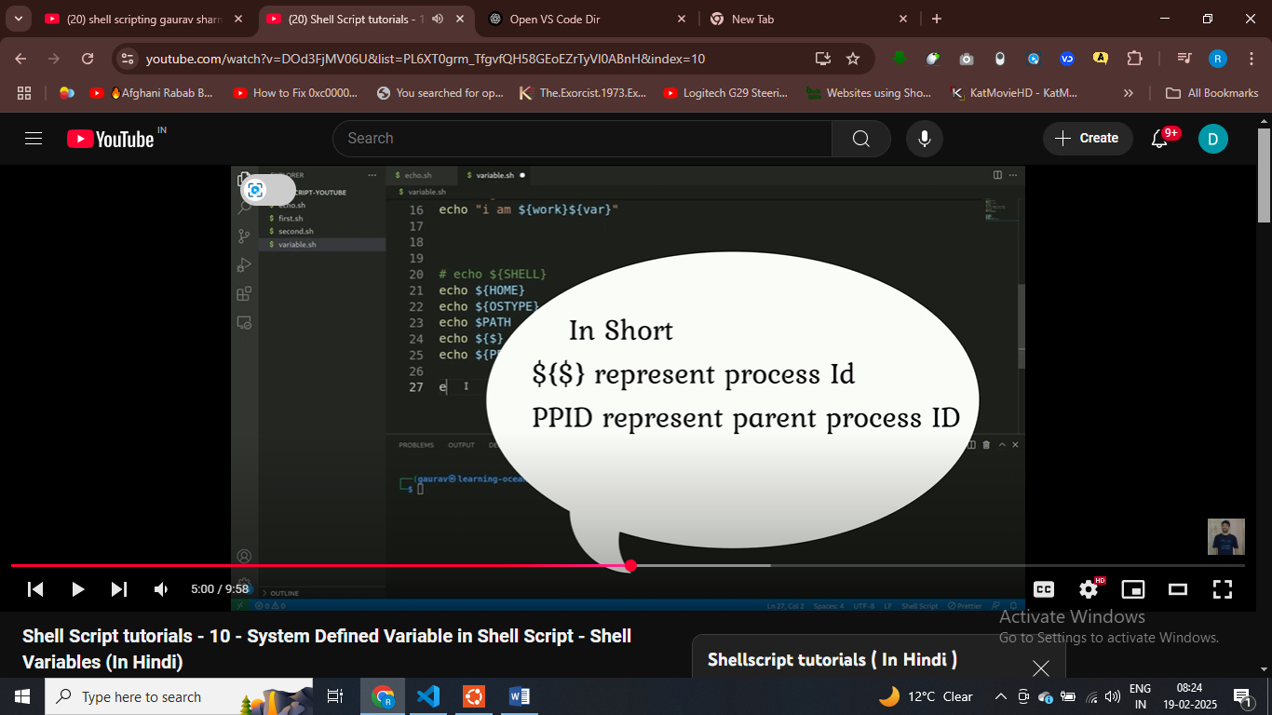

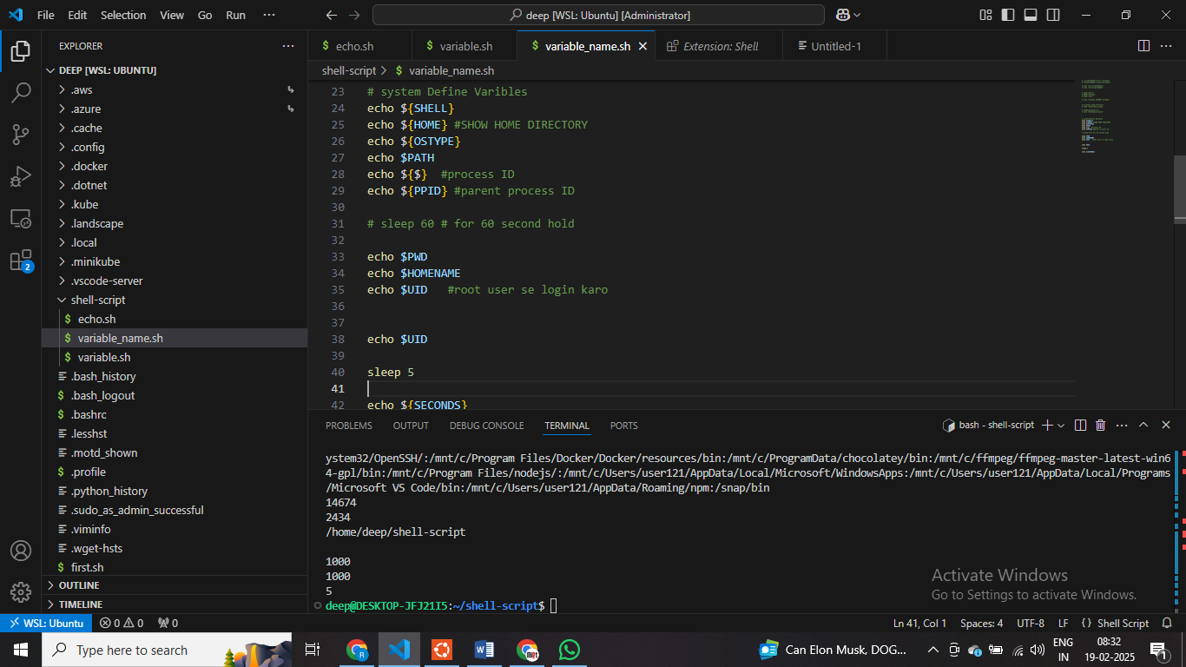

# shell script ko execute main 5 seocnds lage ahi

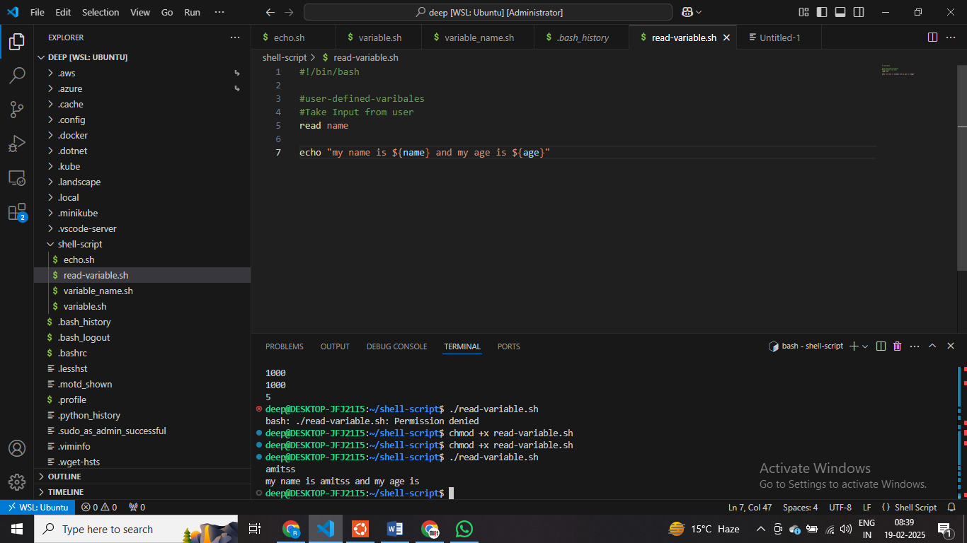

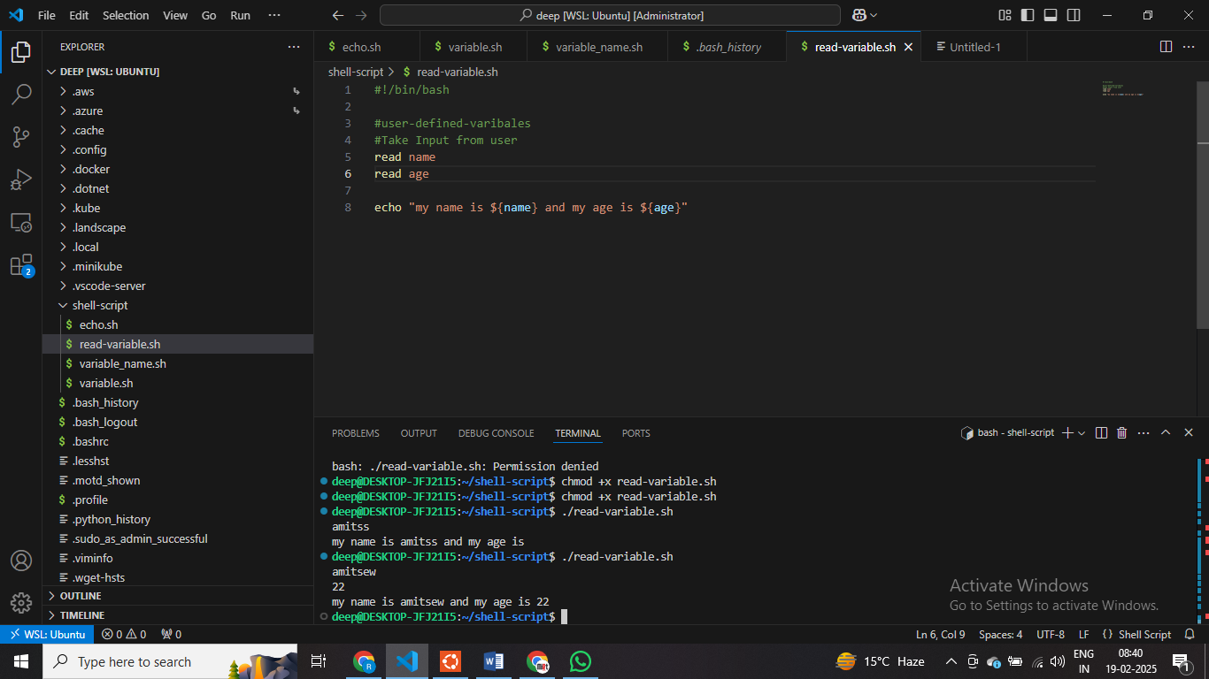

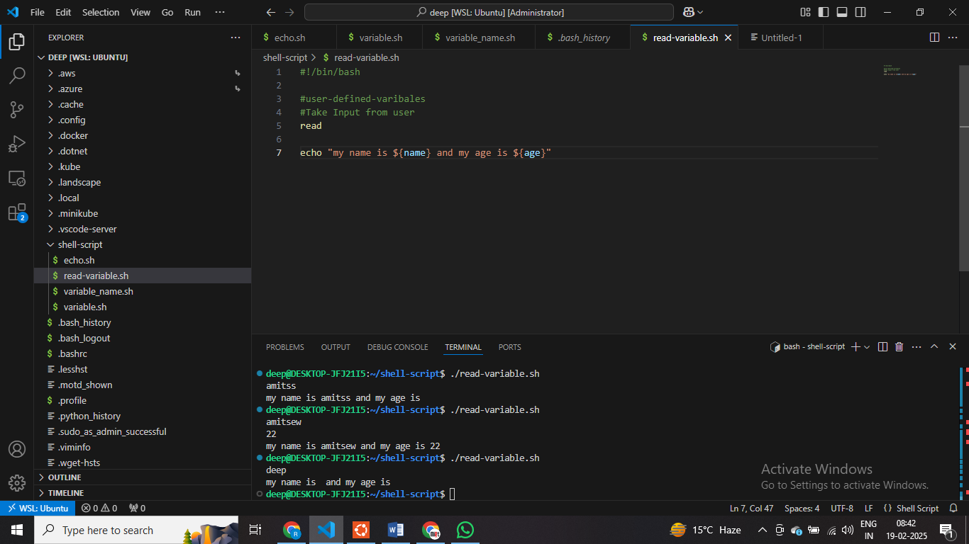

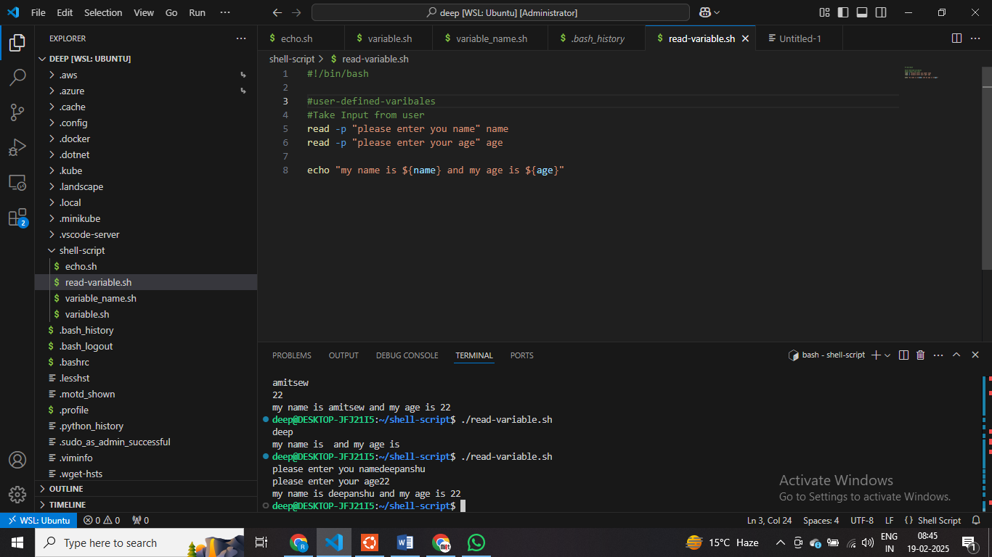

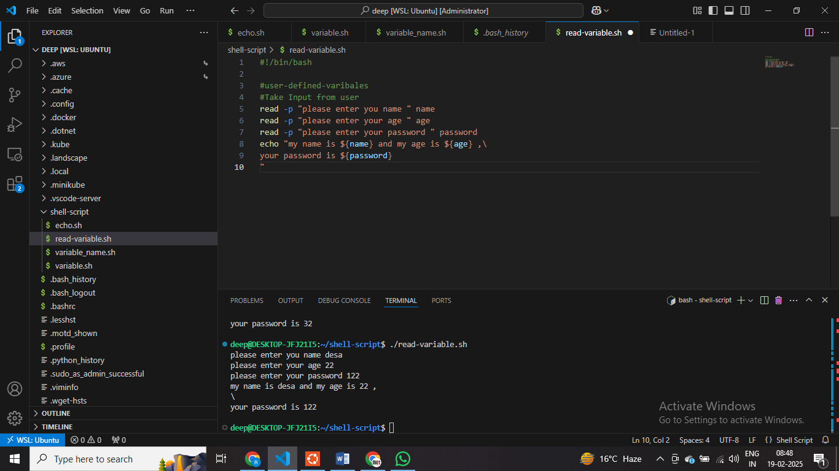

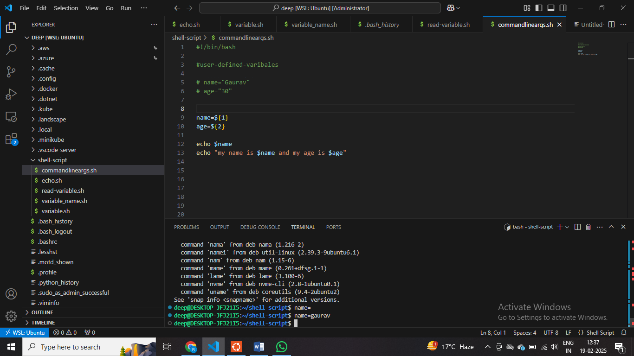

**Name = Gaurav**

**Name= is treated as cmd , and run successfully**

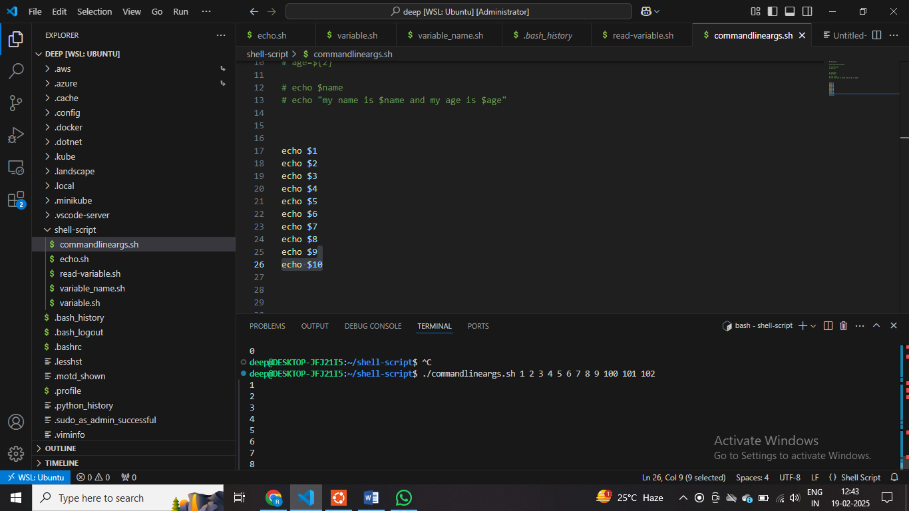

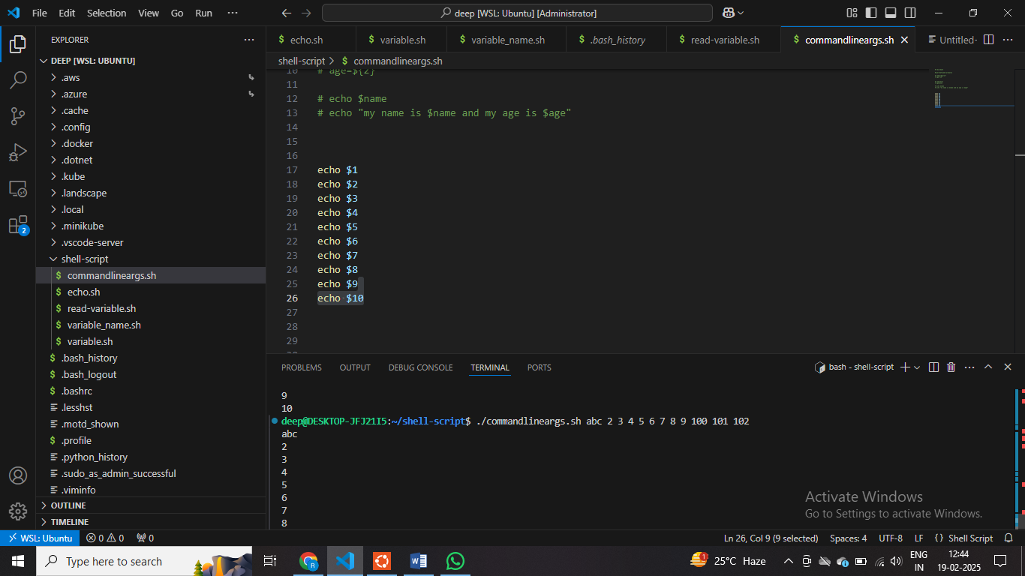

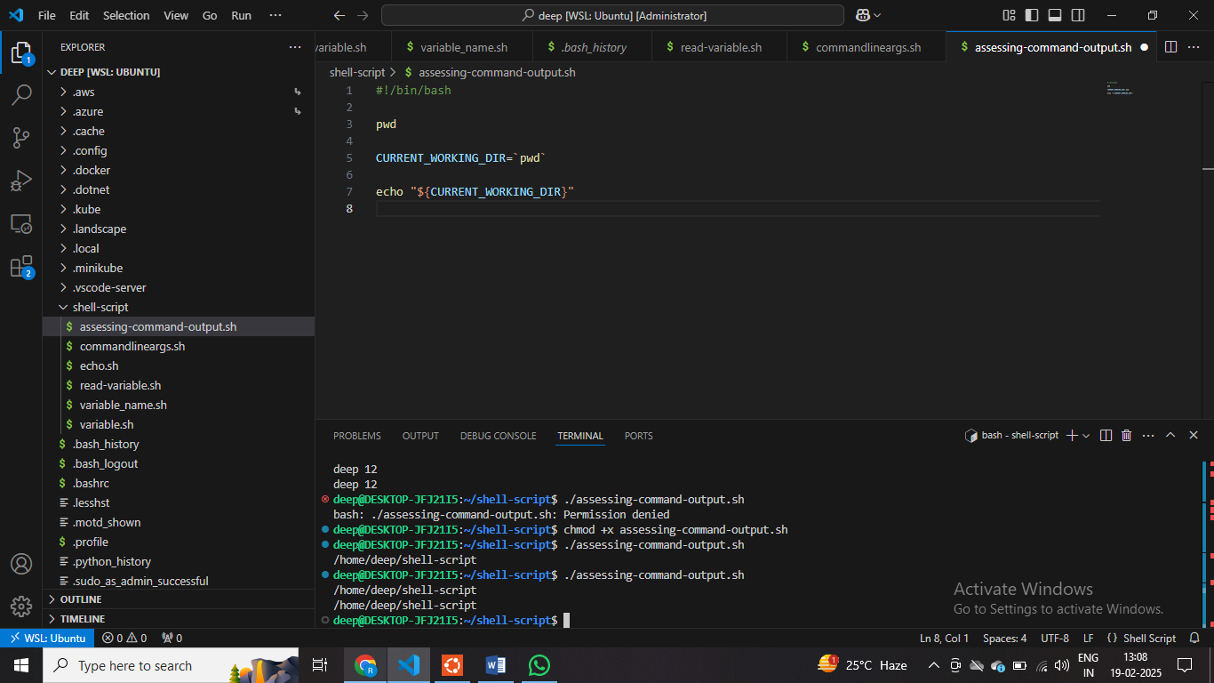

Storing commandd output inside variable

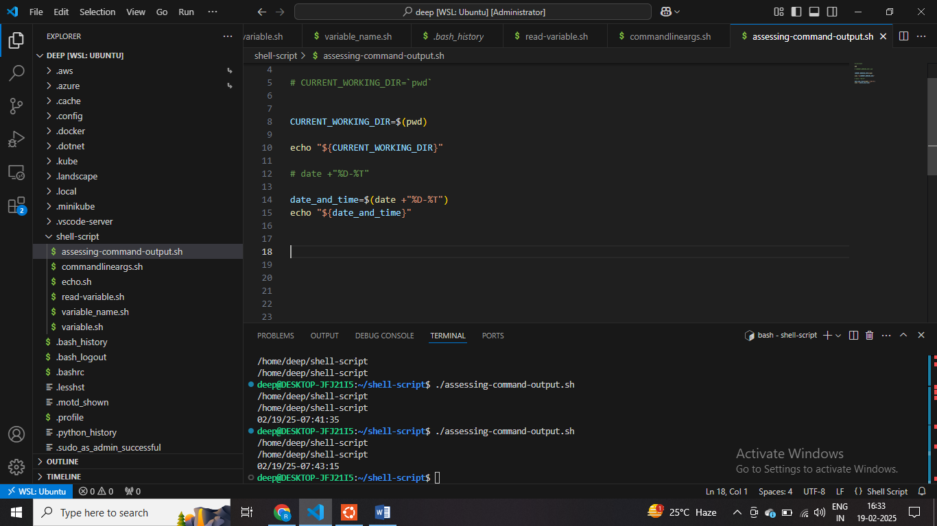

**Crete and read only variable using shell script**

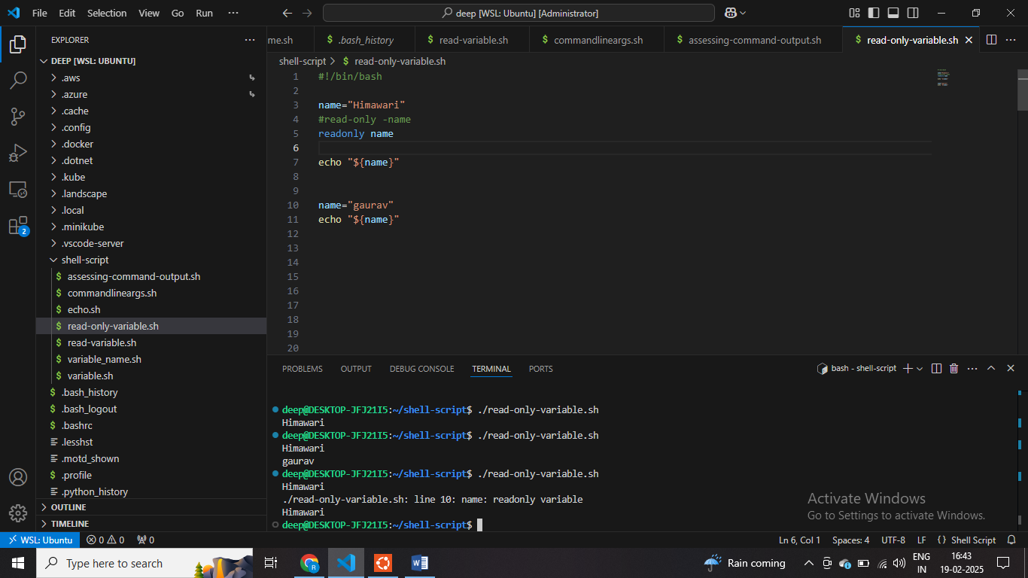

**#UNSET Name**

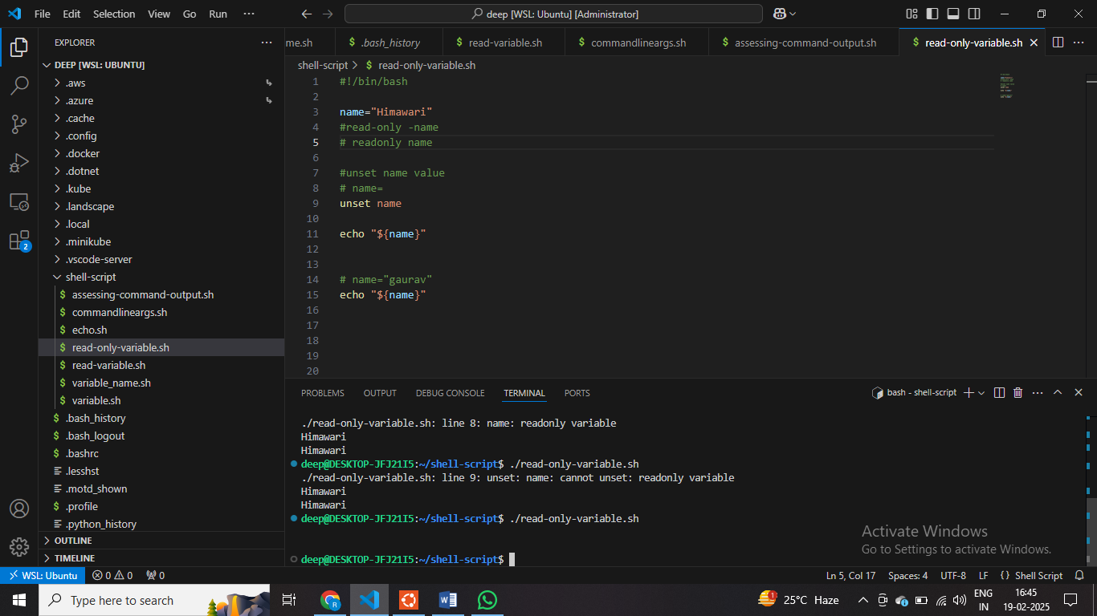

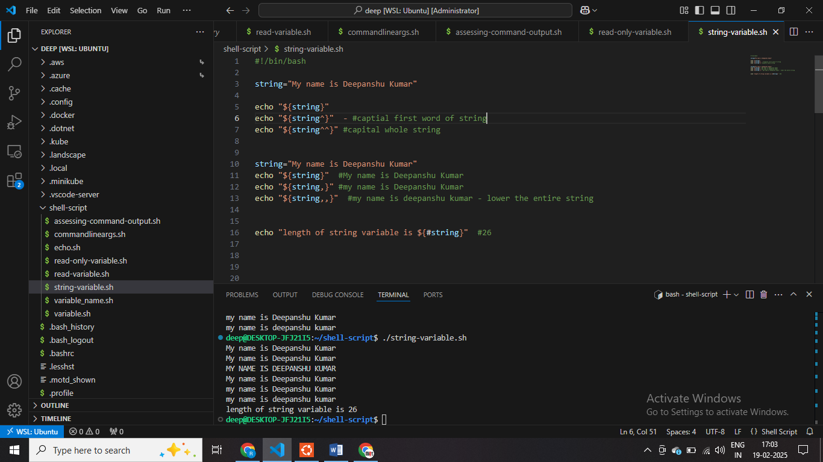

$Convert a string to substring – String MANUPALTION

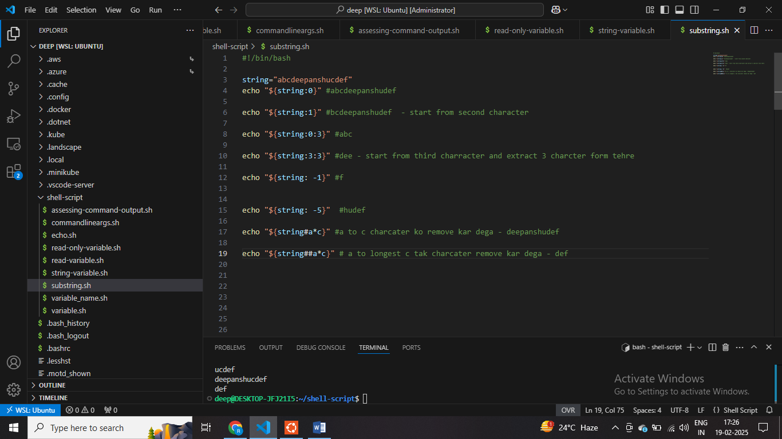

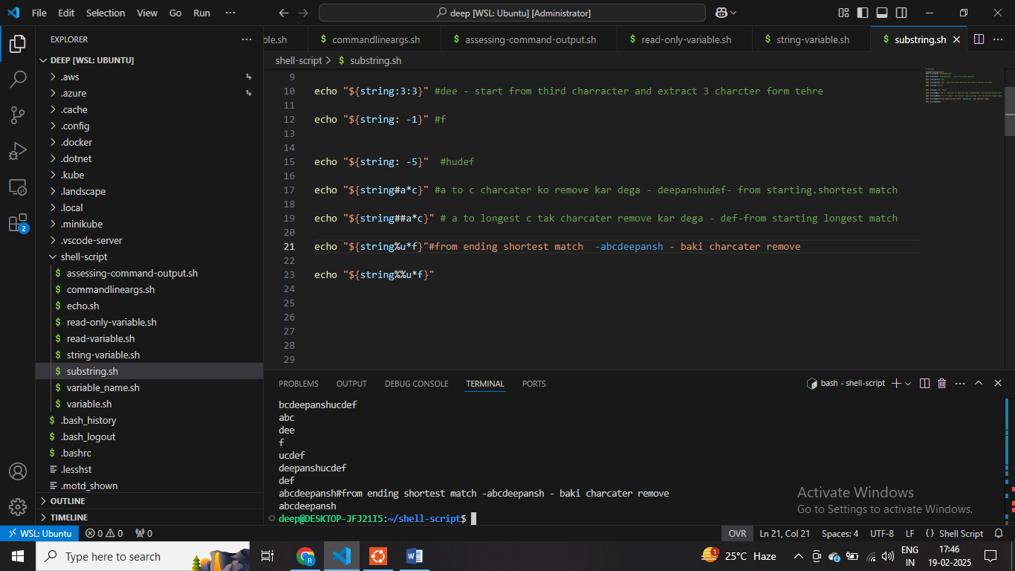

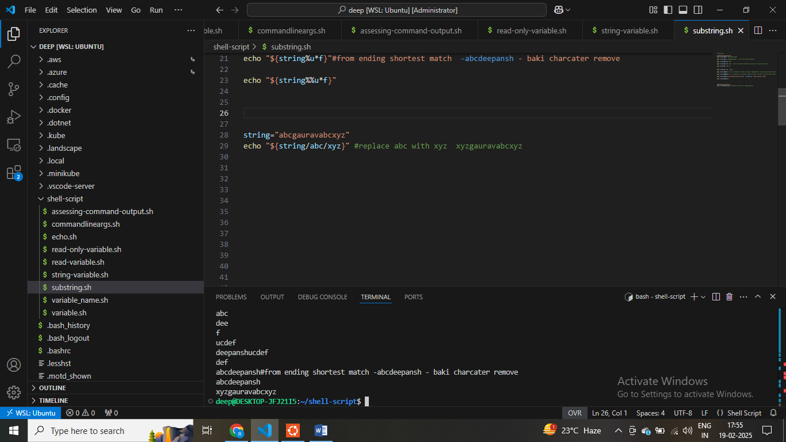

**18 – set default value to variable**

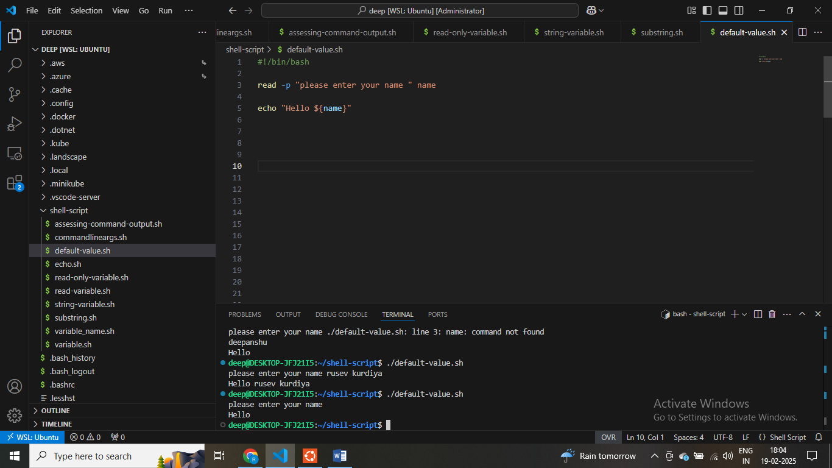



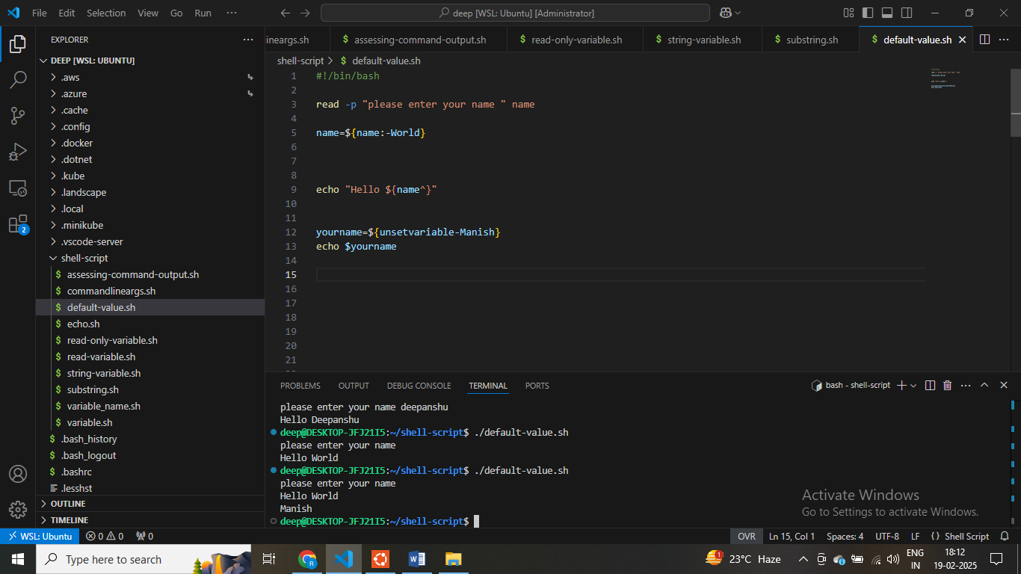

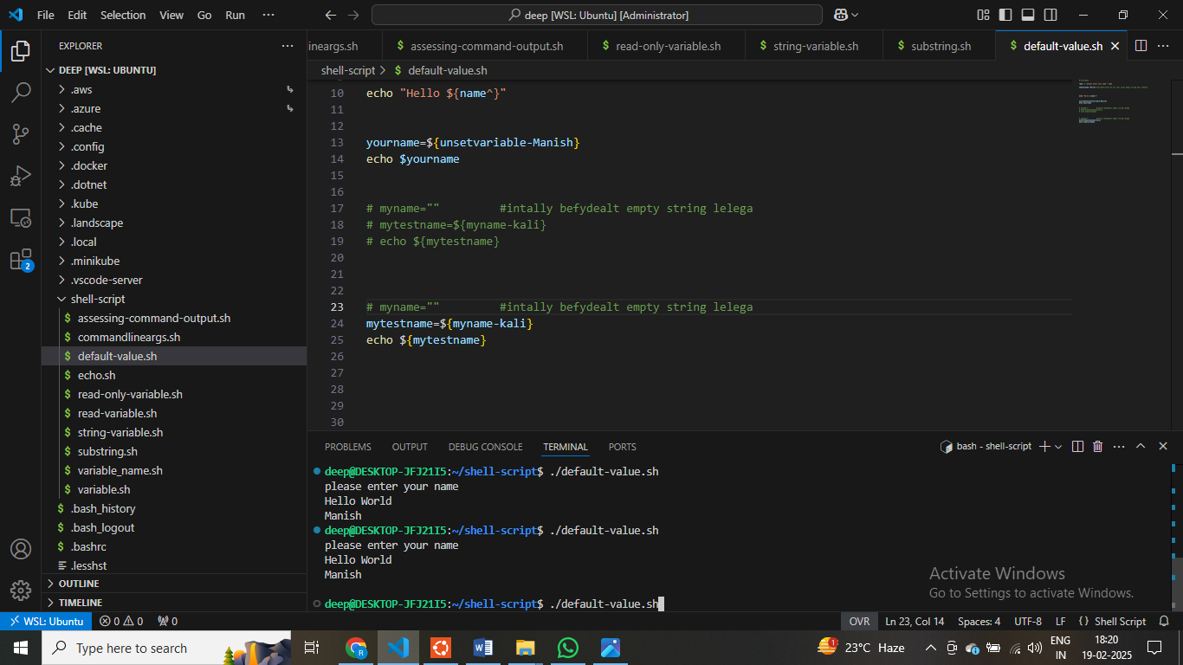

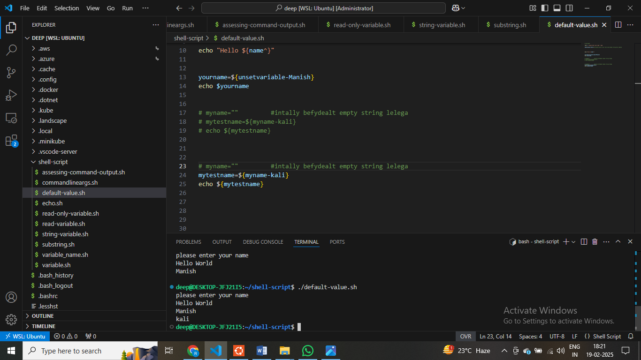

**$ Check if Command line argument passed it or not**

PART 19 CHECK IF COMMAND LINE ARUGEMTN PASSED OR NOT – Varibale ki value set nahi hai agar aapko exit hone toh aap exit ho sakte hoo

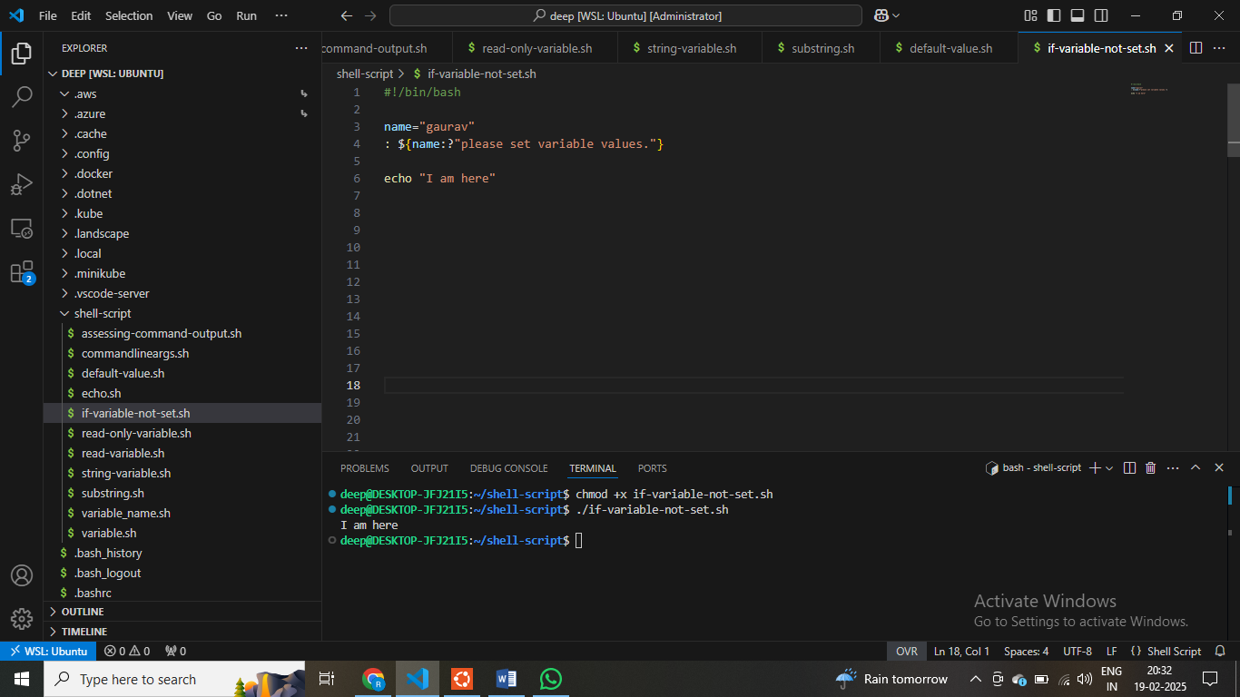

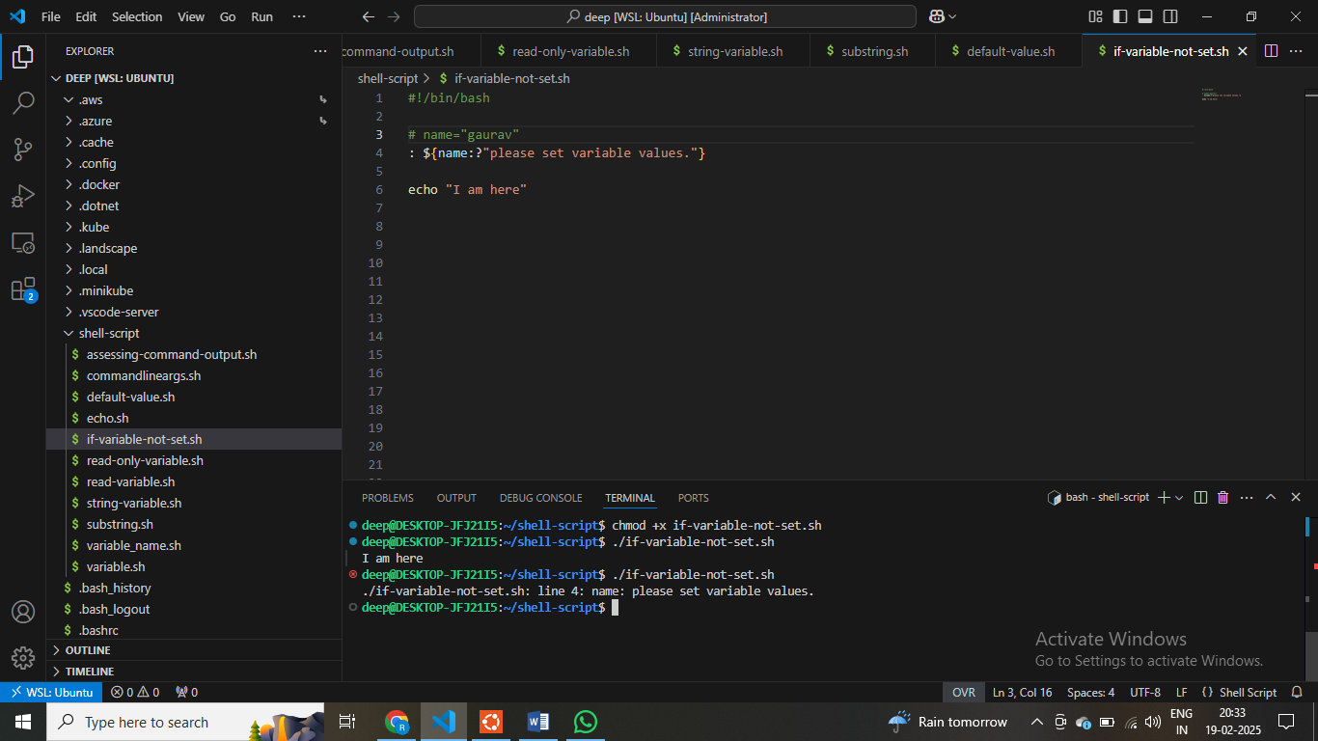

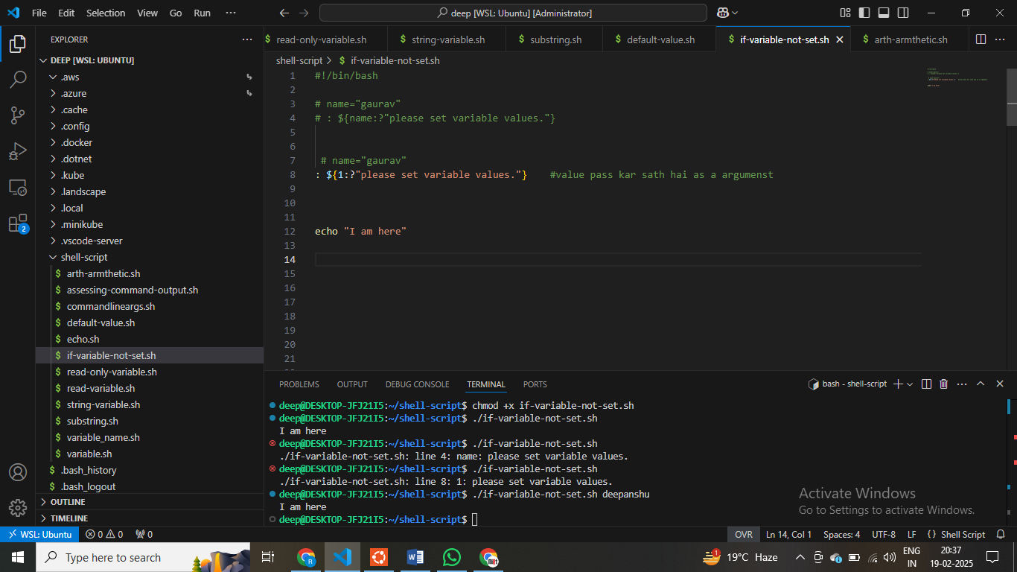

**$ - check if cmd existes or not - $ check if no cmd exists**

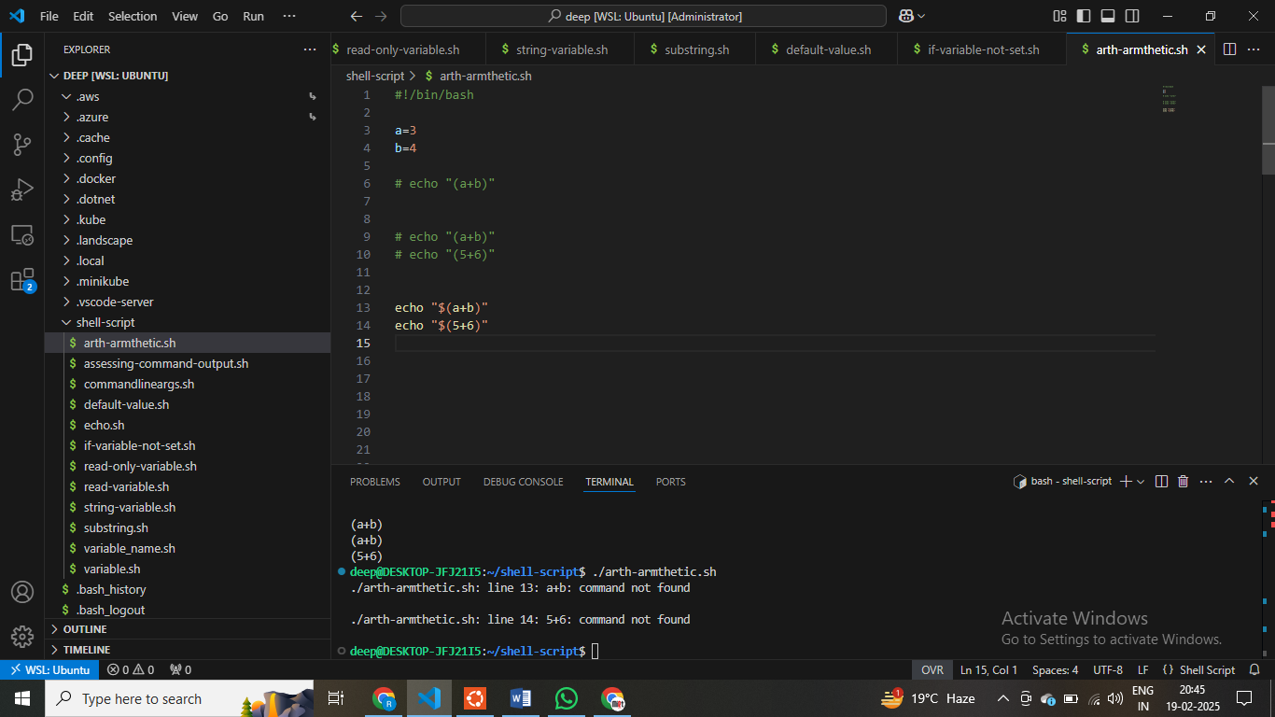

**$ - it check if cmd exists or not**

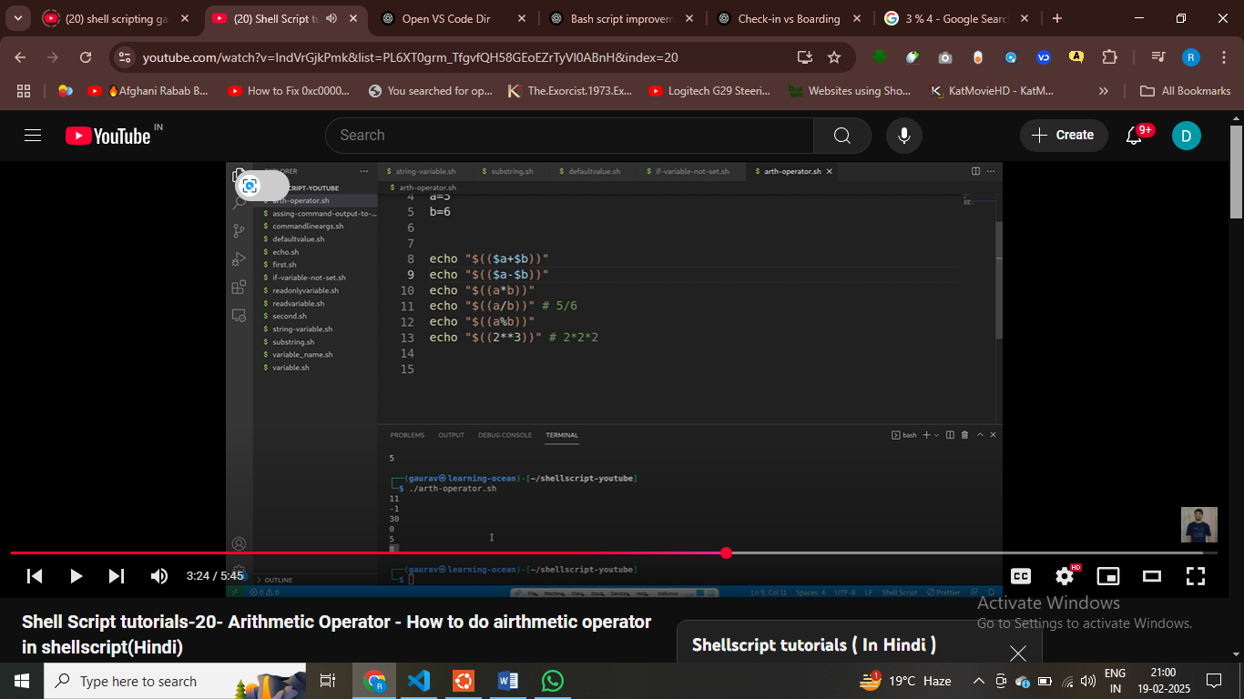

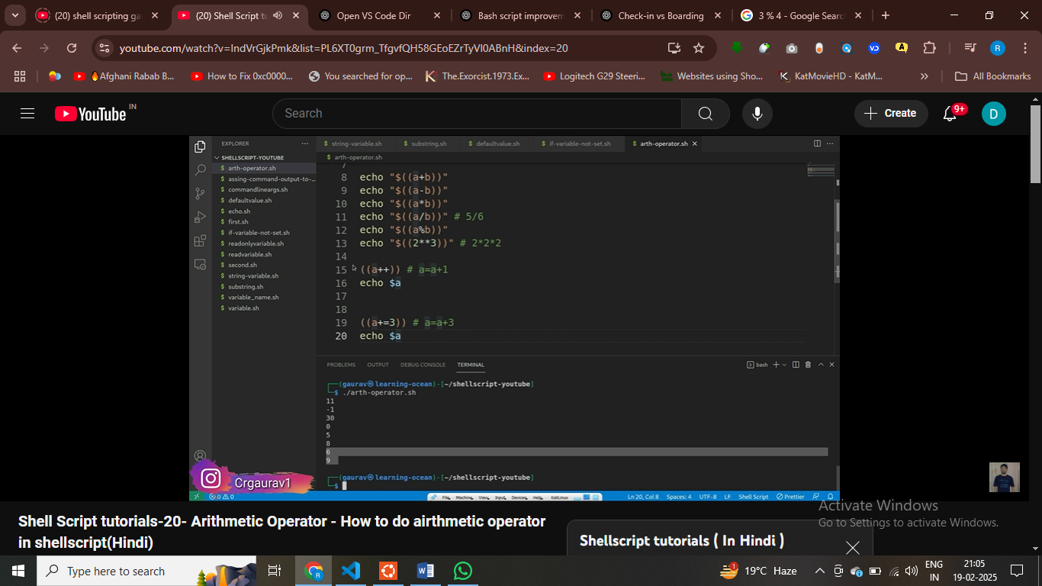

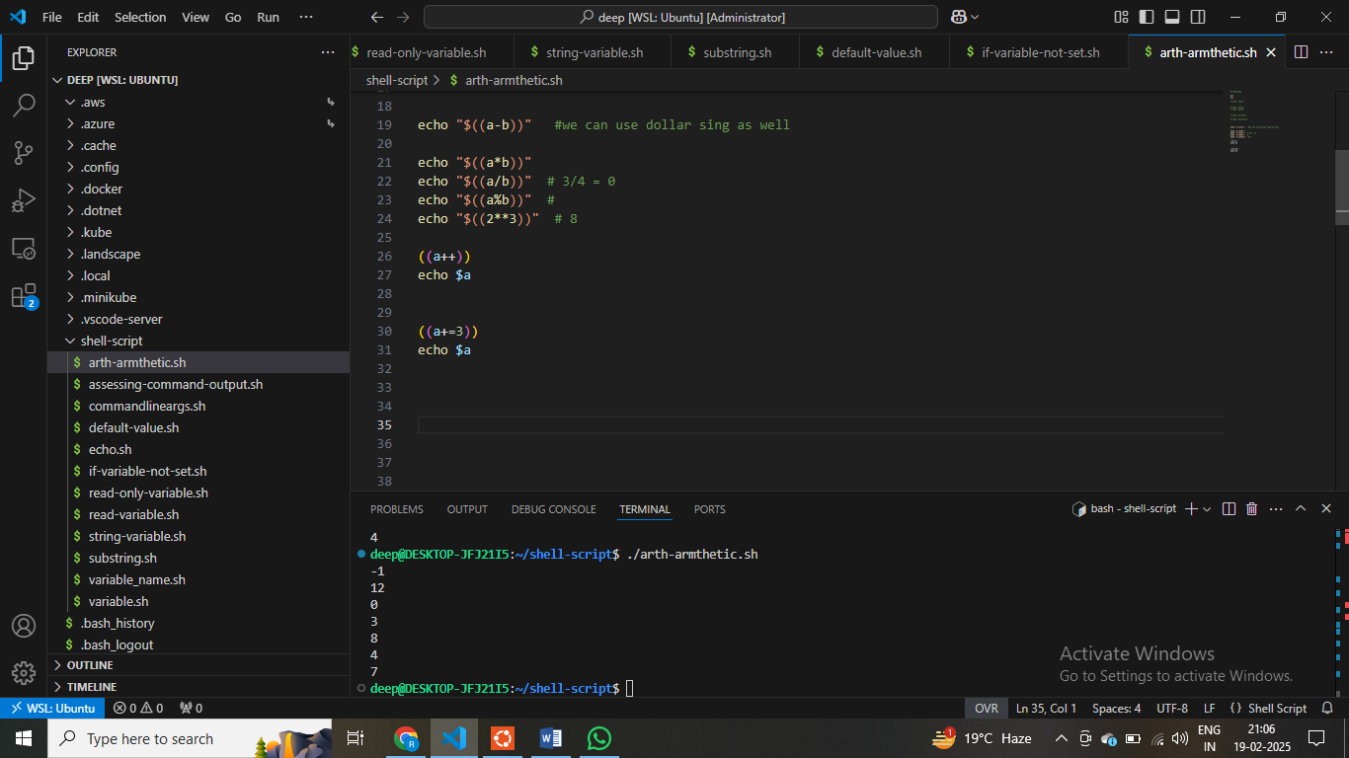

**Shell script 21 fucntions**

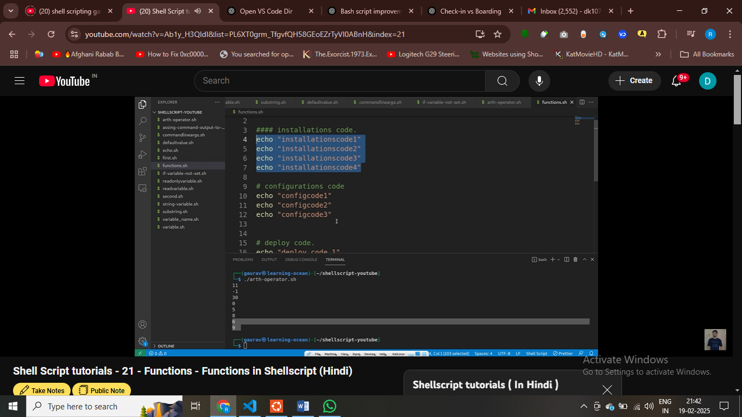

**Echo “deploy code” 2. Echo “deploy code”**

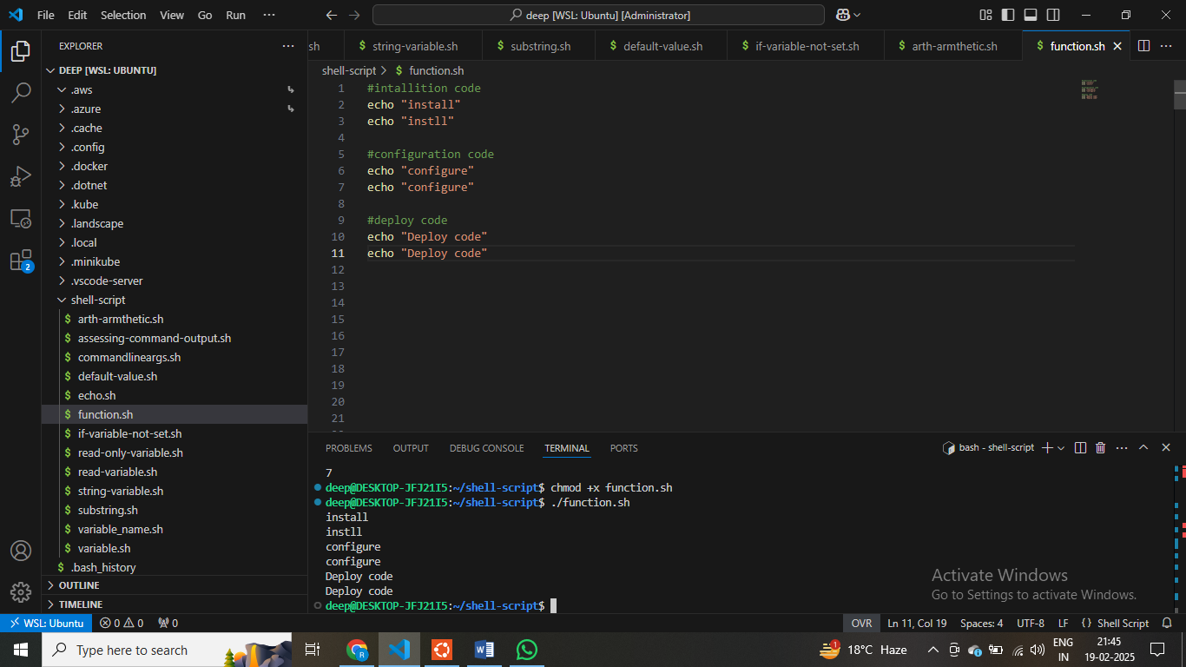

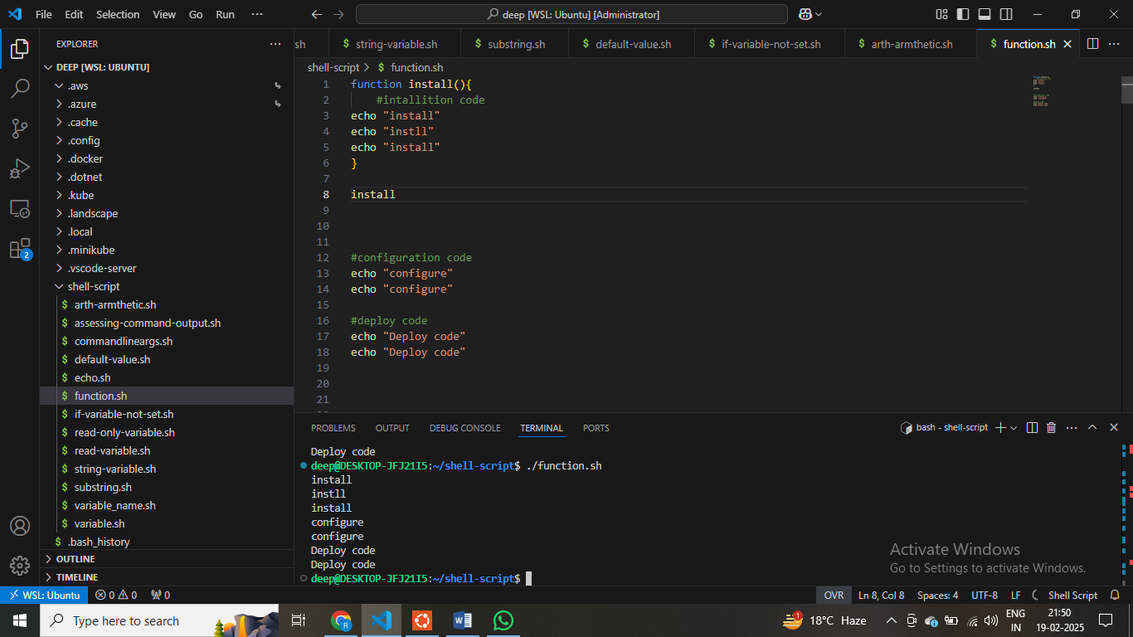

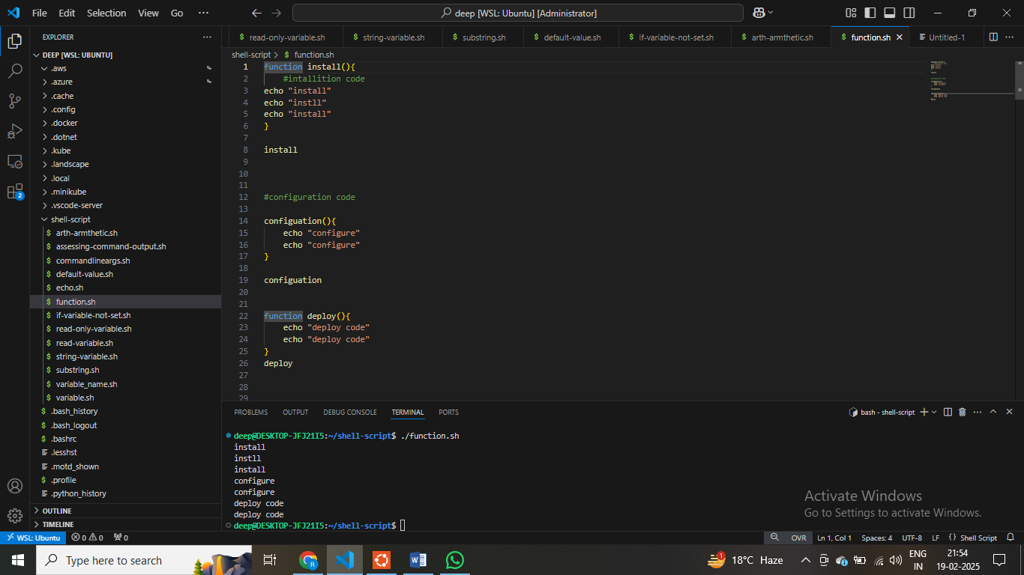

**# line by line execution hote hai shell script**

**$ sabse pahle variables define karo ,variable ka baad function define karo**

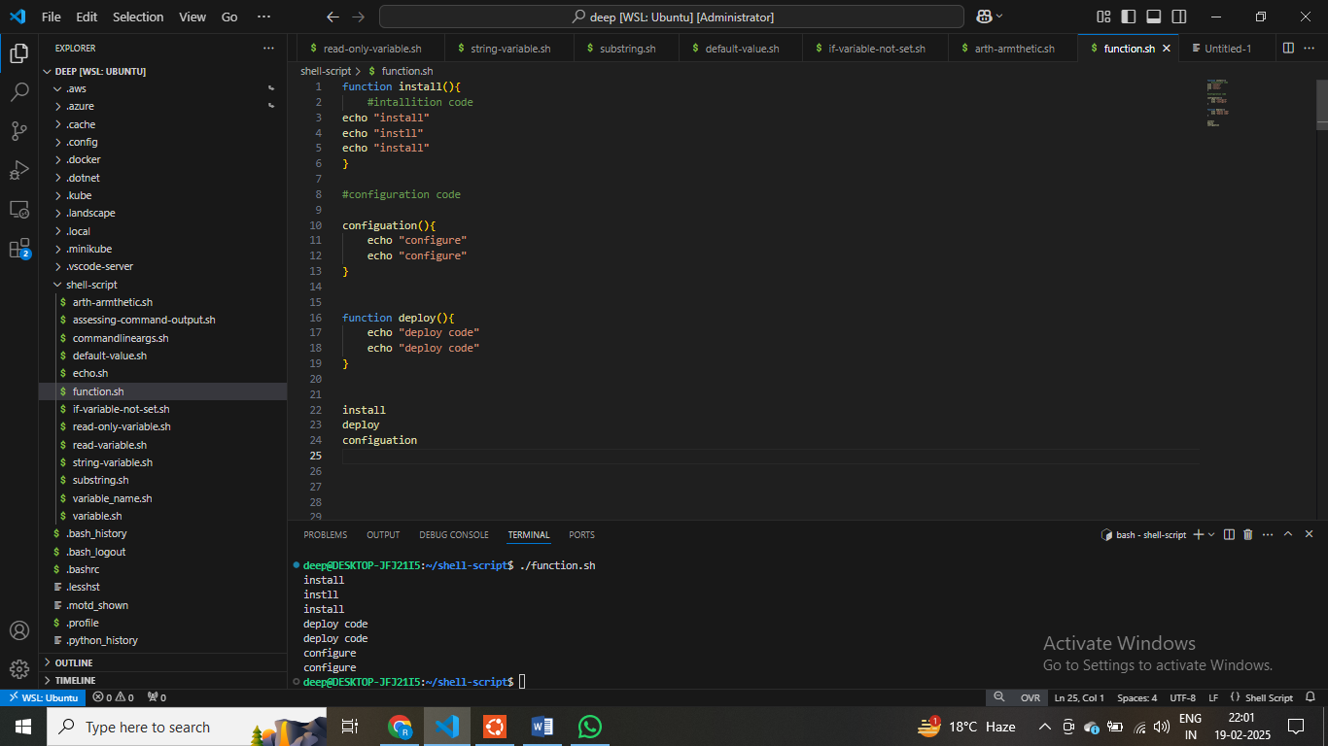

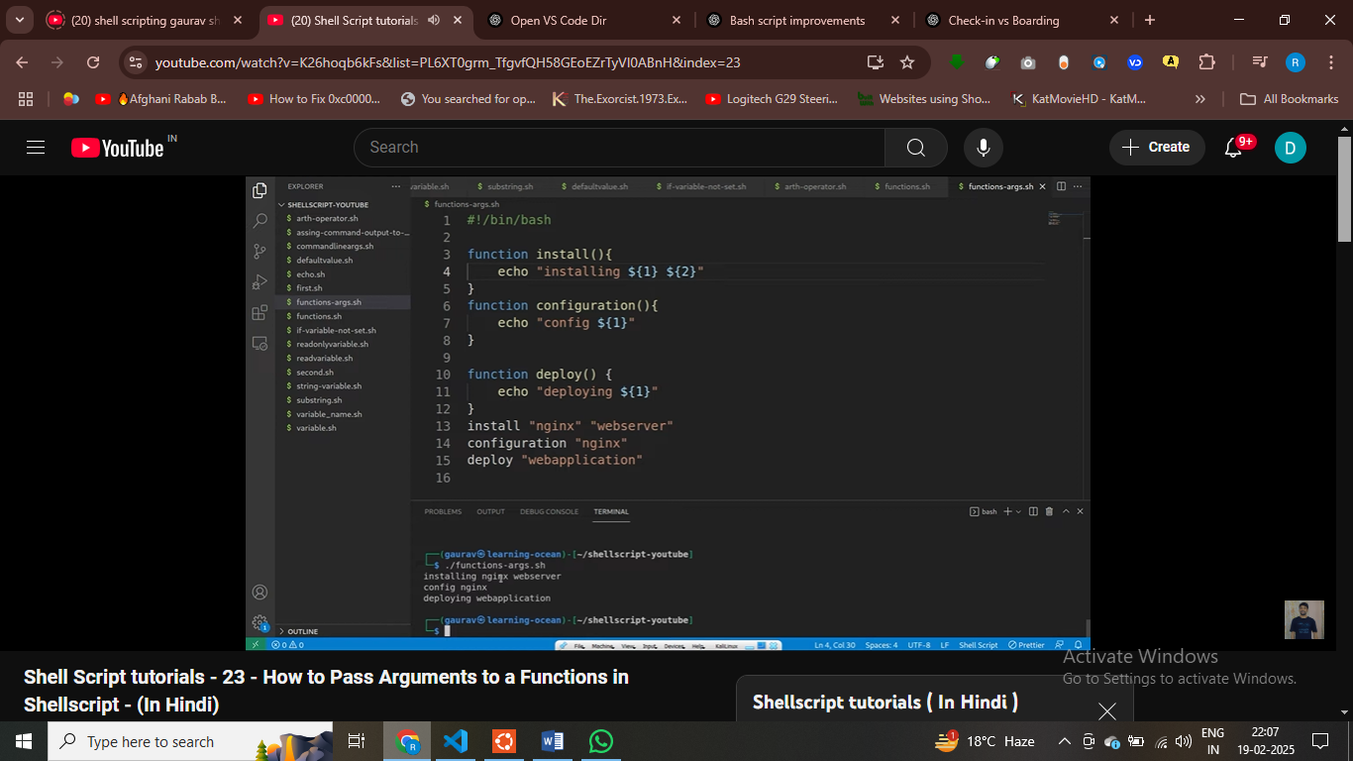

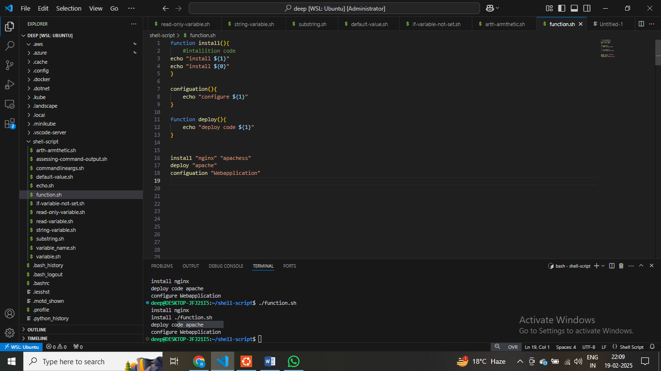

**$ passing cmmd line arugemt inside fucntions**

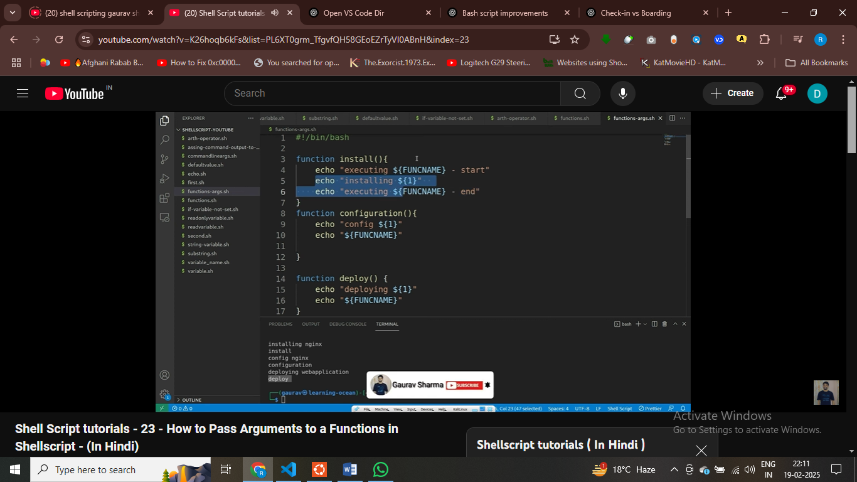

**# CREATE LOCAL VARIABLE IN FUNCTIONS**

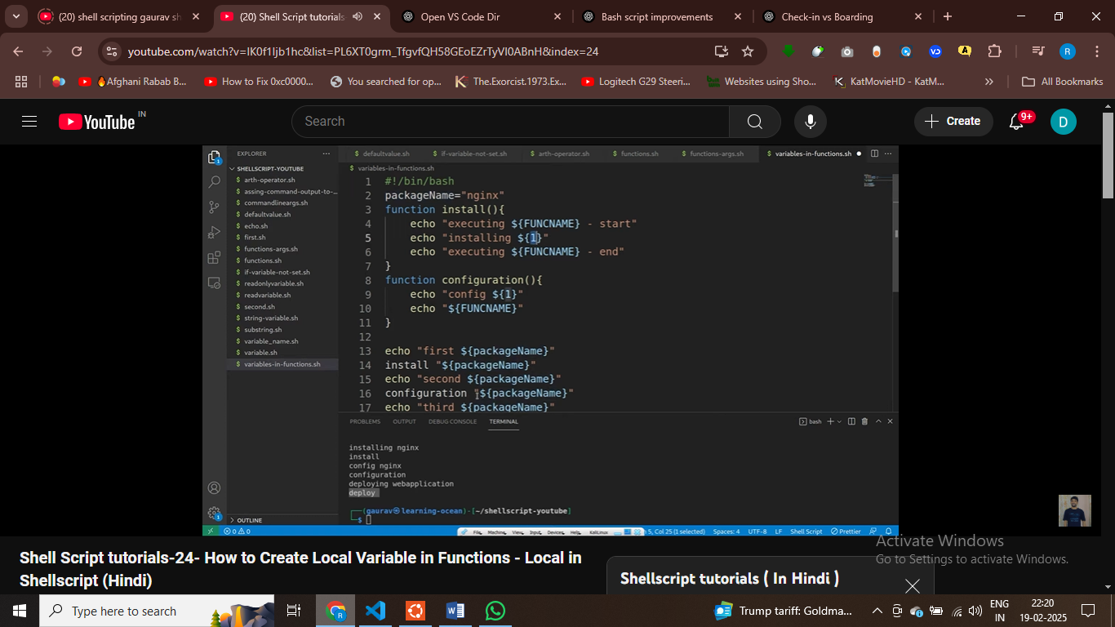

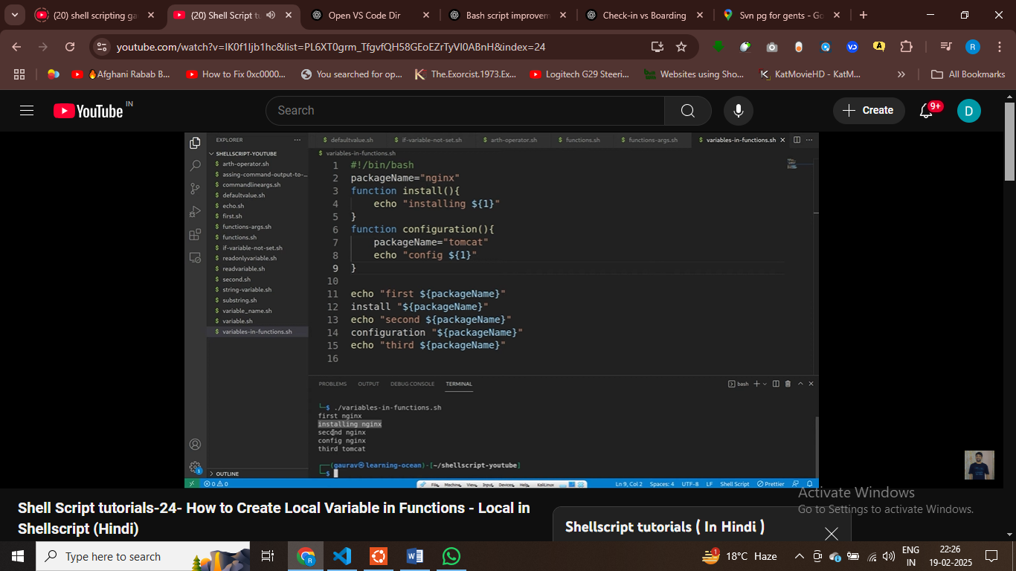



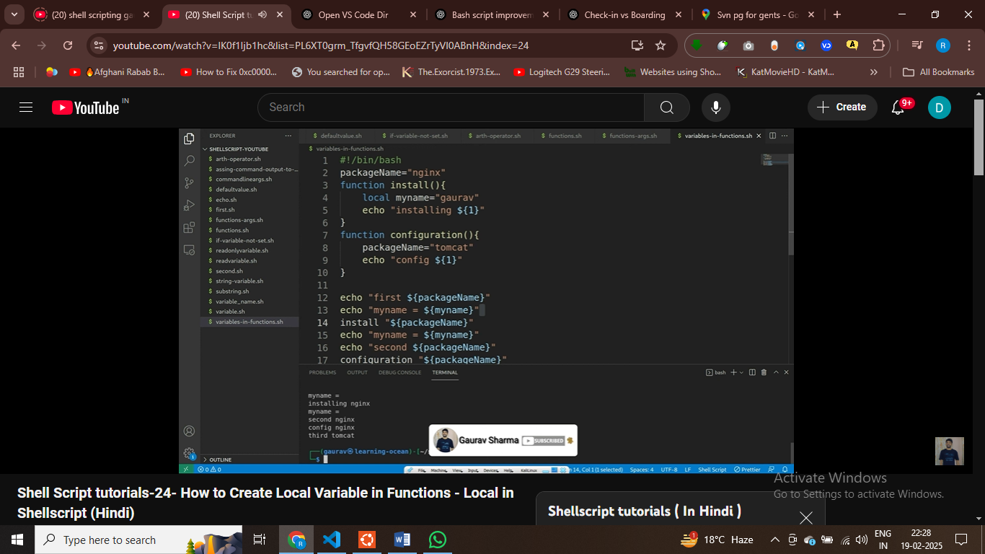

**$ USE Local keyword to create local variable**

**Part 25 – SHELL SCRIPTING**

**deep@DESKTOP-JFJ21I5:~/shell-script$ echo "asdsasdsasdas: command not found"**

**asdsasdsasdas: command not found**

**deep@DESKTOP-JFJ21I5:~/shell-script$ echo $?**

**0**

**$ if last cmd execute sccufsffully then it will return 0**

**deep@DESKTOP-JFJ21I5:~/shell-script$ dafda**

**dafda: command not found**

**deep@DESKTOP-JFJ21I5:~/shell-script$ echo $>**

**-bash: syntax error near unexpected token `newline'**

**deep@DESKTOP-JFJ21I5:~/shell-script$ echo $?**

**2**

**$ if last cmd not execute proepryly tehn it return any number**

**deep@DESKTOP-JFJ21I5:~/shell-script$ help echo**

**echo: echo [-neE] [arg ...]**

**deep@DESKTOP-JFJ21I5:~/shell-script$ man grep**

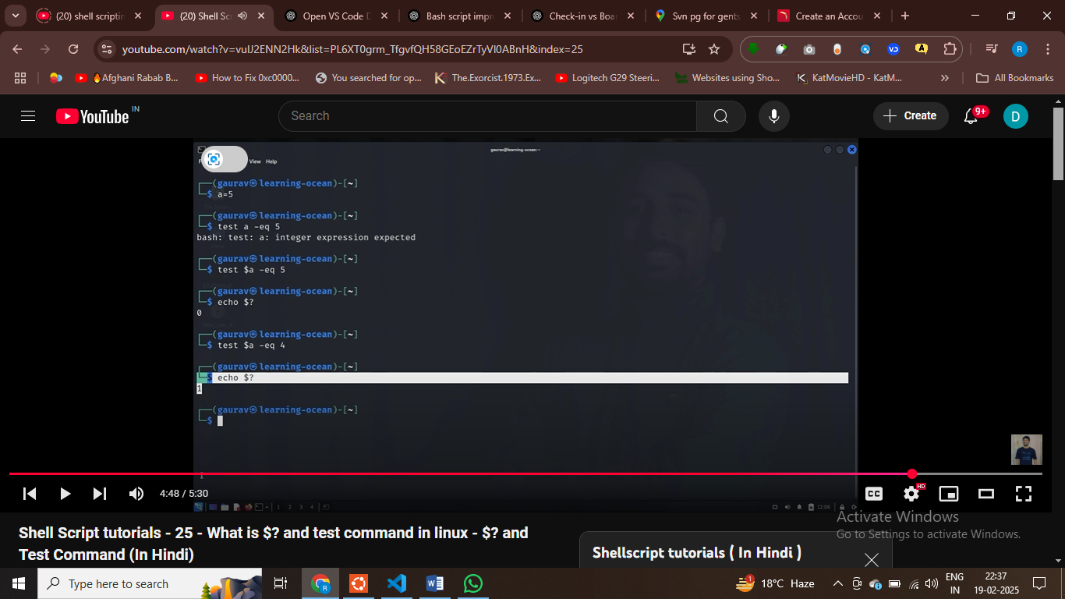

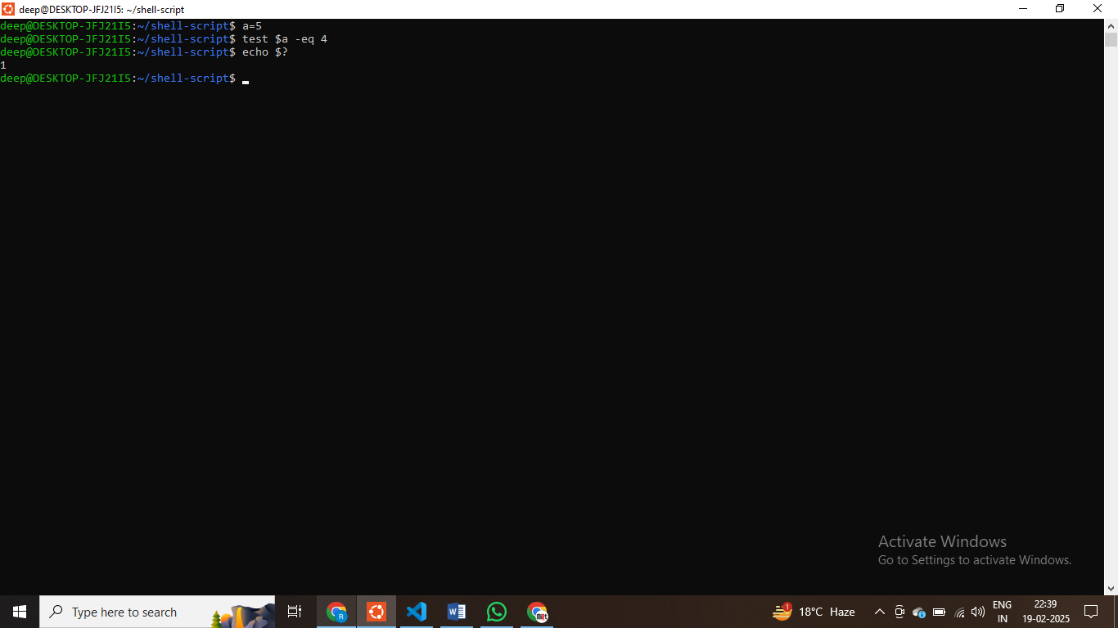

**$ cond false toh isne zero return kar diya , -eq == equal to**

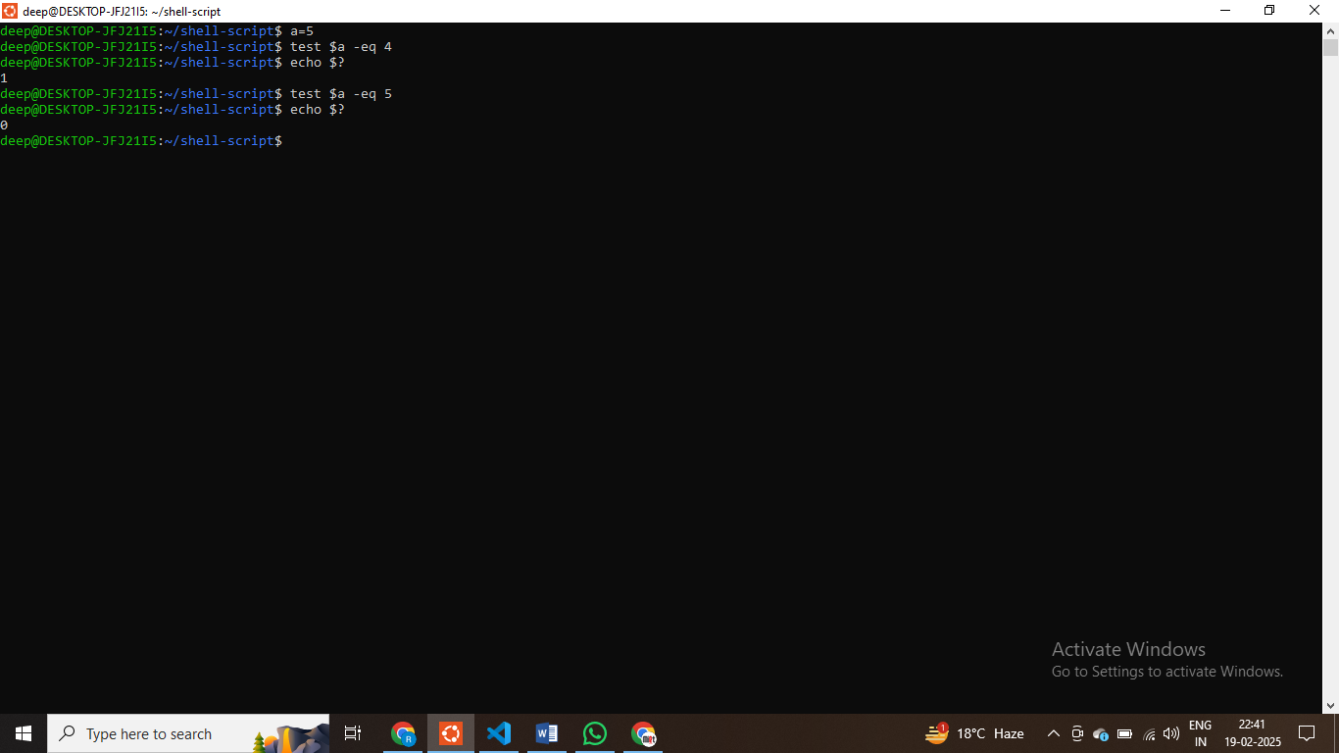

**$ return 0 if cond are satisfied , else return 1 means false**

**deep@DESKTOP-JFJ21I5:~/shell-script$ man test**

**deep@DESKTOP-JFJ21I5:~/shell-script$**

**shell scripting 26 – HOW TO USE IF COMMAND**

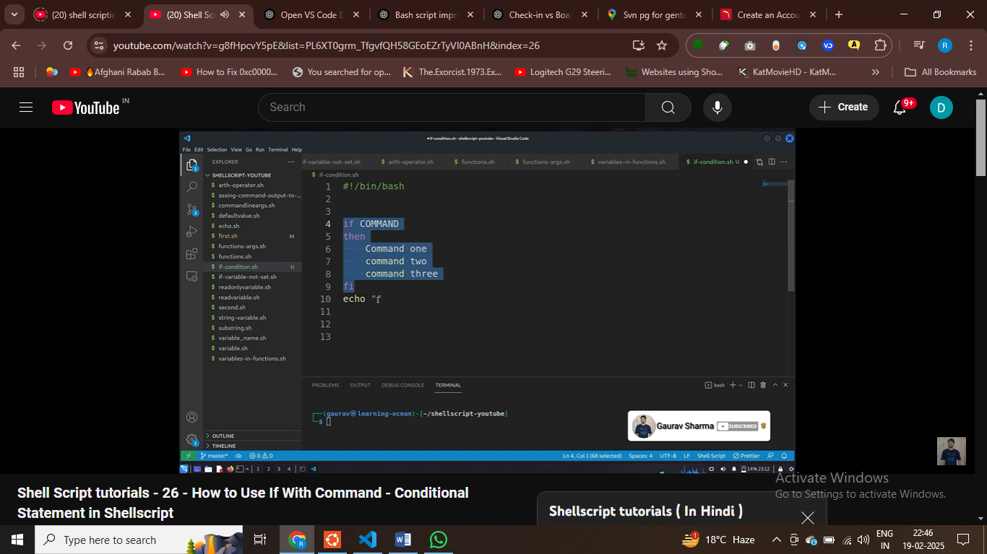

**IF CMD WALI STATEMTN SUCCESS – THEN EXECUTE ALL THE cmd and run all the cmd**

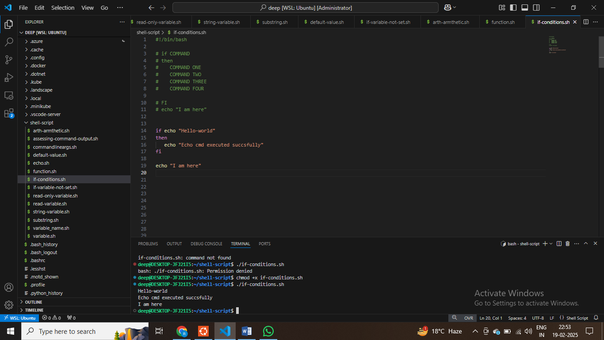

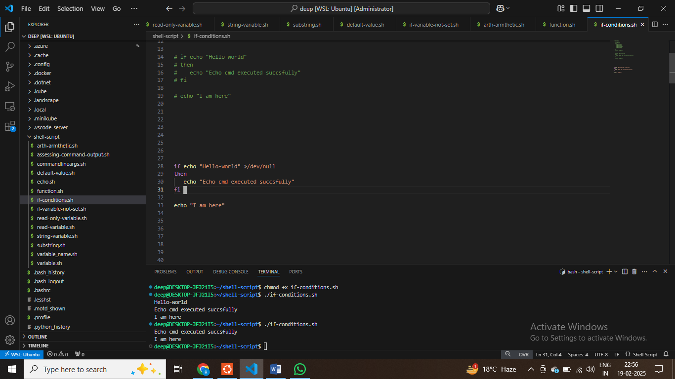

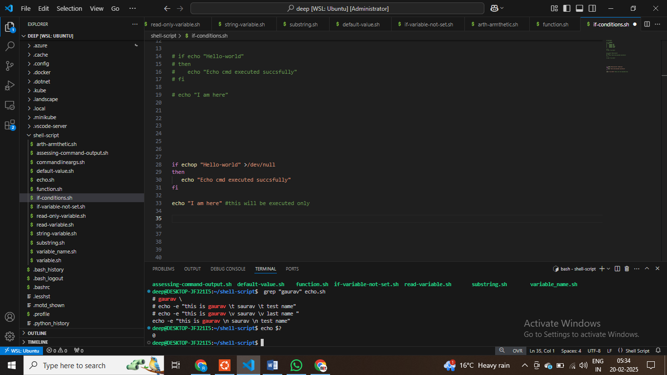

**$ if cmd executed successfully then it will return 0 , $? -0**

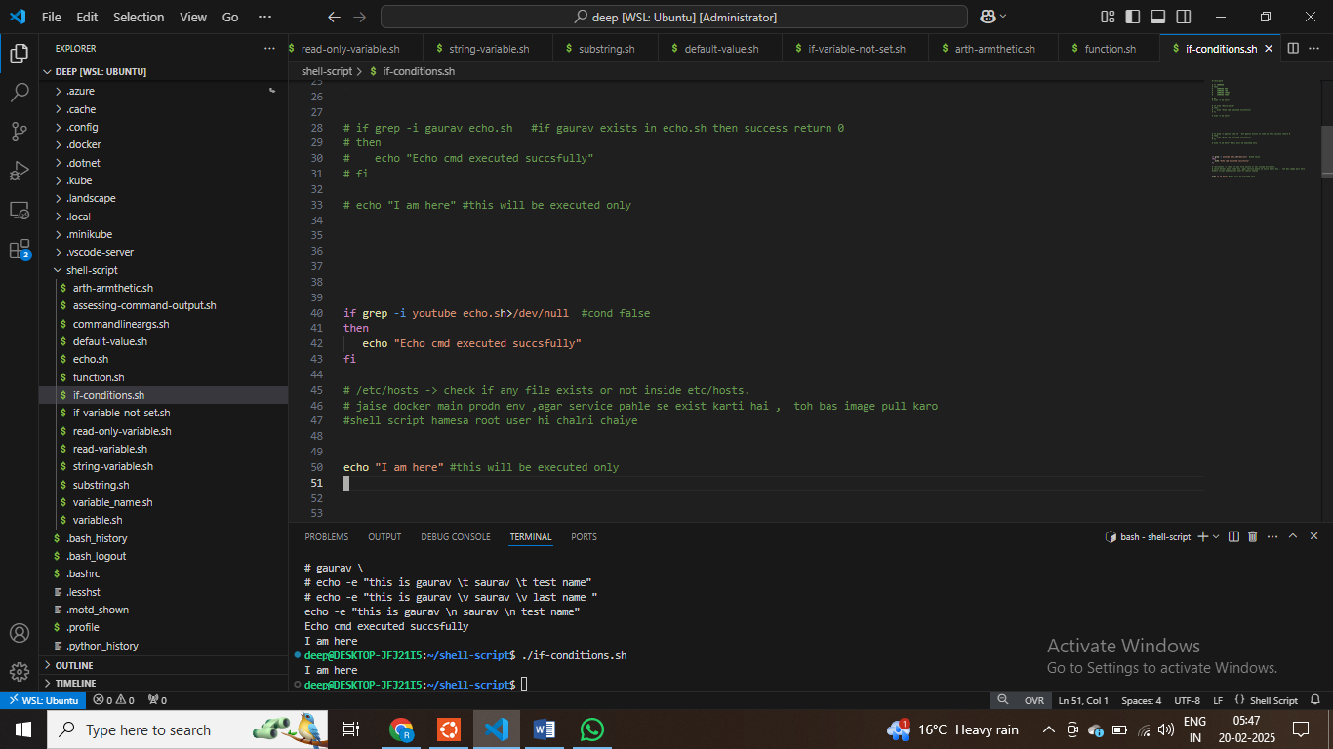

**# How to use if-with square brackets – Integer comparisons**

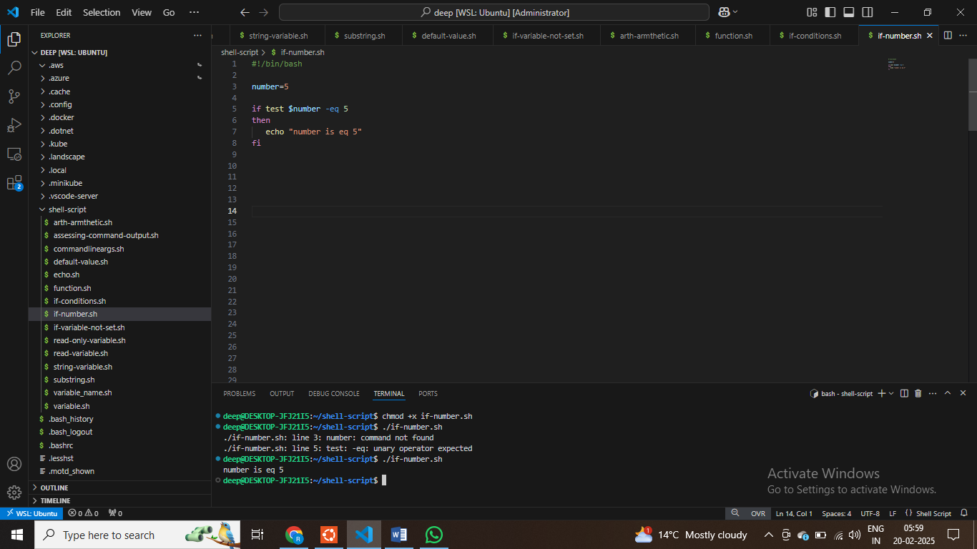

**# line by line execution of shell-script**

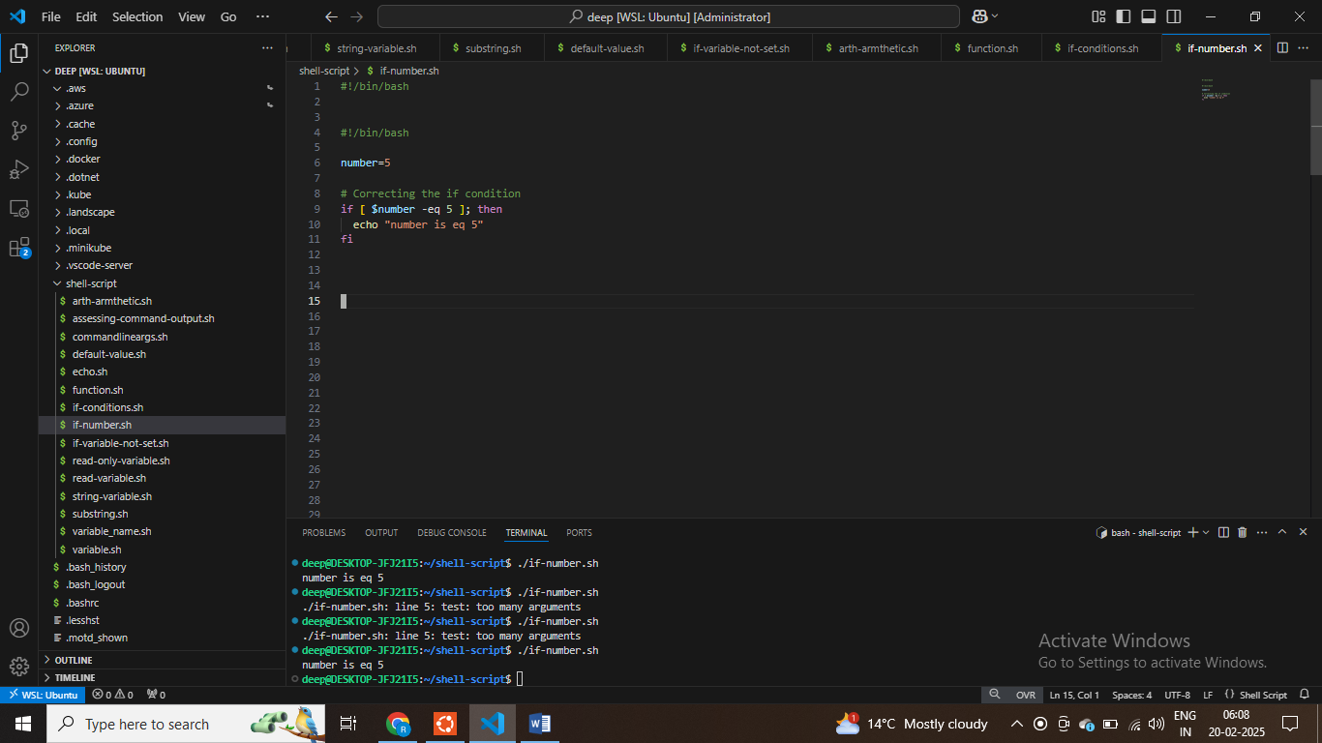

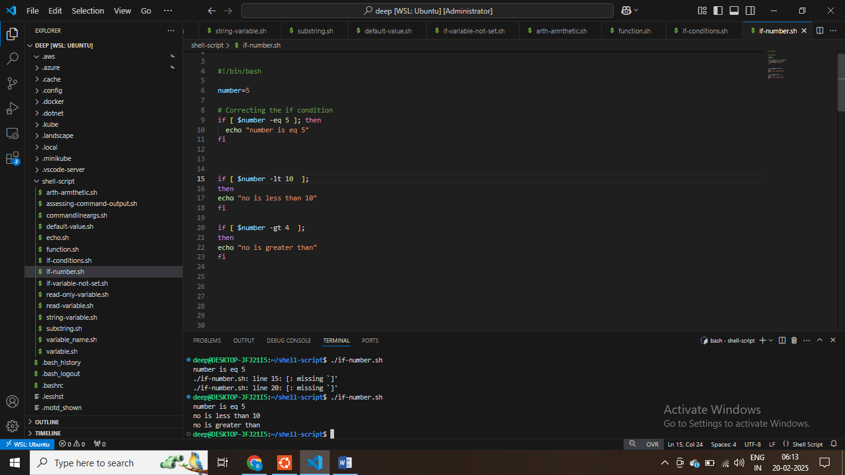

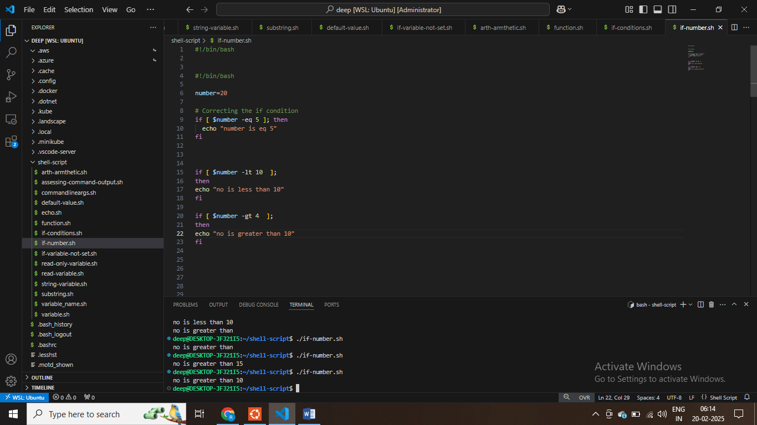

**# string compoarison in shell script**

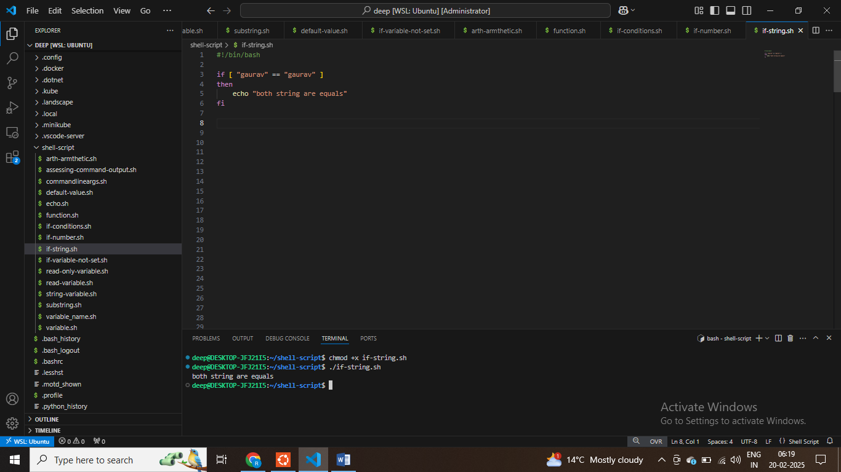

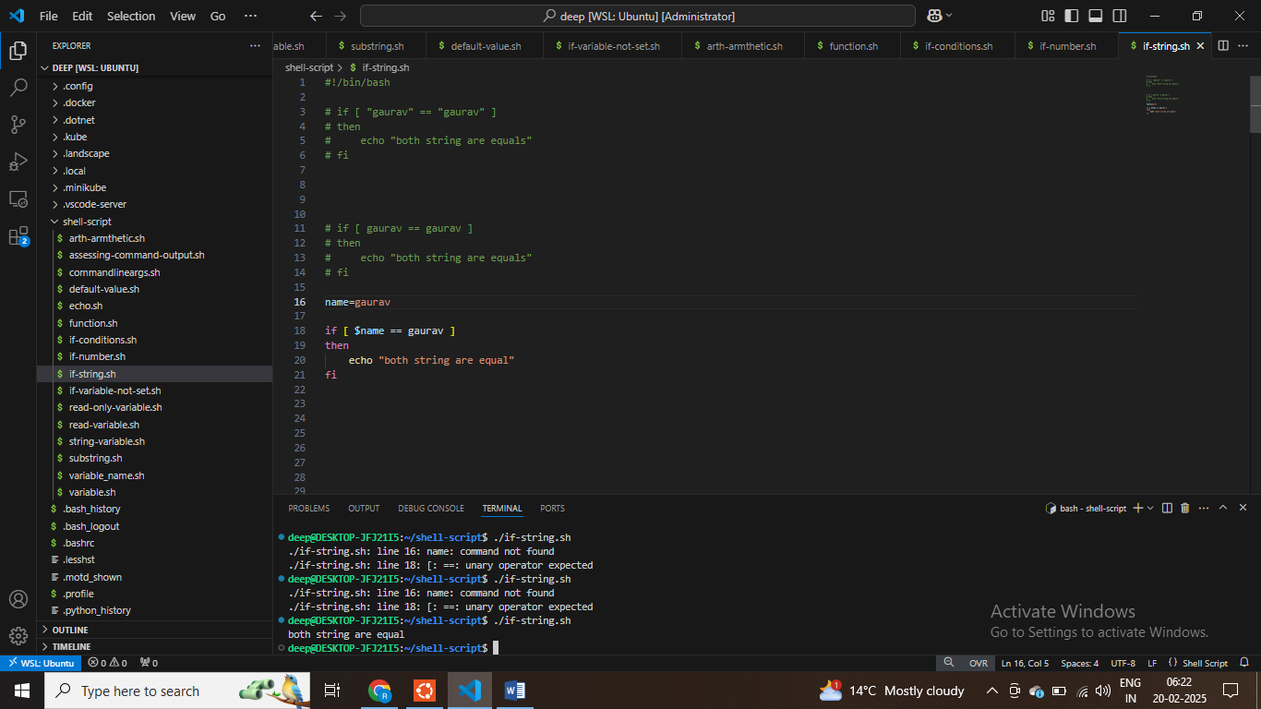

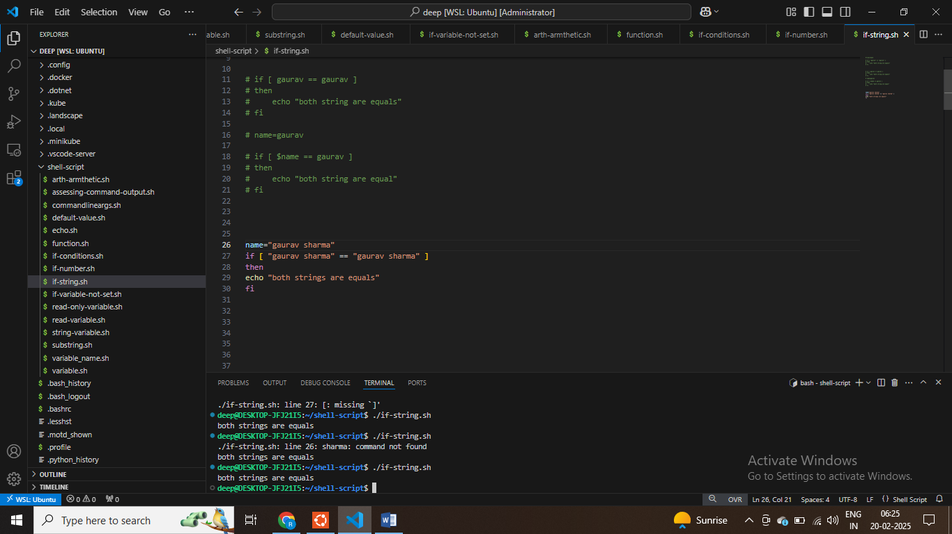

name="gaurav sharma"

if [ "$name" == "gaurav sharma" ]

then

echo "both strings are equals"

fi

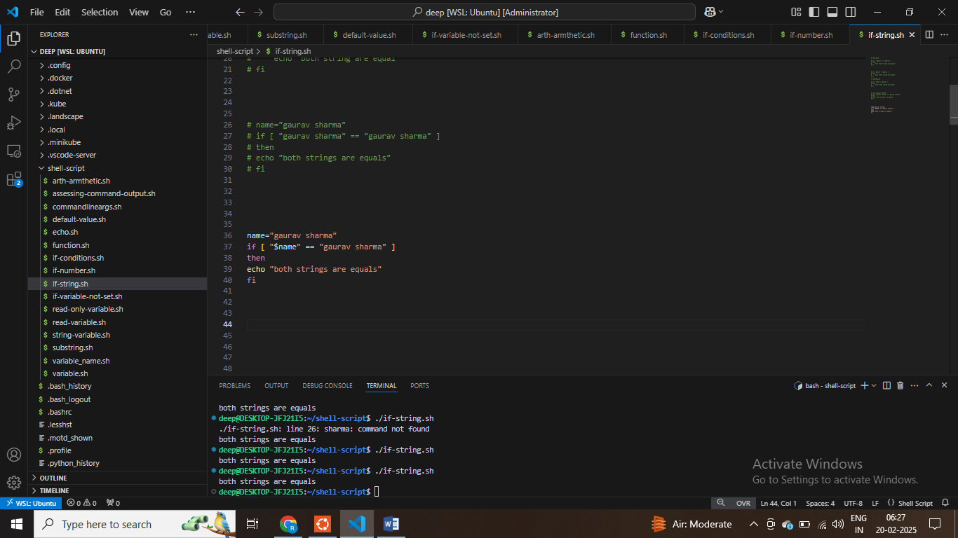

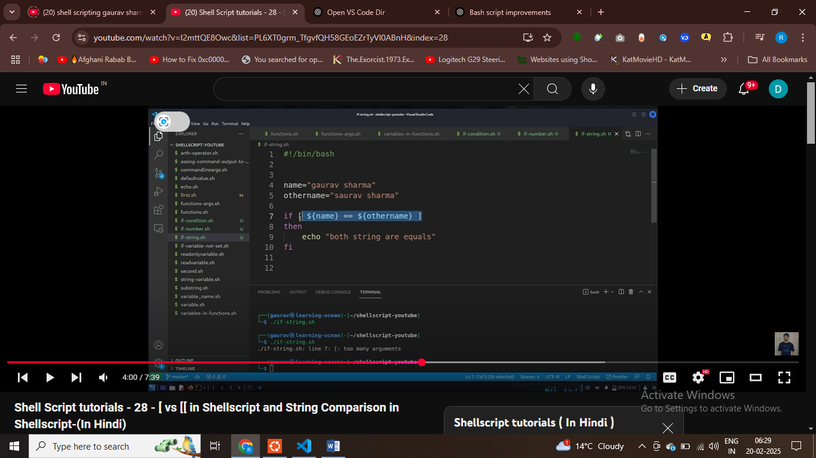

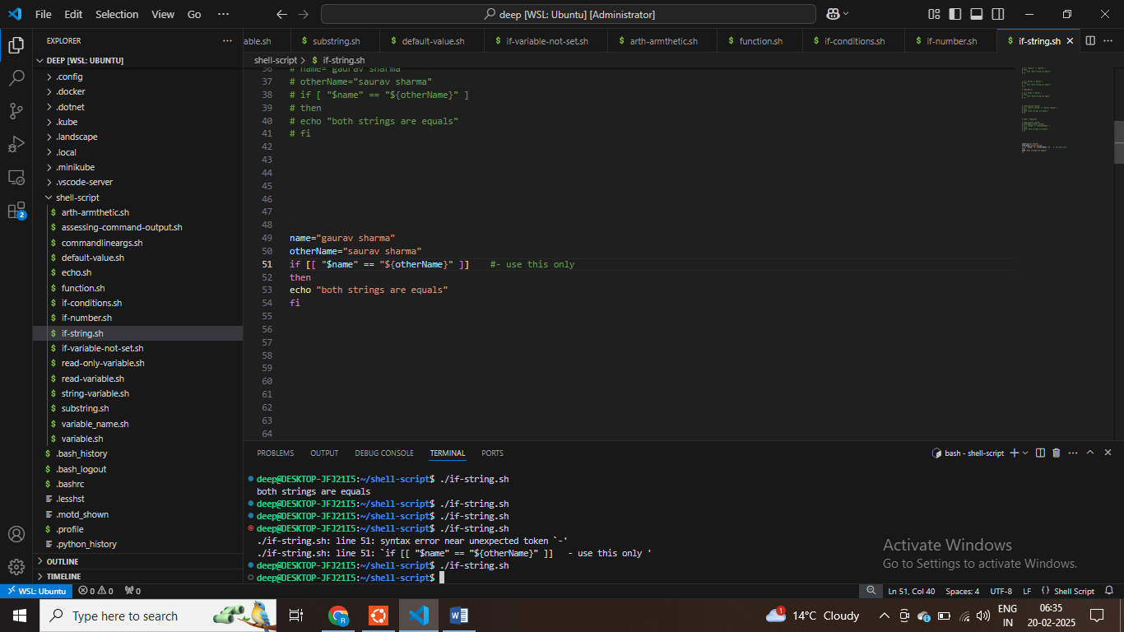

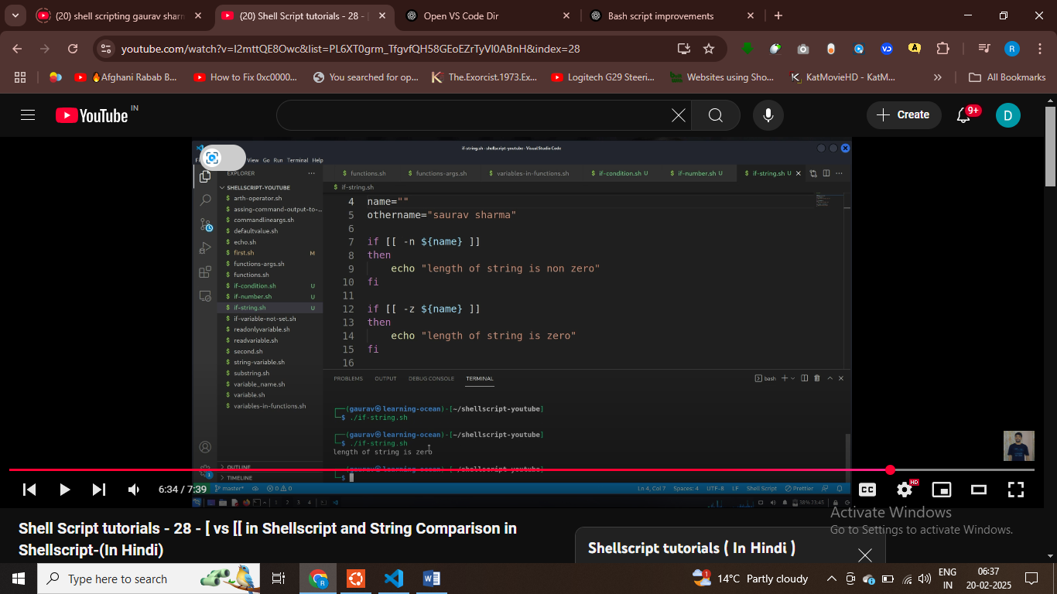

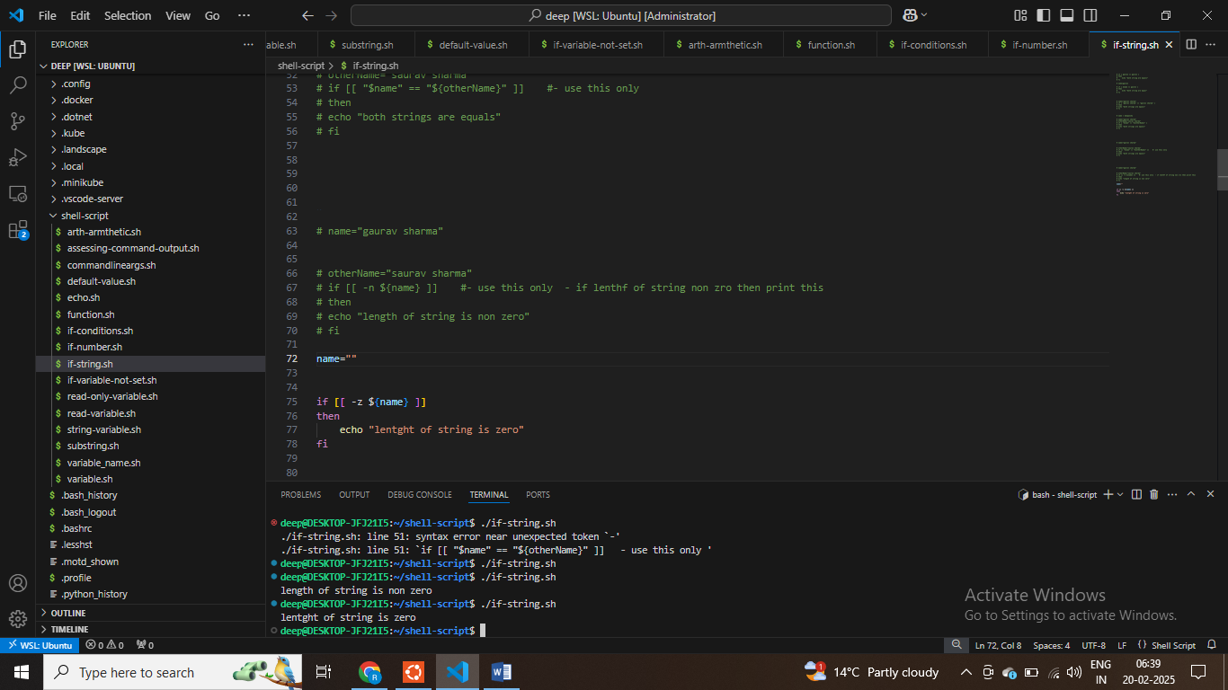

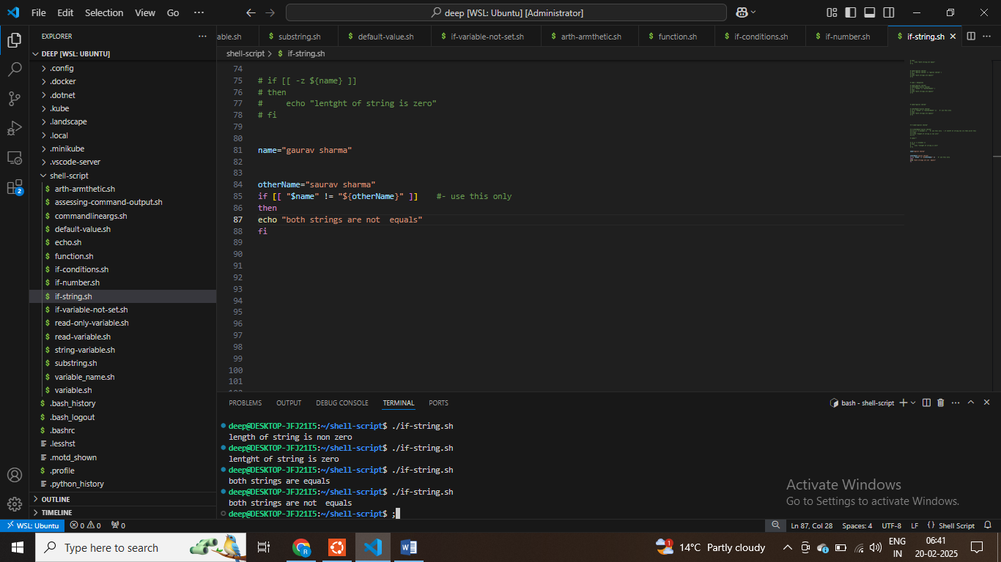

**Shell Script tutorials - 29 - How to Check File is Exist, Directory, Block Device, Character Device**

**$ b block device, l refer to symbolic link , d refer to directory**

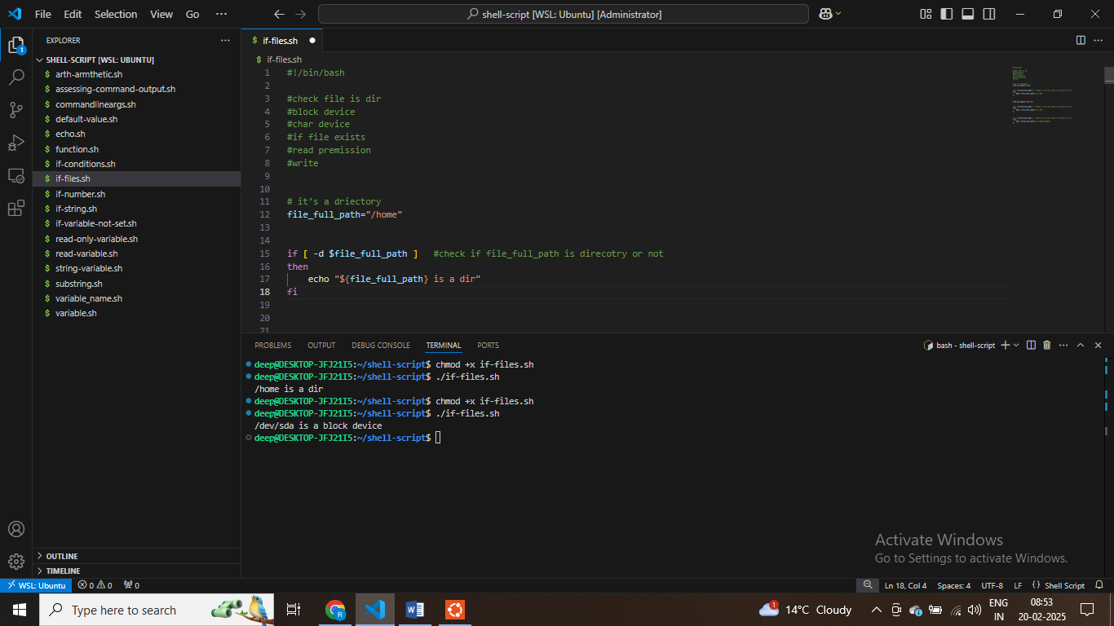

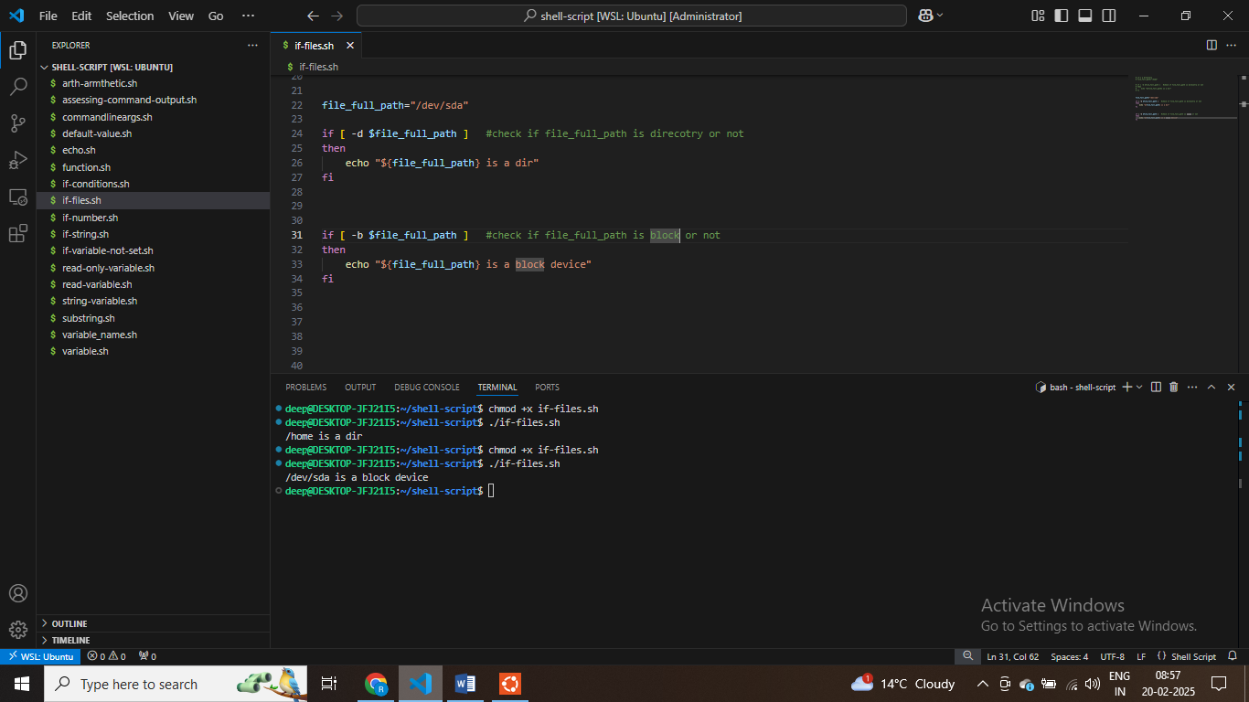

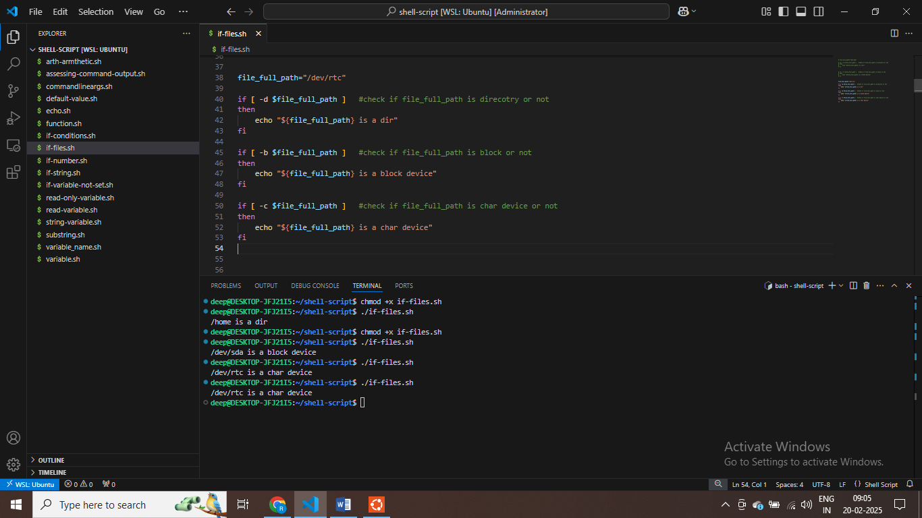

**$ Check if /dev/rtc is char device or not**

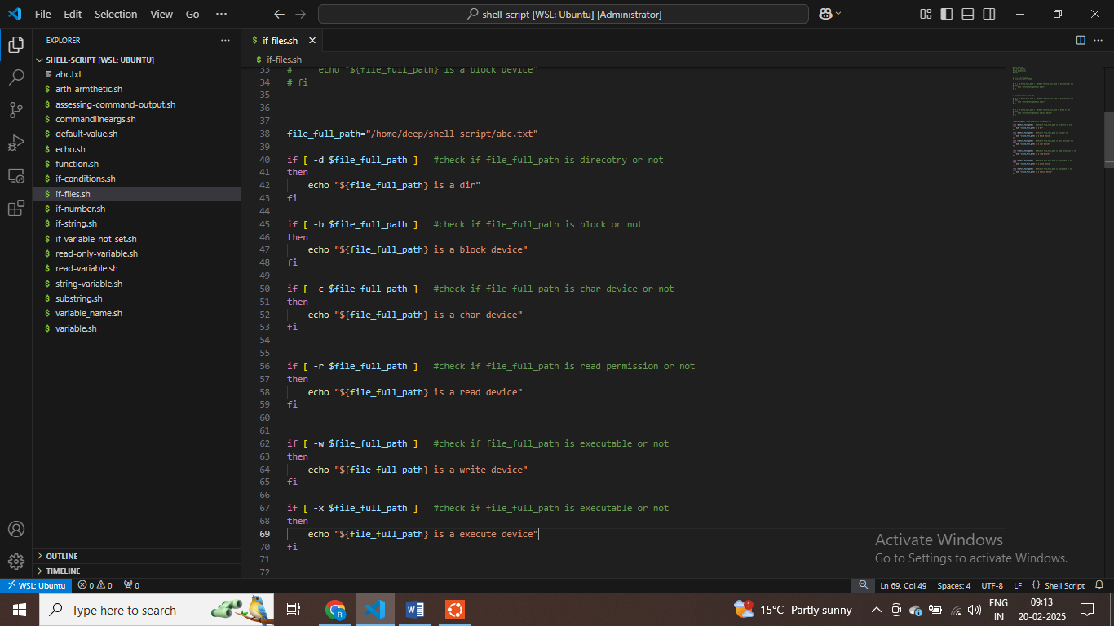

**deep@DESKTOP-JFJ21I5:~/shell-script$ chmod +x abc.txt**

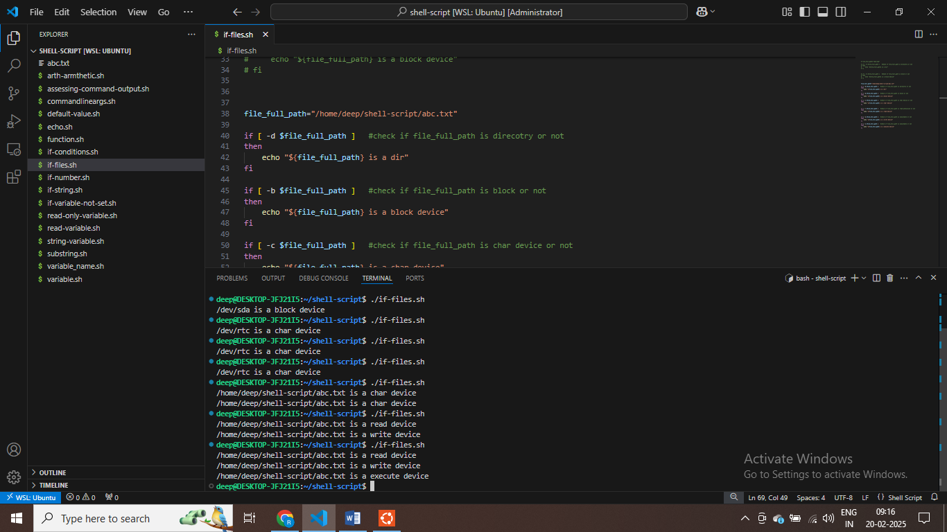

**Shell-script = not operator – part 30**

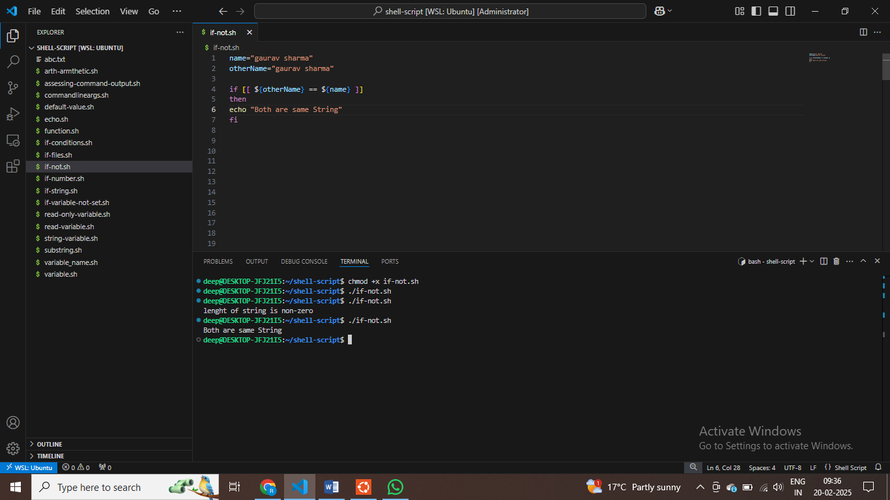

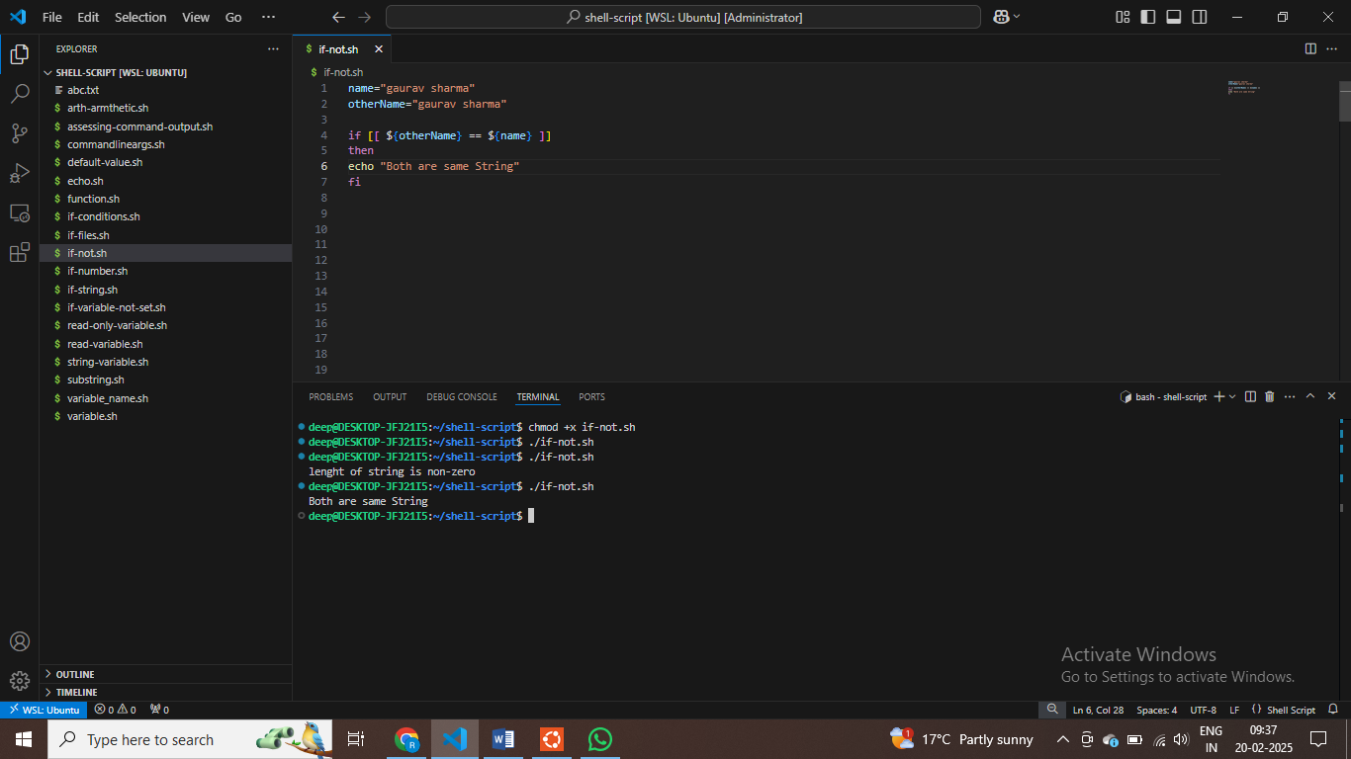

**$ check if both character are same**

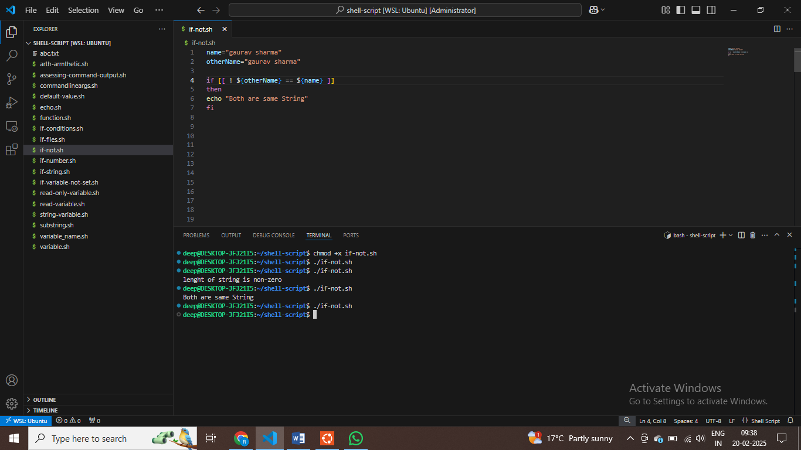

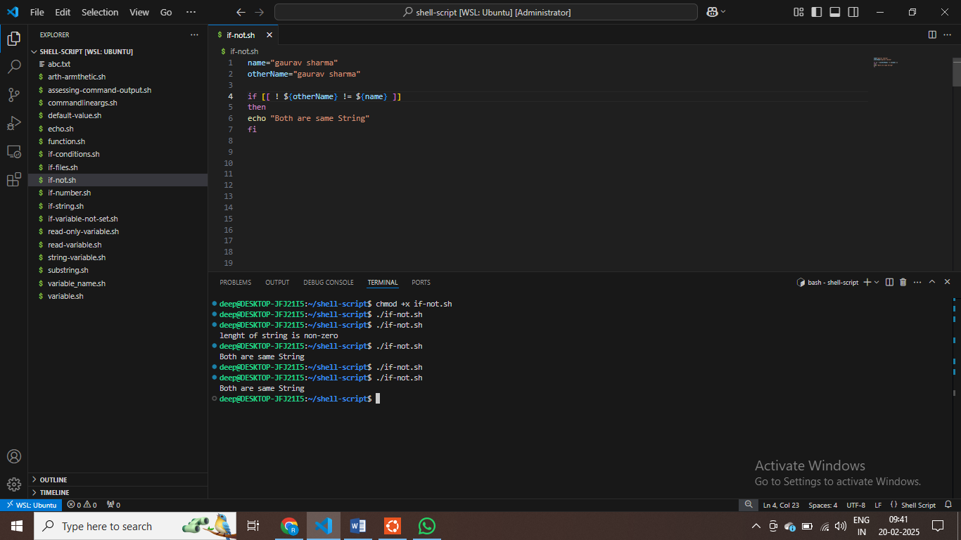

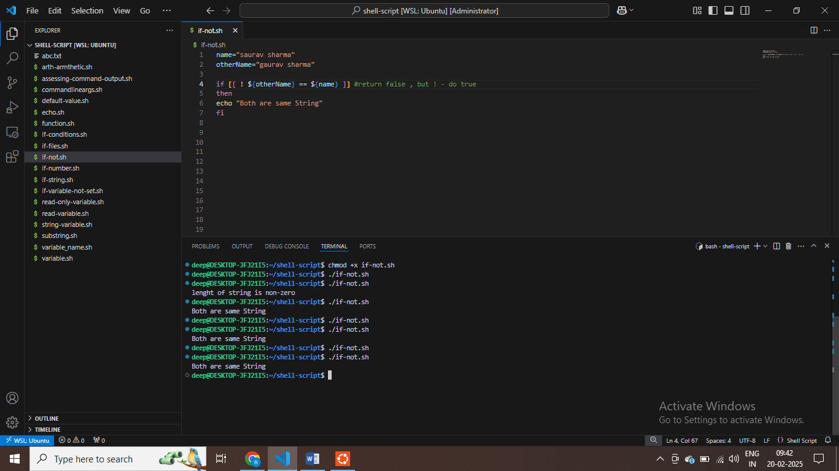

**deep@DESKTOP-JFJ21I5:~/shell-script$ ls && echo "last command execute succesfully"**

**abc.txt commandlineargs.sh function.sh if-not.sh if-variable-not-set.sh string-variable.sh variable_name.sh**

**deep@DESKTOP-JFJ21I5:~/shell-script$ ls /trrr**

**ls: cannot access '/trrr': No such file or directory**

**deep@DESKTOP-JFJ21I5:~/shell-script$ echo $?**

**2**

**$ last cmd not execute successfully , thas why return 2**

**deep@DESKTOP-JFJ21I5:~/shell-script$ ls /trrr && echo "last command execute succesfully"**

**ls: cannot access '/trrr': No such file or directory**

**deep@DESKTOP-JFJ21I5:~/shell-script$ ls && echo "last command execute succesfully"**

**abc.txt commandlineargs.sh function.sh if-not.sh if-variable-not-set.sh string-variable.sh variable_name.sh**

**arth-armthetic.sh default-value.sh if-conditions.sh if-number.sh read-only-variable.sh substring.sh**

**assessing-command-output.sh echo.sh if-files.sh if-string.sh read-variable.sh variable.sh**

**last command execute successfully**

**$ using two cmd together**

**deep@DESKTOP-JFJ21I5:~/shell-script$ ls && echo "last cmd execute succesfully." && date**

**abc.txt commandlineargs.sh function.sh if-not.sh if-variable-not-set.sh string-variable.sh variable_name.sh**

**arth-armthetic.sh default-value.sh if-conditions.sh if-number.sh read-only-variable.sh substring.sh**

**assessing-command-output.sh echo.sh if-files.sh if-string.sh read-variable.sh variable.sh**

**last cmd execute succesfully.**

**Thu Feb 20 04:32:46 UTC 2025**

**deep@DESKTOP-JFJ21I5:~/shell-script$ echo $?**

**0**

**$ multiple cmd together we can write**

**$ sequence by sequence line or code execute hote hai , phale ls phir echo execute then date return hoge**

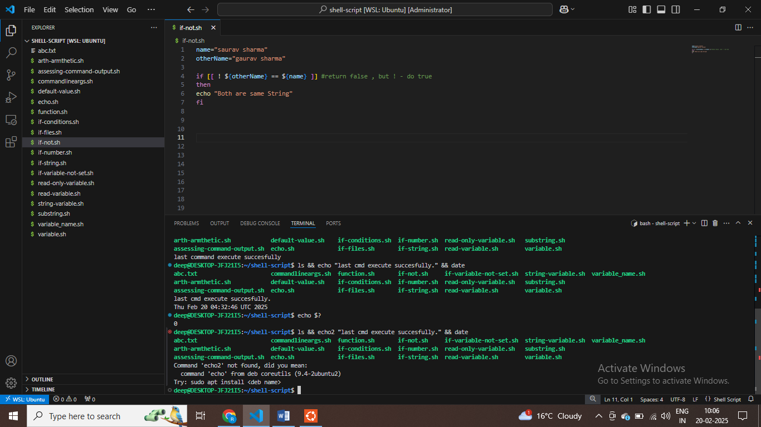

Try: sudo apt install <deb name>

deep@DESKTOP-JFJ21I5:~/shell-script$ ping -c 1 8.8.8.8

PING 8.8.8.8 (8.8.8.8) 56(84) bytes of data.

64 bytes from 8.8.8.8: icmp_seq=1 ttl=58 time=12.6 ms

**deep@DESKTOP-JFJ21I5:~/shell-script$ ping -c 1 8.8.8.8 && echo "Internet working fine"**

**PING 8.8.8.8 (8.8.8.8) 56(84) bytes of data.**

**64 bytes from 8.8.8.8: icmp_seq=1 ttl=58 time=178 ms**

**--- 8.8.8.8 ping statistics ---**

**1 packets transmitted, 1 received, 0% packet loss, time 0ms**

**PART 31 - Shell Script tutorials - 31 - AND operator in Shellscript - && in shellscript**

**rtt min/avg/max/mdev = 177.602/177.602/177.602/0.000 ms**

**Internet working fine**

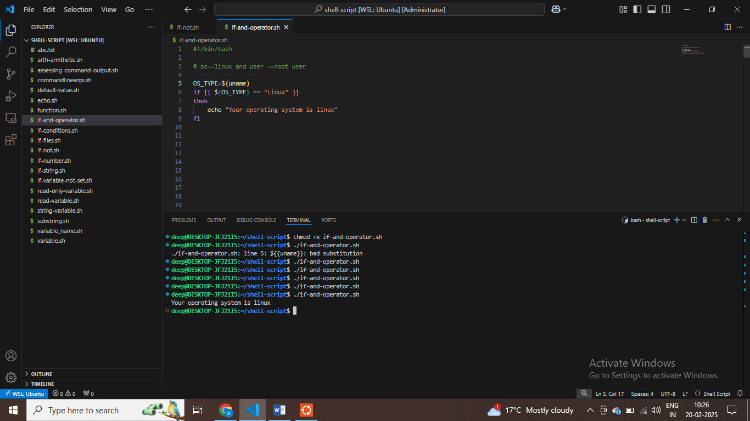

**deep@DESKTOP-JFJ21I5:~/shell-script$ ping -c 1 8.8.8.8>/dev/null && echo "Internet working fine"**

**Internet working fine**

**deep@DESKTOP-JFJ21I5:~/shell-script$ uname**

**Linux**

**$ to check OS**

**deep@DESKTOP-JFJ21I5:~/shell-script$ echo $uid**

**deep@DESKTOP-JFJ21I5:~/shell-script$ echo $UID**

**1000**

**deep@DESKTOP-JFJ21I5:~/shell-script$ sudo i**

**[sudo] password for deep:**

**sudo: i: command not found**

**deep@DESKTOP-JFJ21I5:~/shell-script$ sudo -i**

**root@DESKTOP-JFJ21I5:~# echo $UID**

**0**

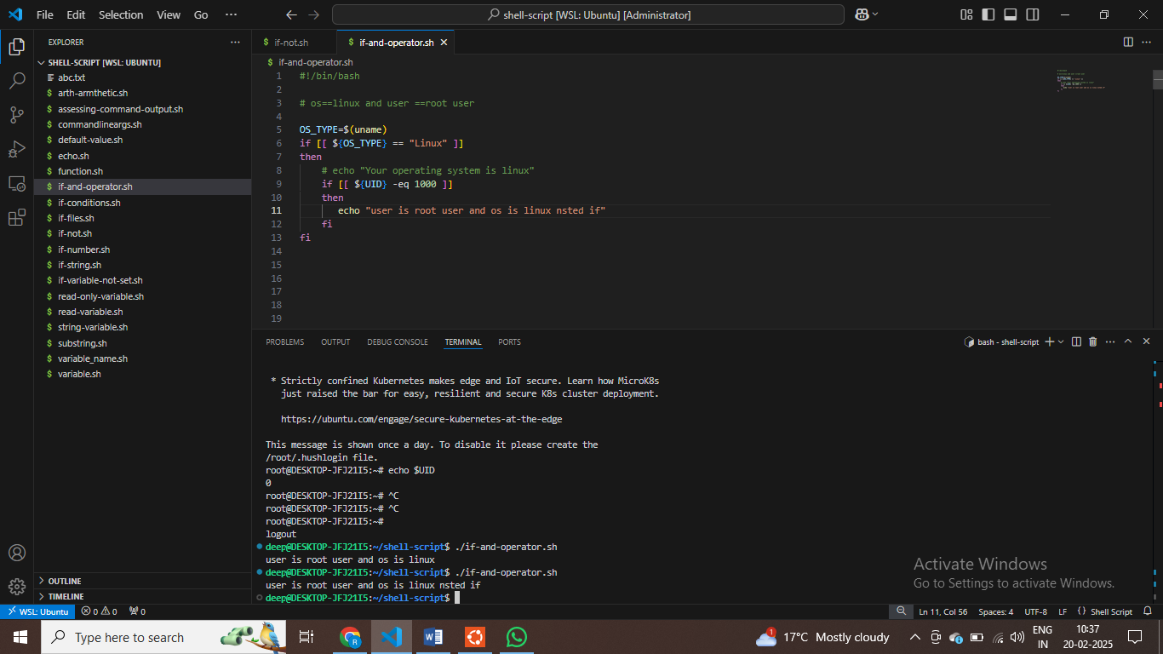

**$ nested if else we have**

**$Using of and operator**

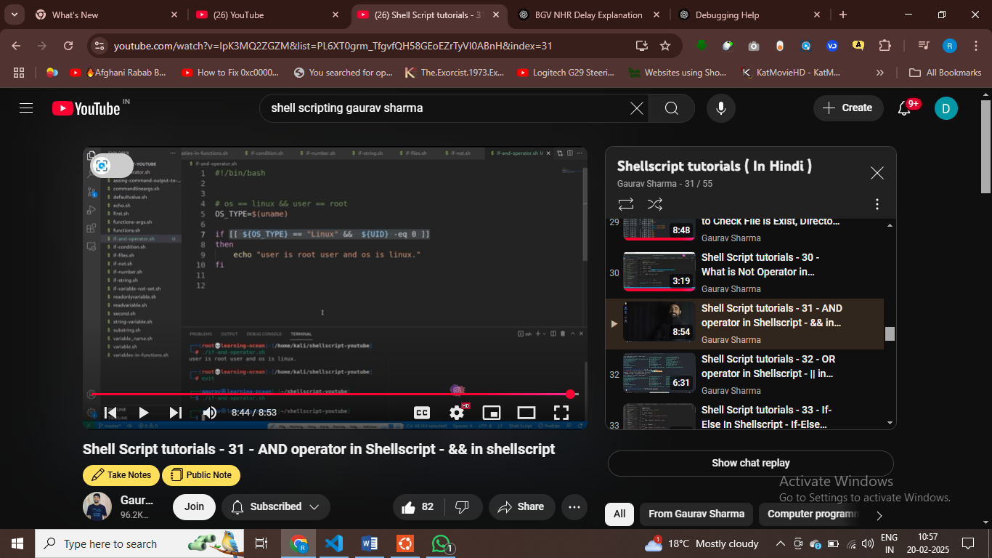

**OR operator part 32**

**deep@DESKTOP-JFJ21I5:~/shell-script$ ping -c 2 google.com >/dev/null && echo1 "Internet working fine"**

**Command 'echo1' not found, did you mean:**

**command 'echo' from deb coreutils (9.4-2ubuntu2)**

**Try: sudo apt install <deb name>**

**deep@DESKTOP-JFJ21I5:~/shell-script$ echo $?**

**127**

**$ previous cmd not working , return random number**

**deep@DESKTOP-JFJ21I5:~/shell-script$ echo "solve mystery" || ls**

**solve mystery**

**deep@DESKTOP-JFJ21I5:~/shell-script$ echo $?**

**0**

**deep@DESKTOP-JFJ21I5:~/shell-script$ echo "this is awesome" || echo1 "rusev"**

**this is awesome**

**deep@DESKTOP-JFJ21I5:~/shell-script$**

**# OR SEE only one first cmd and give output**

**v**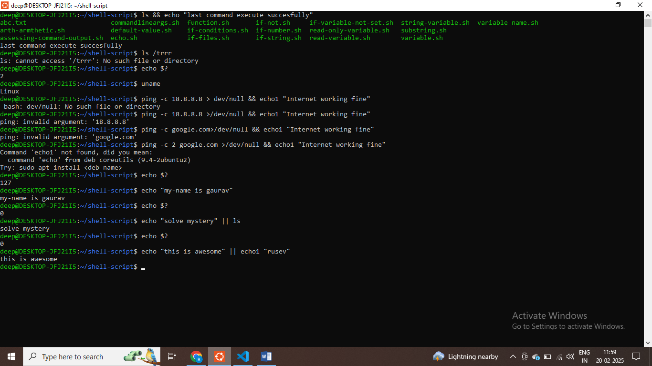

**this is awesome**

**deep@DESKTOP-JFJ21I5:~/shell-script$ kubectl get svc serivename || kubectl create svc**

**deep@DESKTOP-JFJ21I5:~/shell-script**

**$anyof cmd will execute using OR**

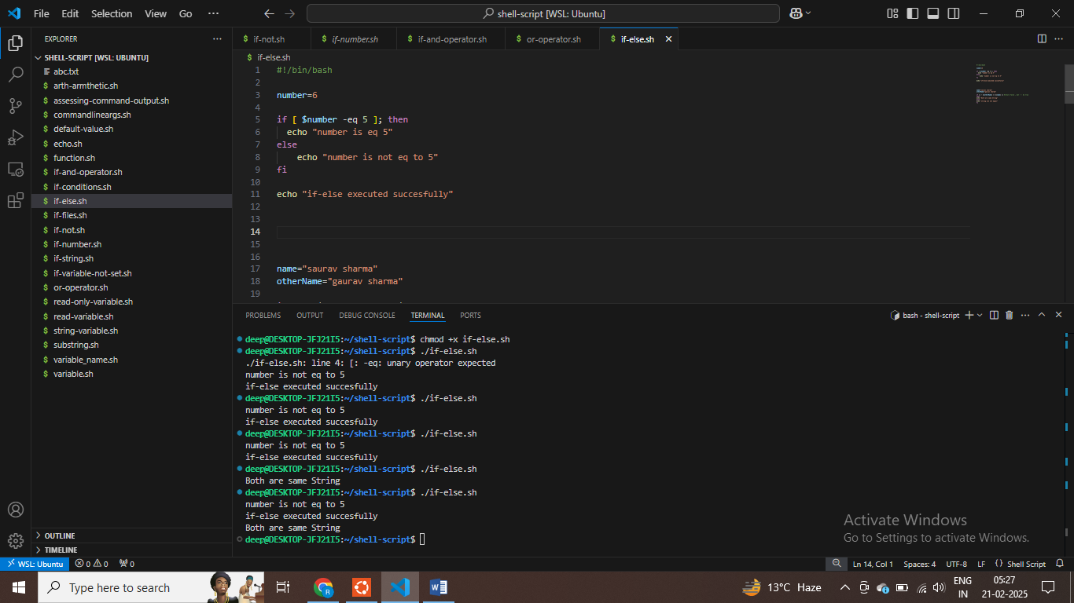

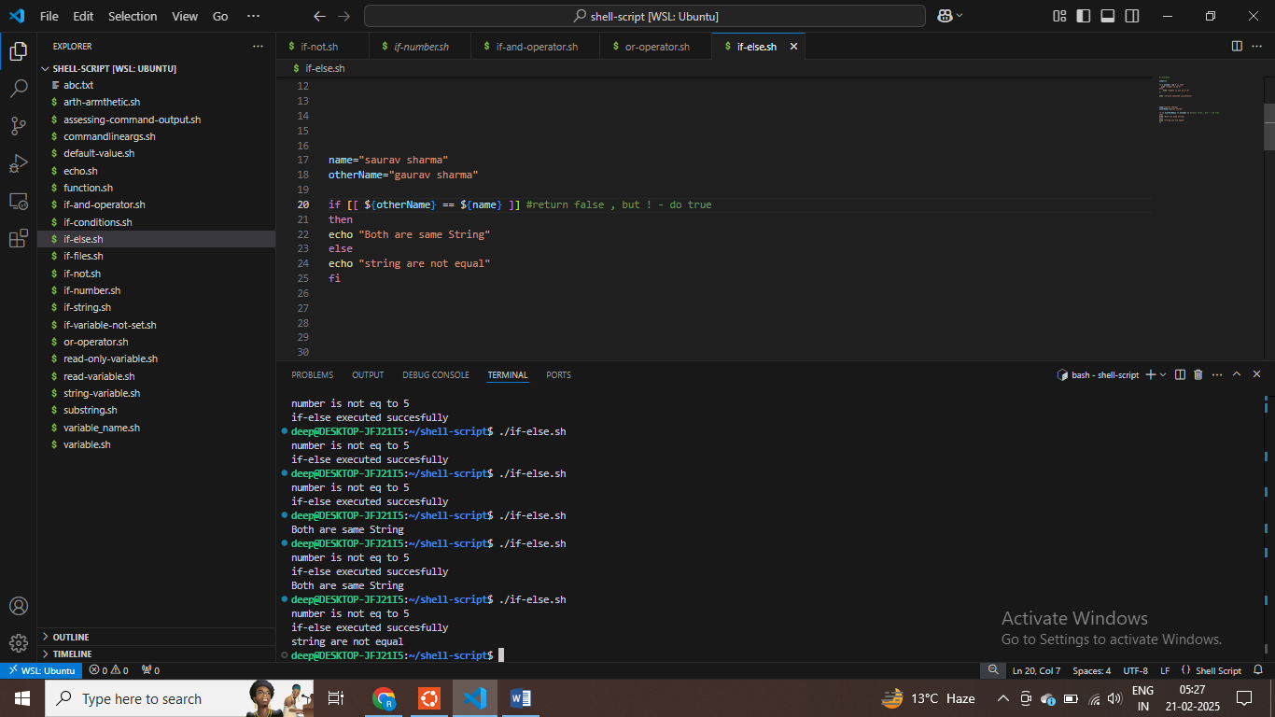

**NESTED IF-ELSE IN Shell Scripting – part 34**

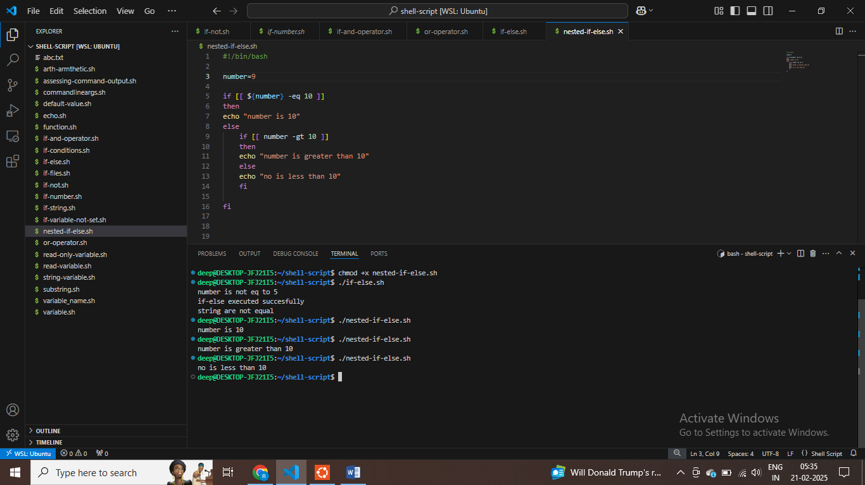

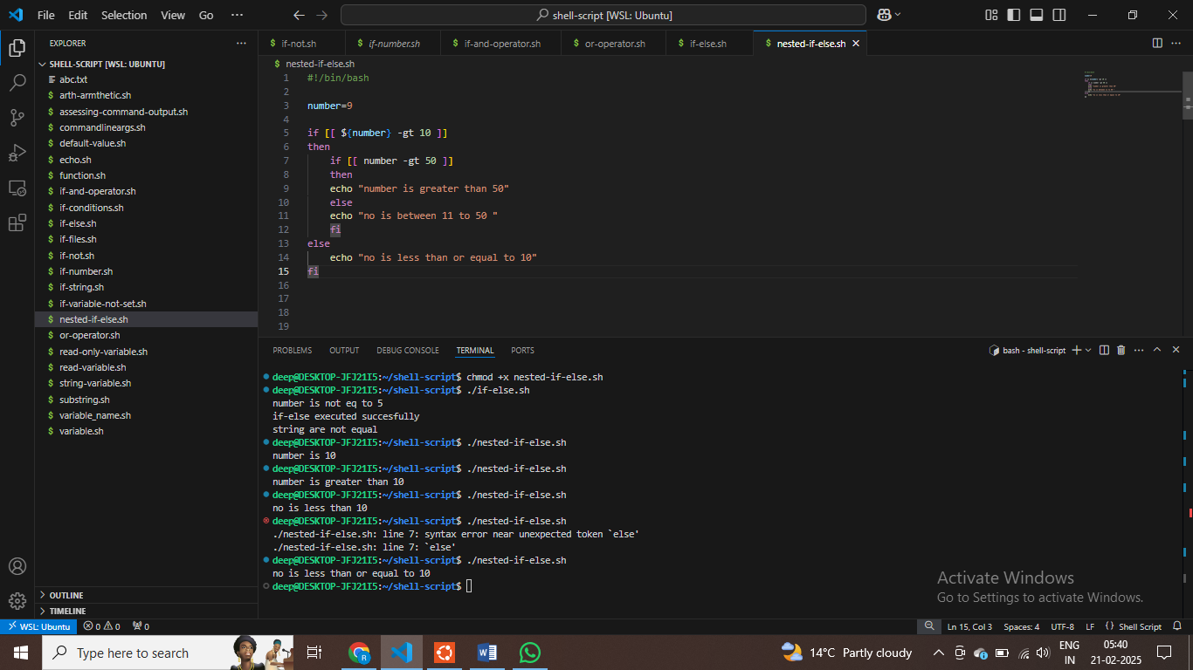

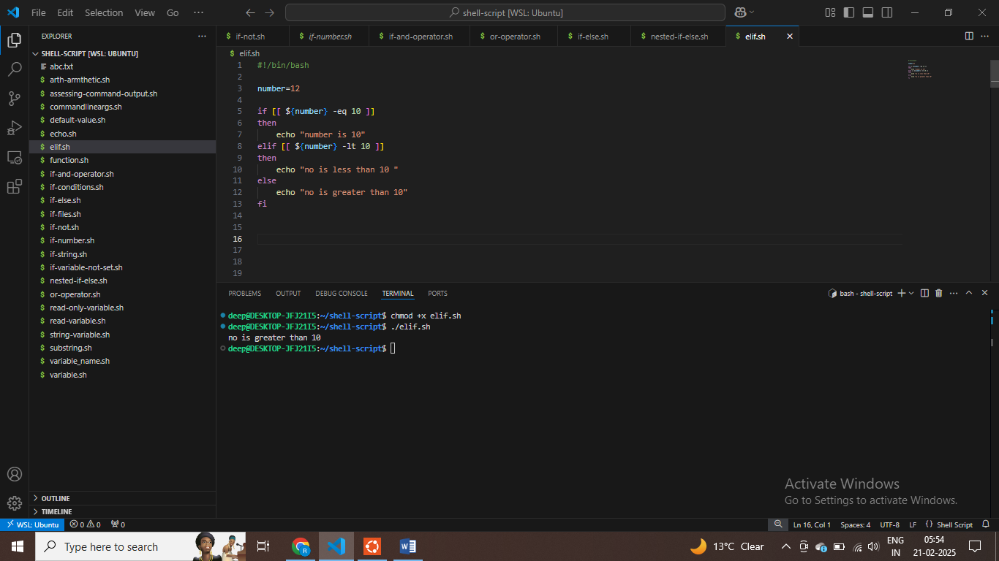

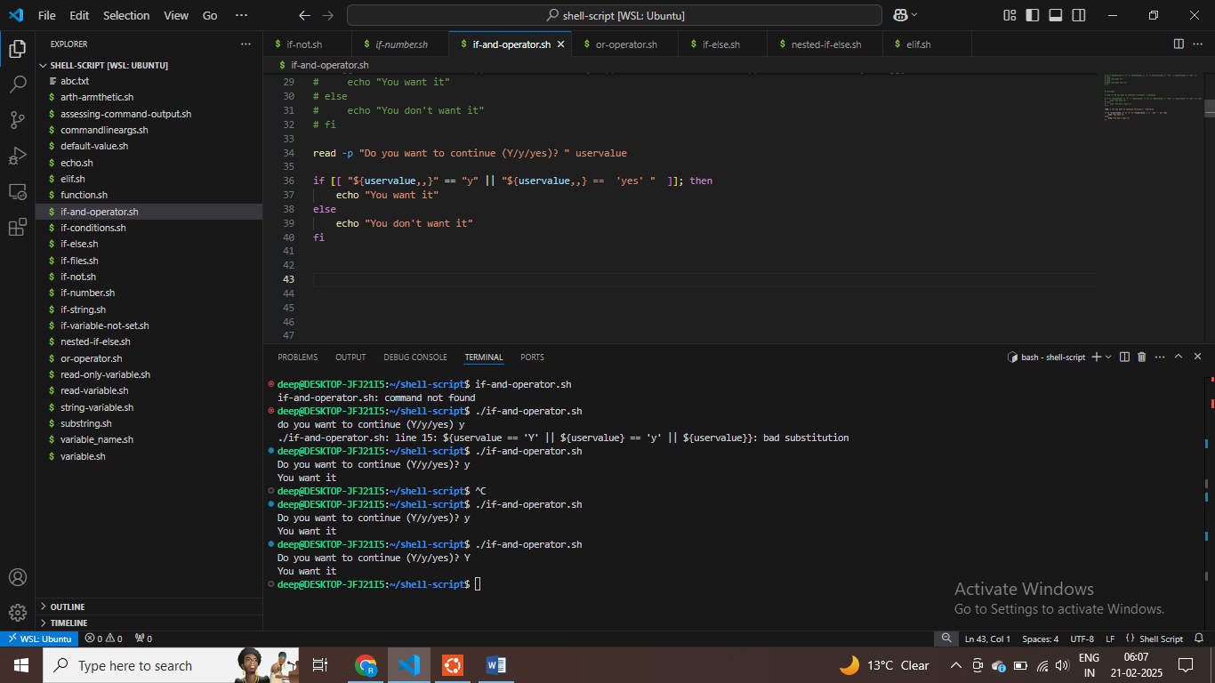

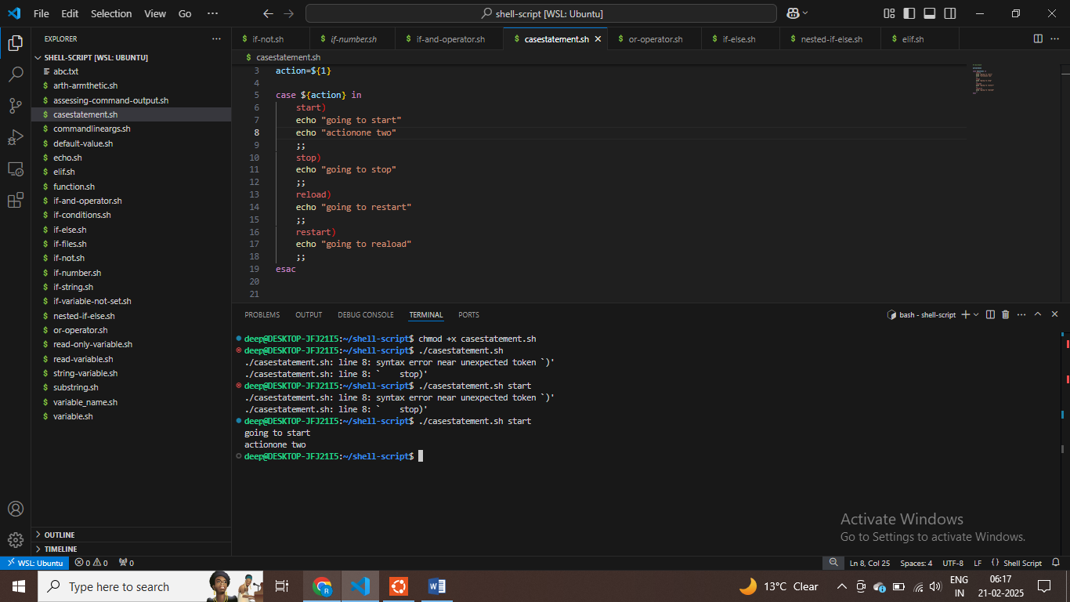

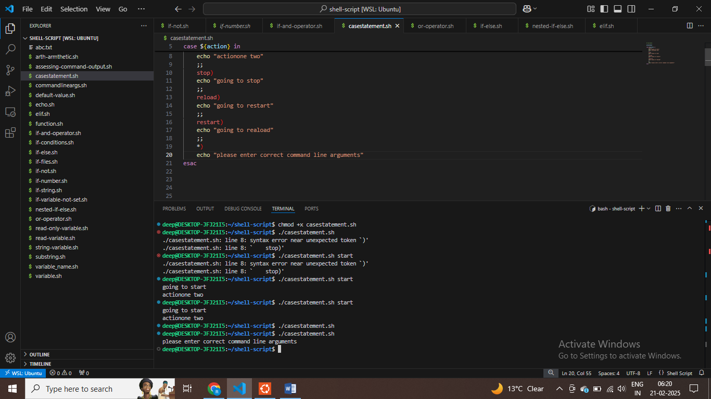

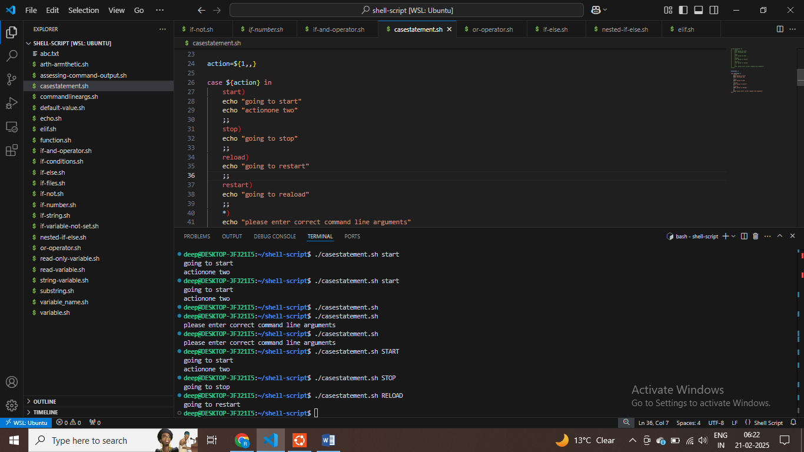

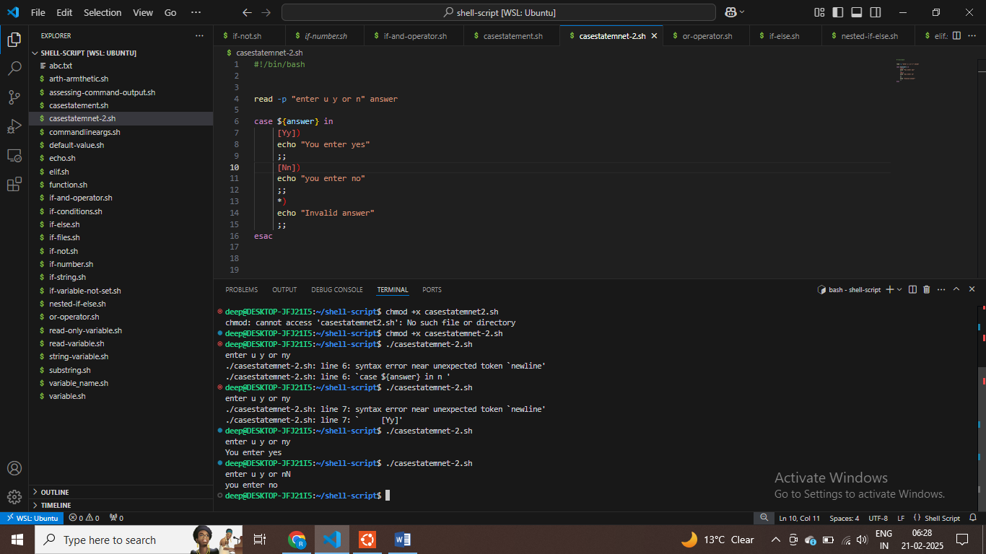

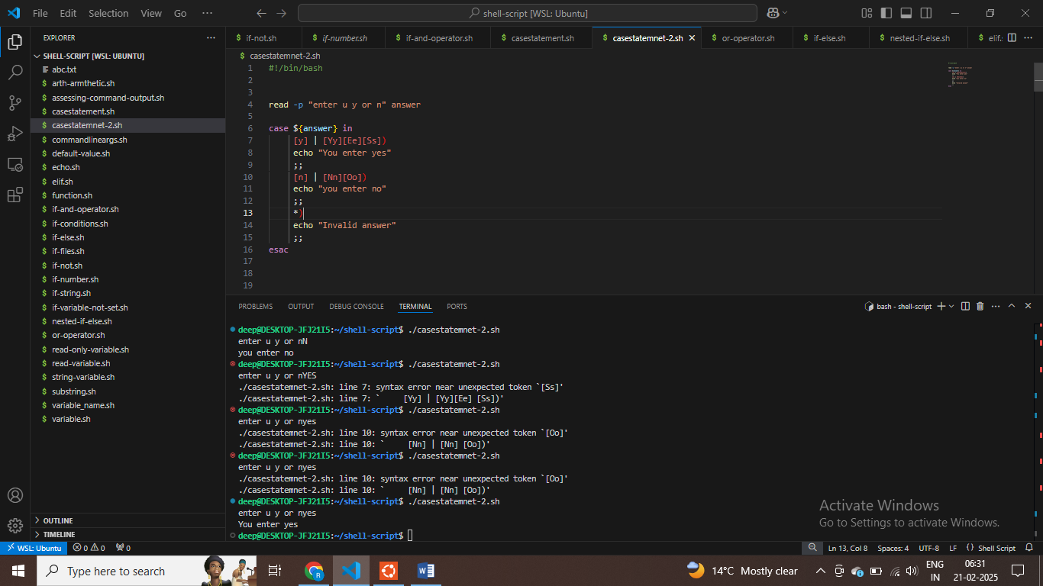

**$ IF character matches or not . then it is valid approach**

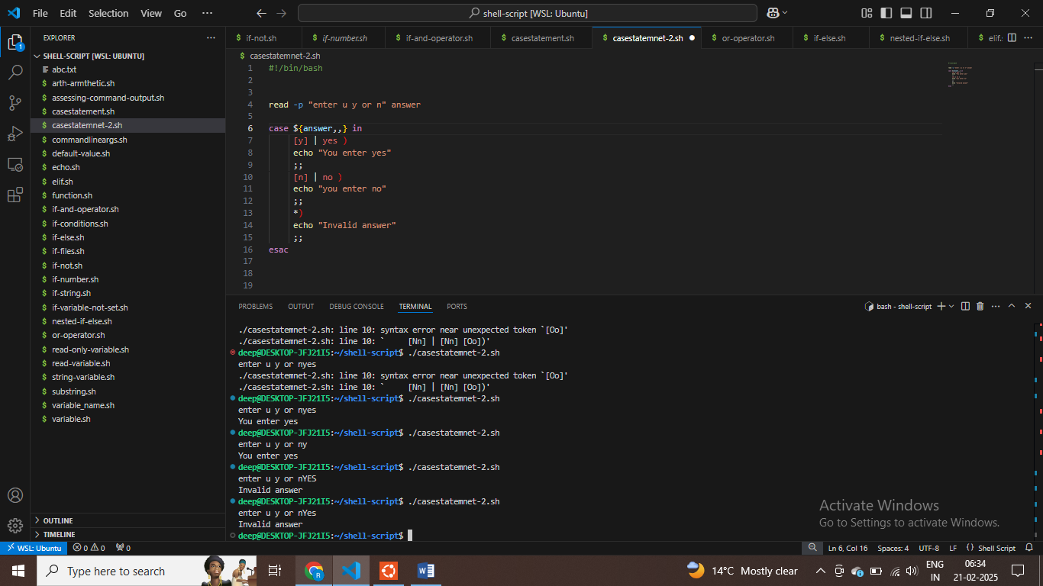

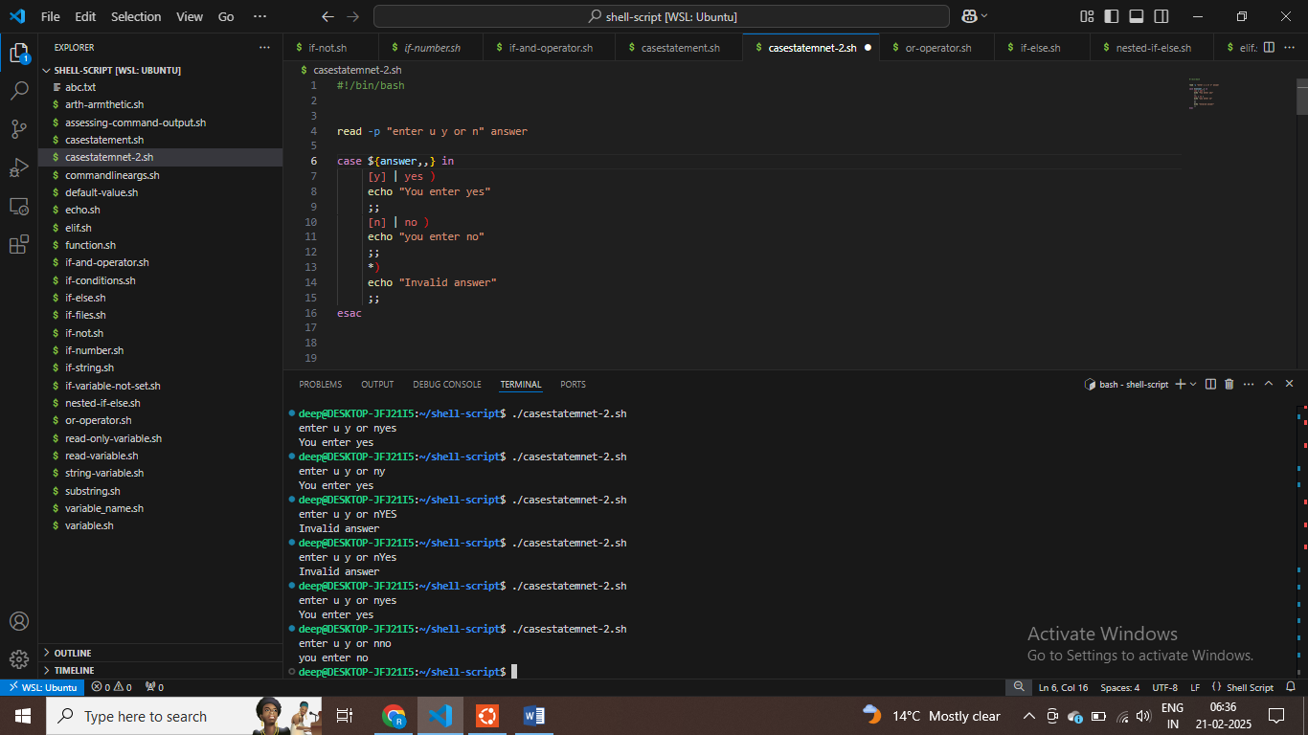

**$ Use case statement when you need to start the service or stop the service both**

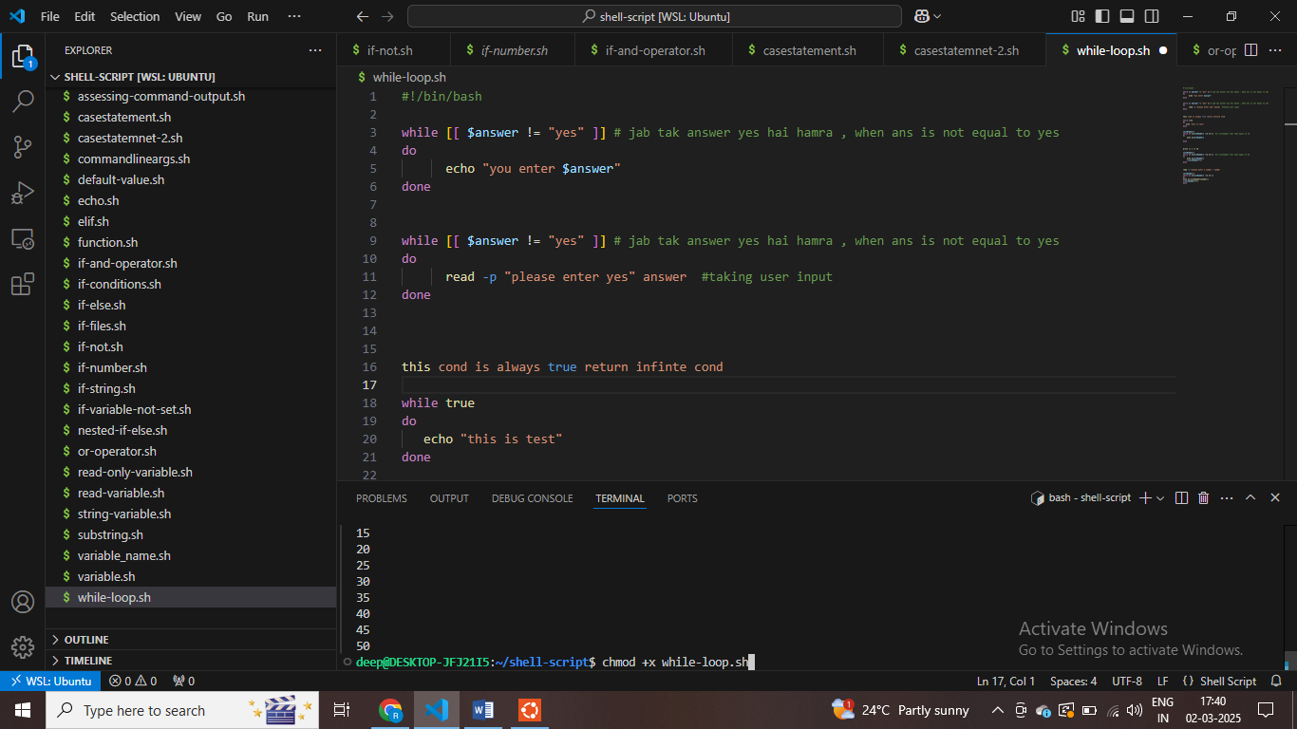

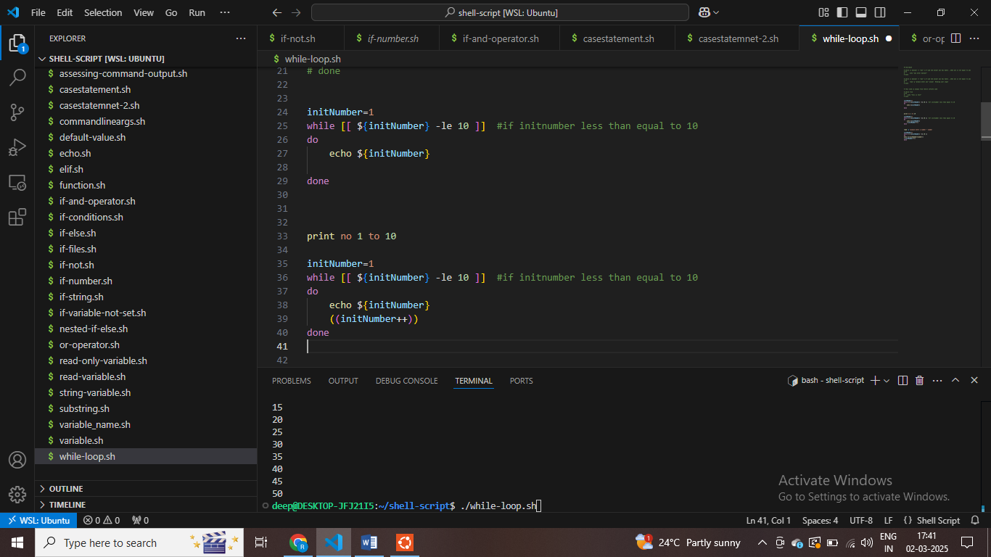

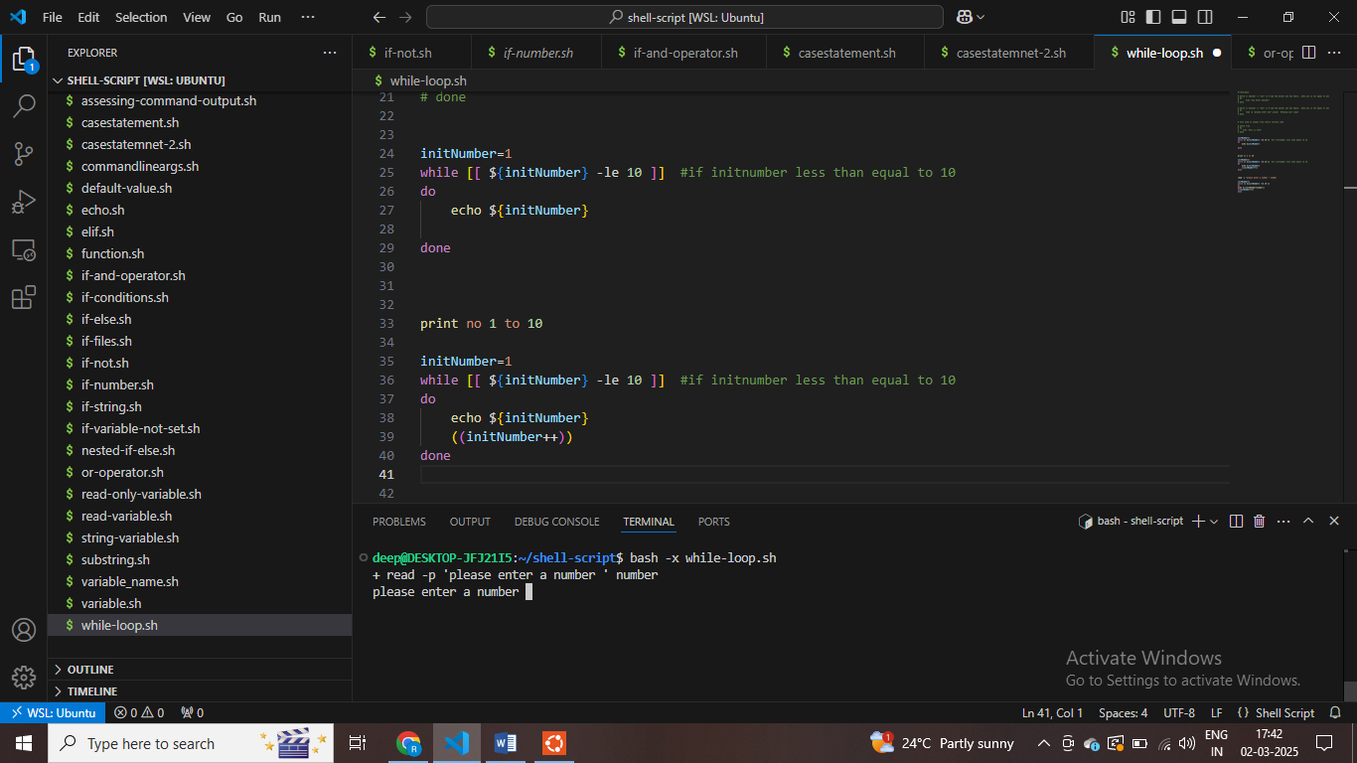

**# run command in debug mode**

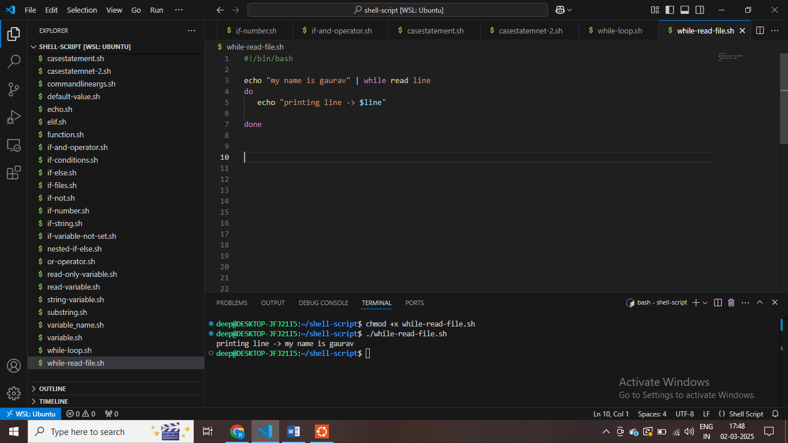

**# while –read file .sh - part 39**

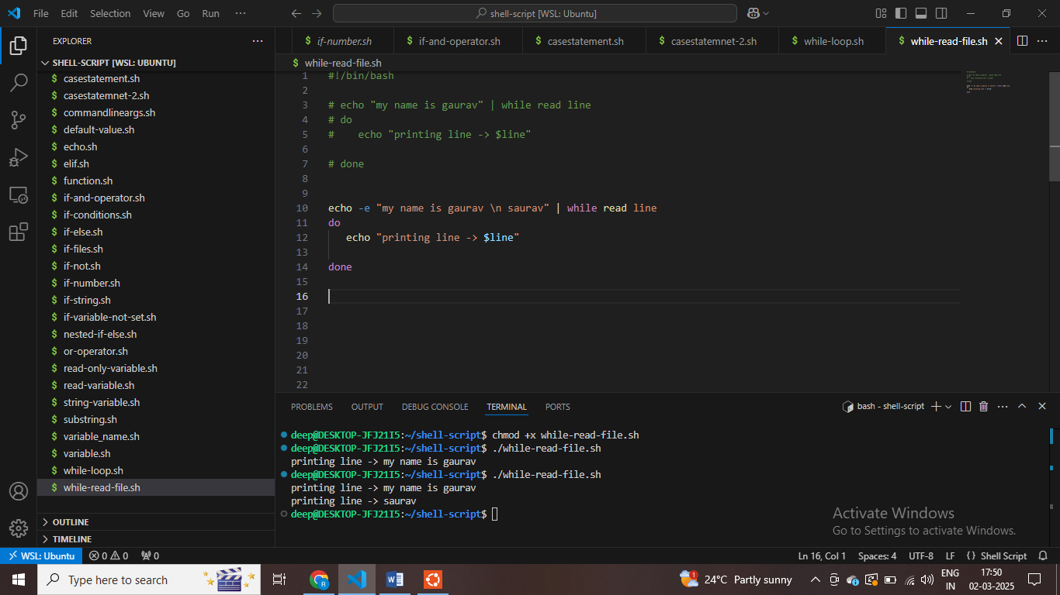

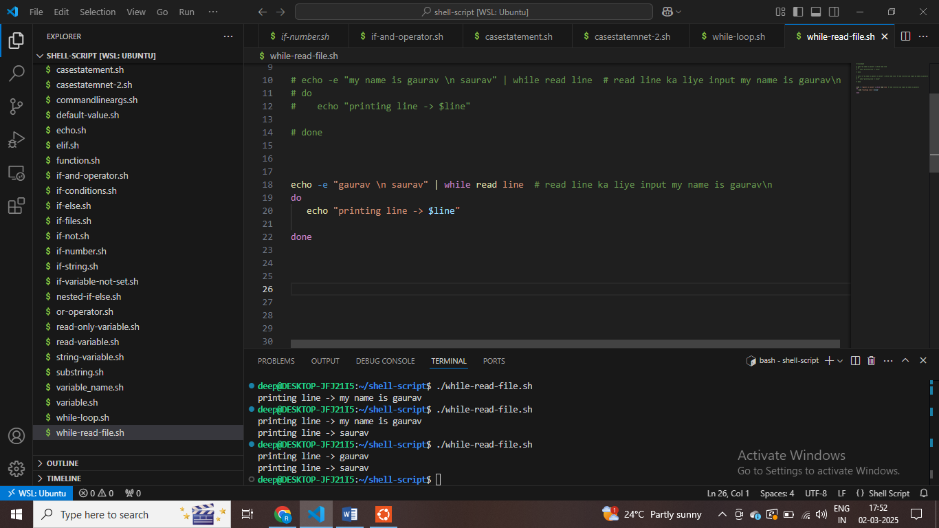

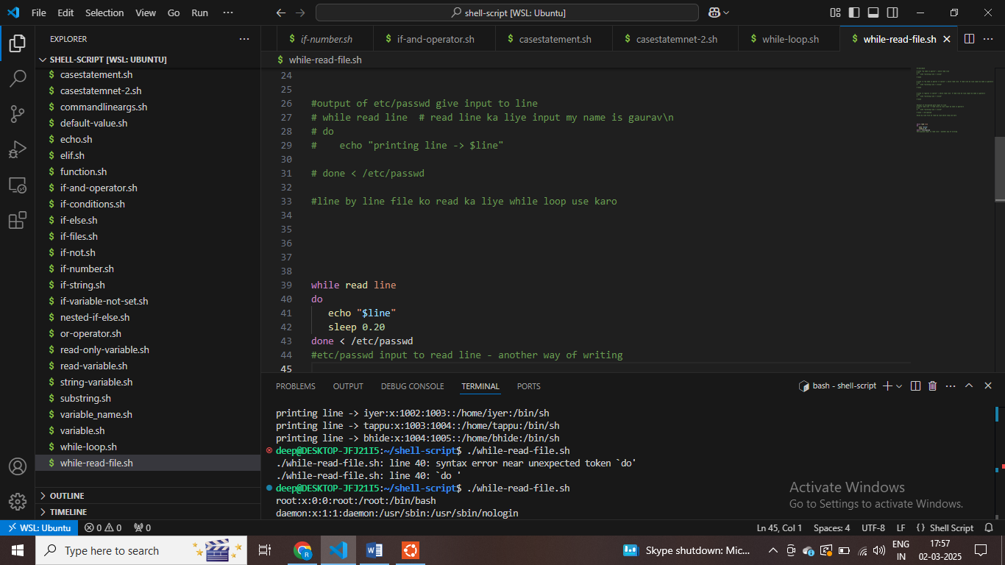

**UNTIL loop = jab tak cond false toh loop execute karo , till the cond to be true – execute loop = using until loop**

**As cond return false we can execute until loop**

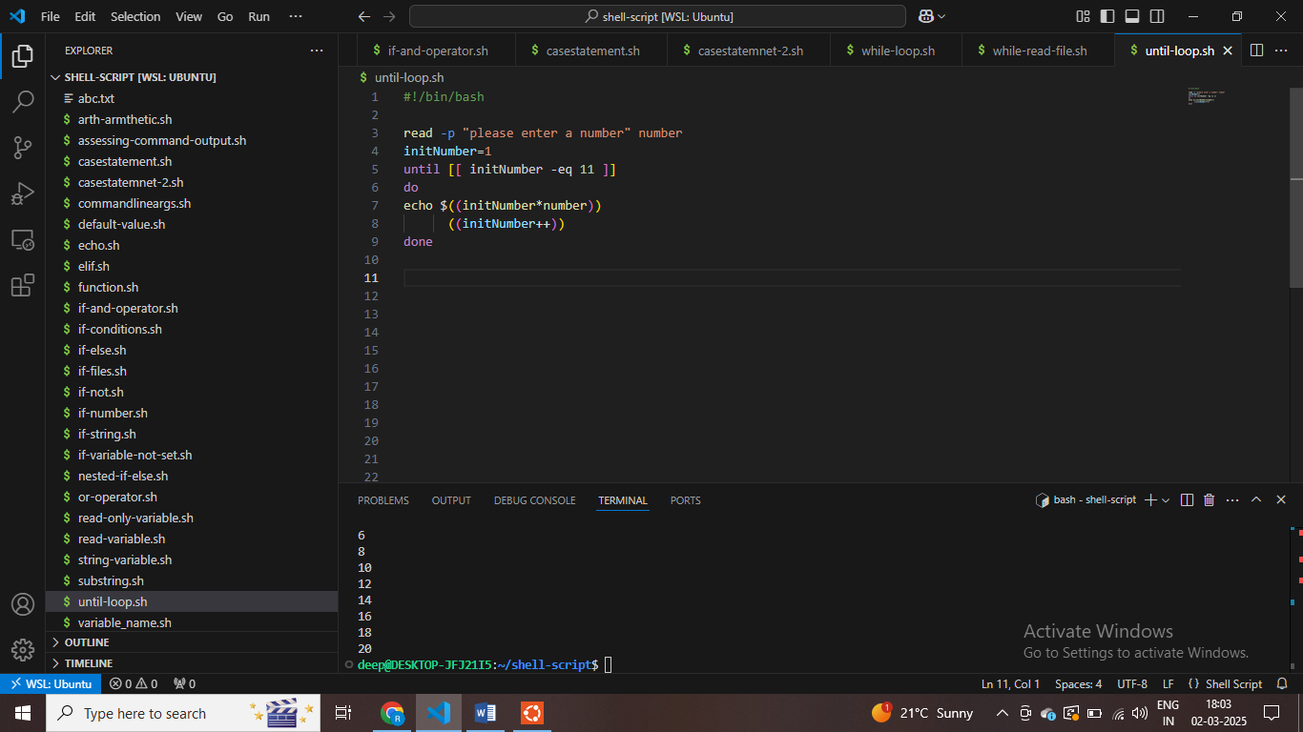

**For loop part 40**

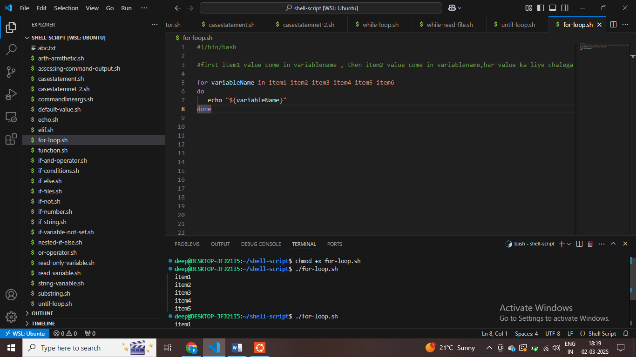

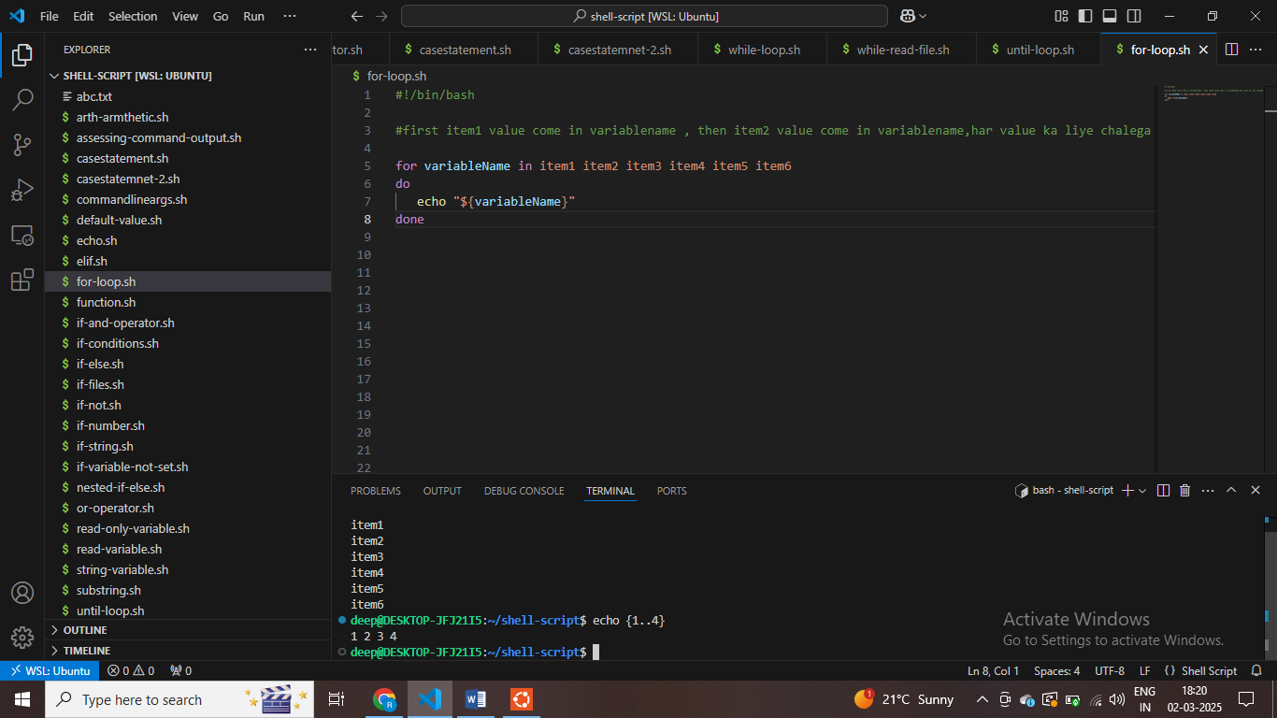

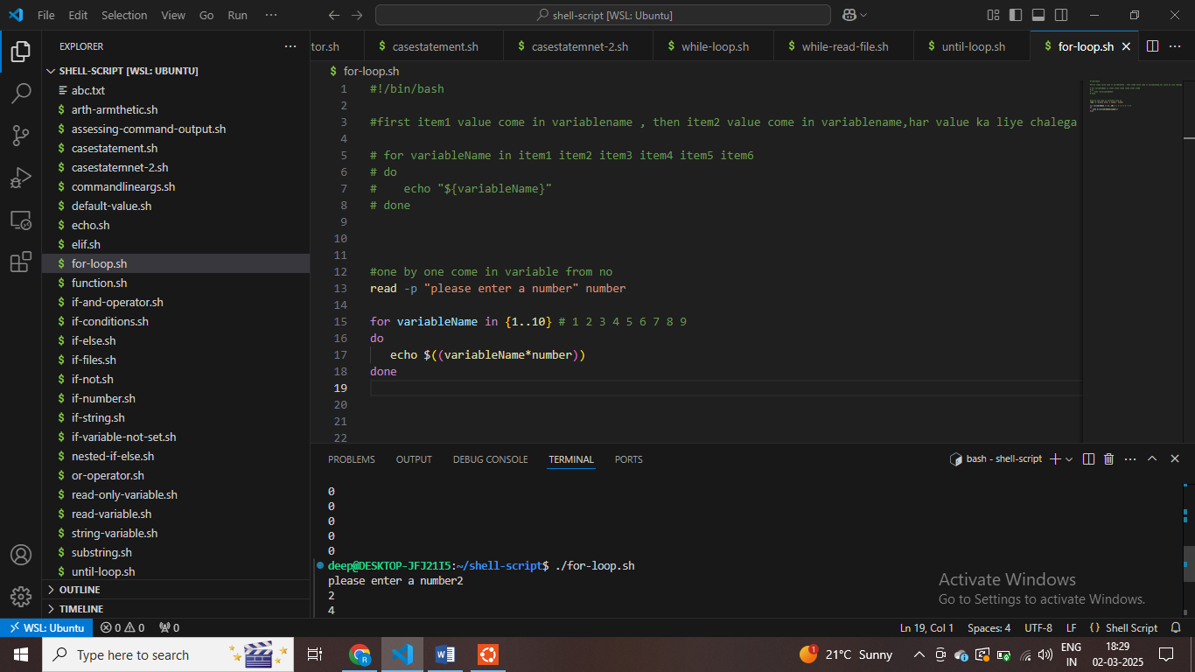

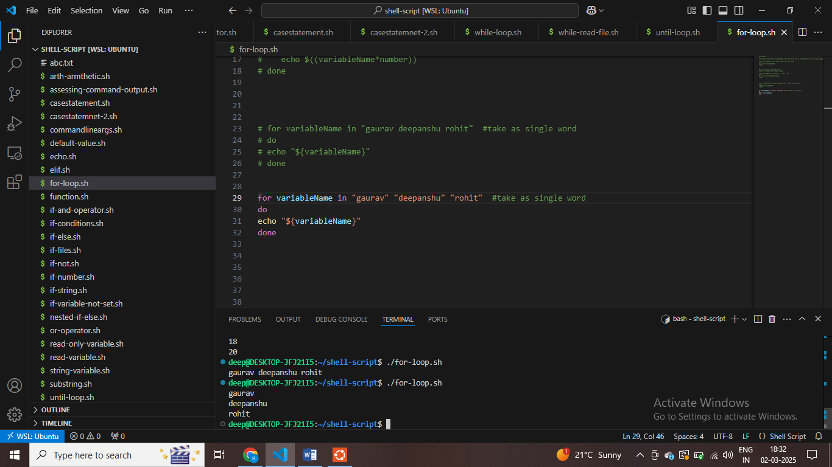

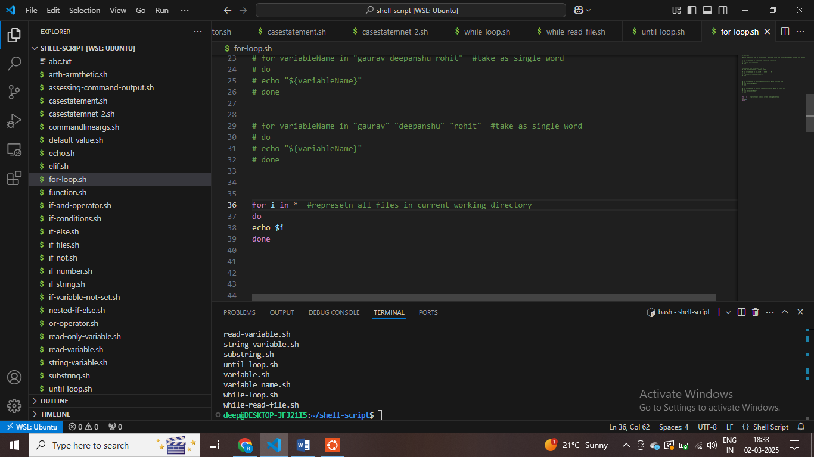

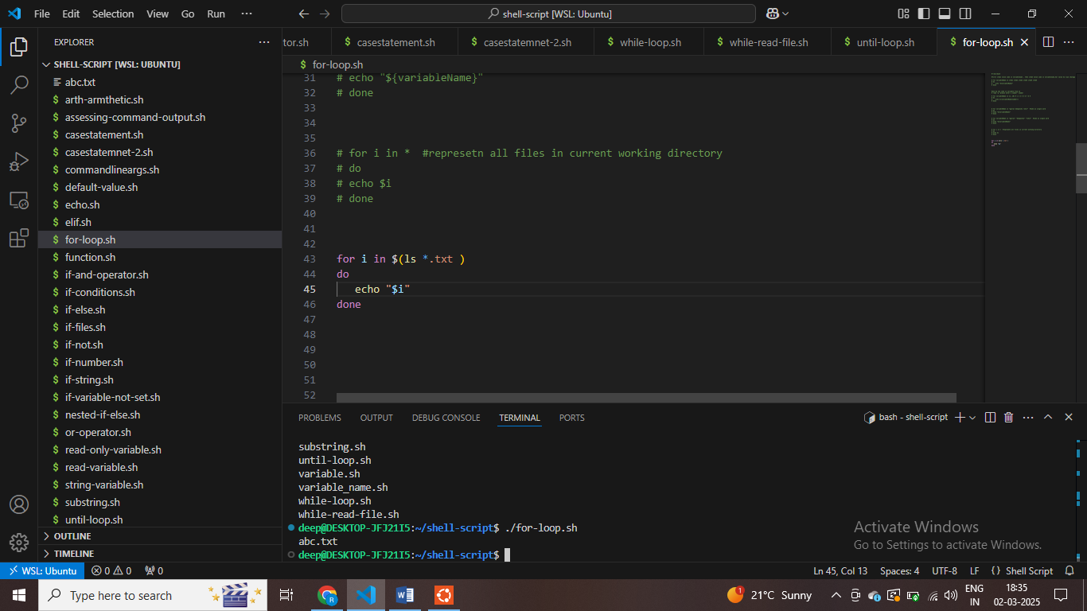

**#show file end with txt**

**Shell Script tutorials - 41 - Difference between $@ and $* in Shell script**

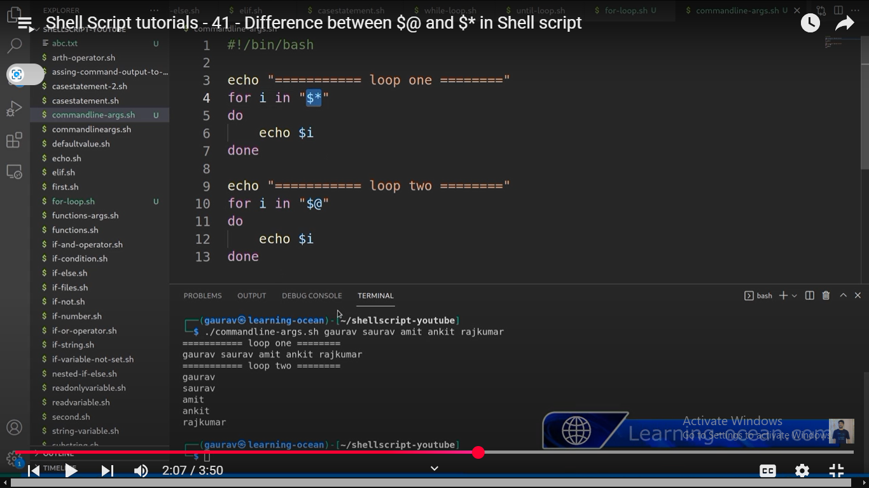

**$* sign – sabko ek hi word samjh liye in “” – if using this**

**“$a” – isne sabko alag samjha – string ko**

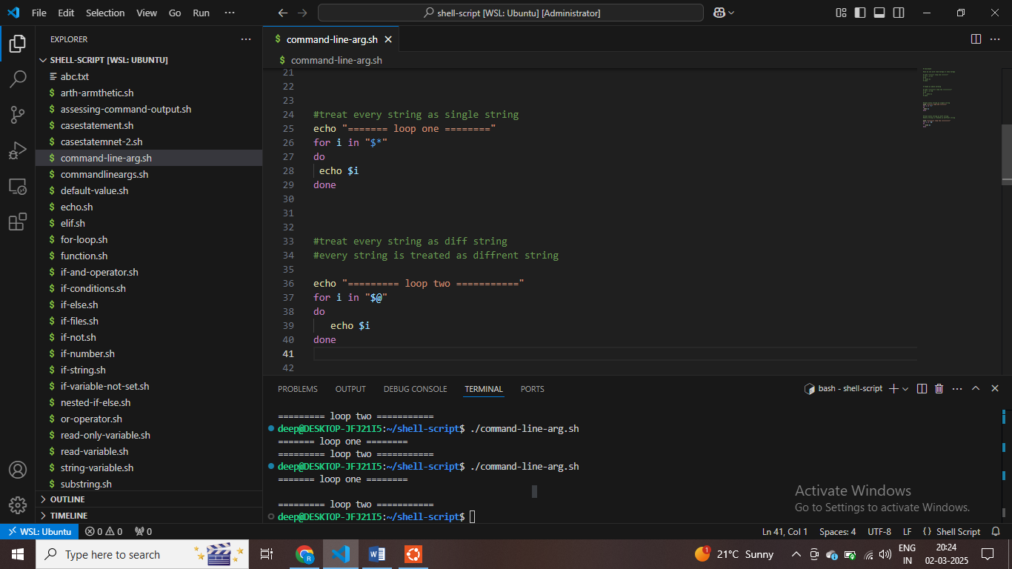

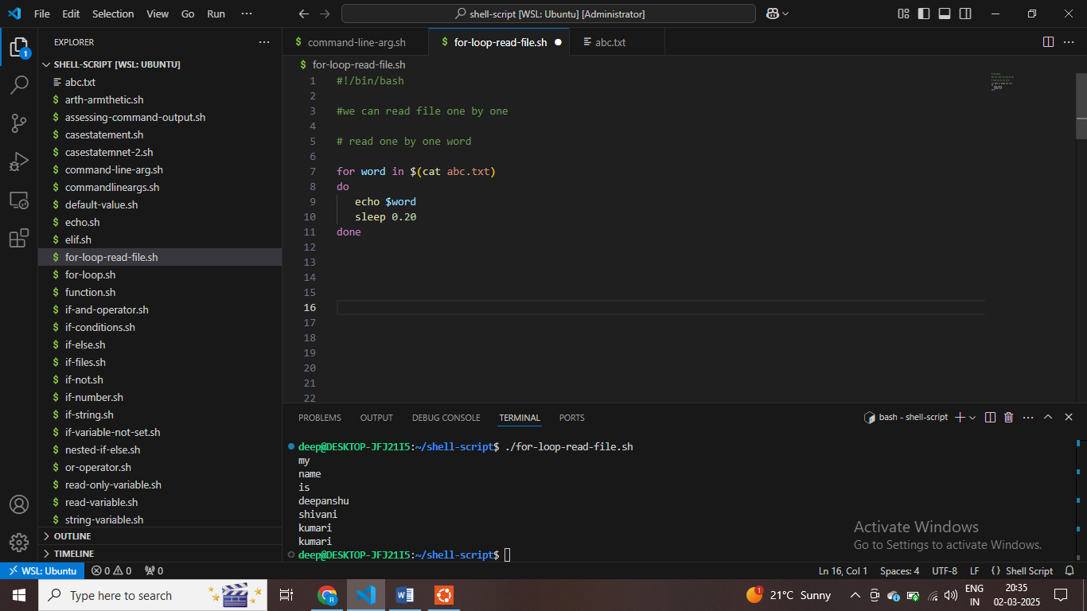

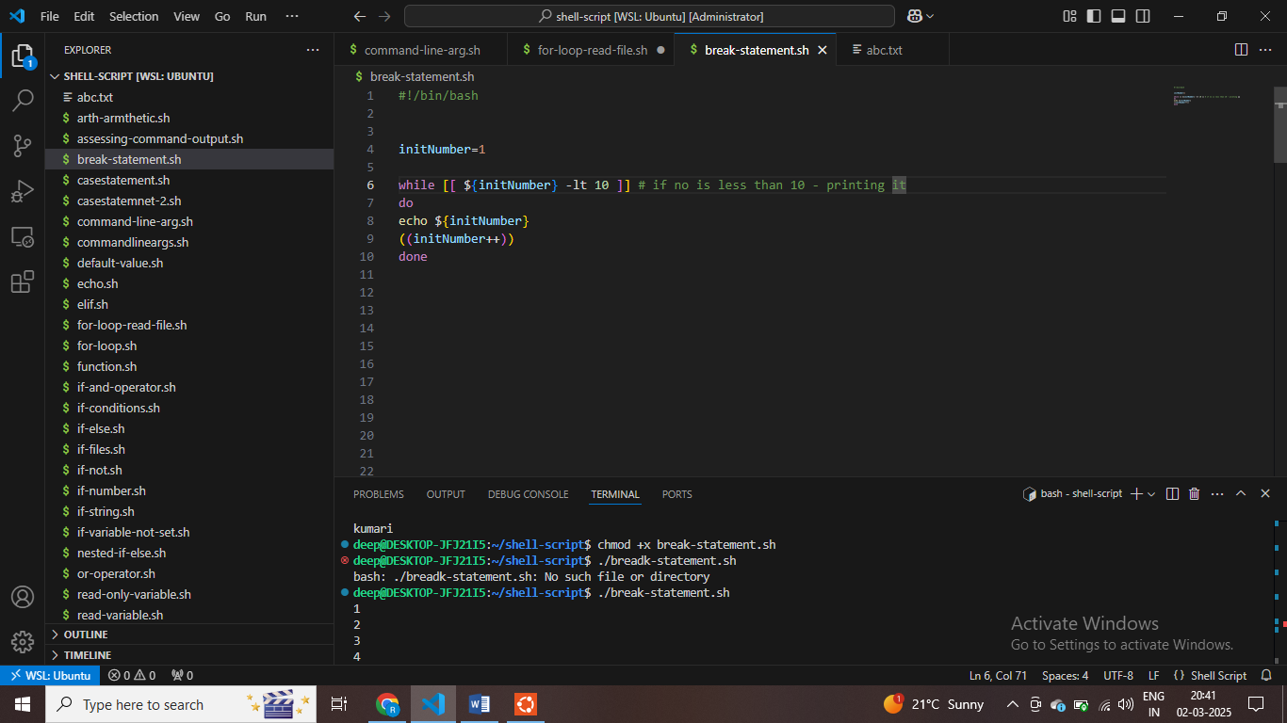

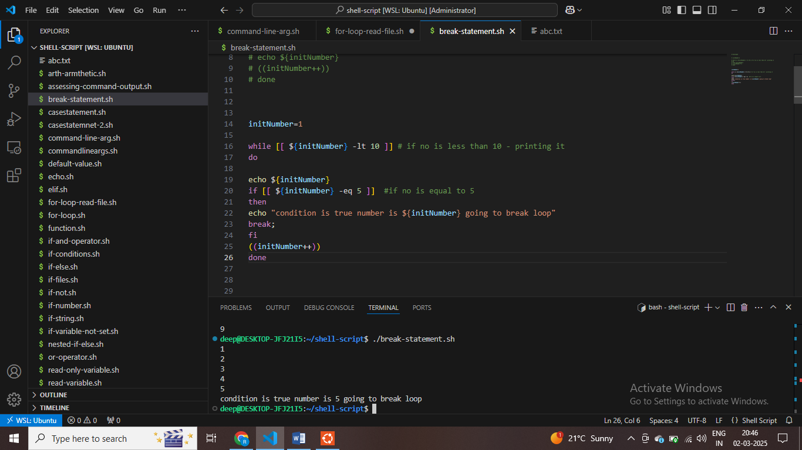

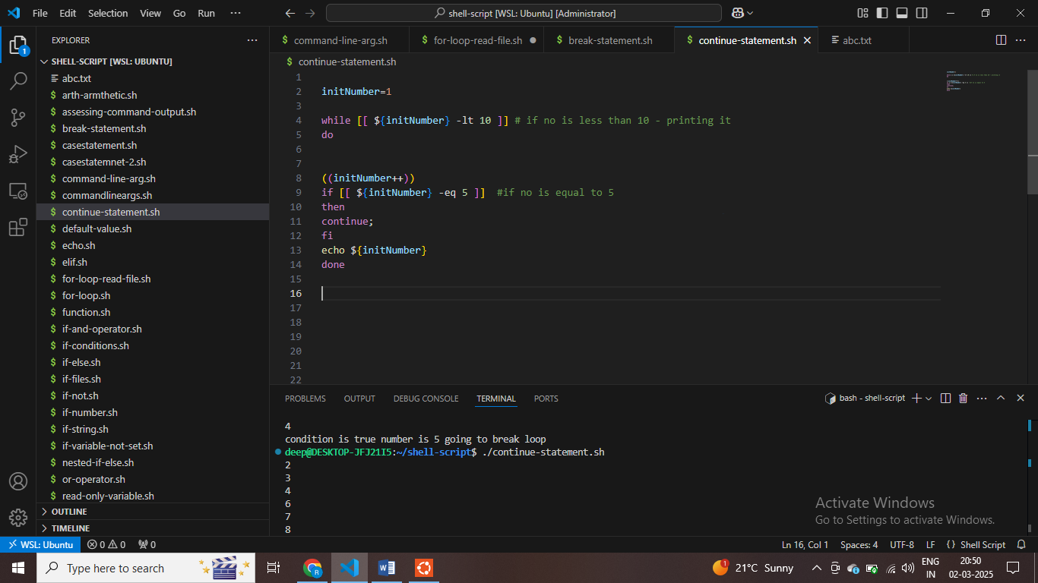

**Shell script 44 Nested Loops**

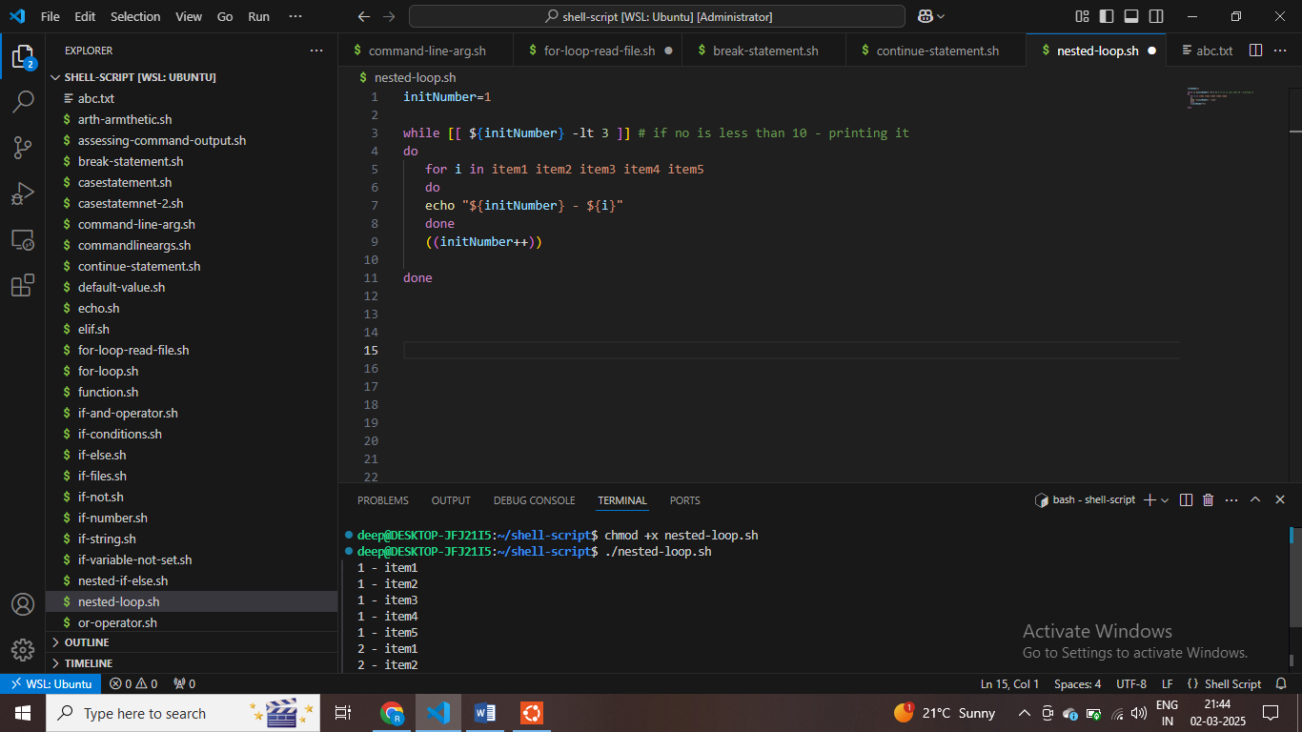

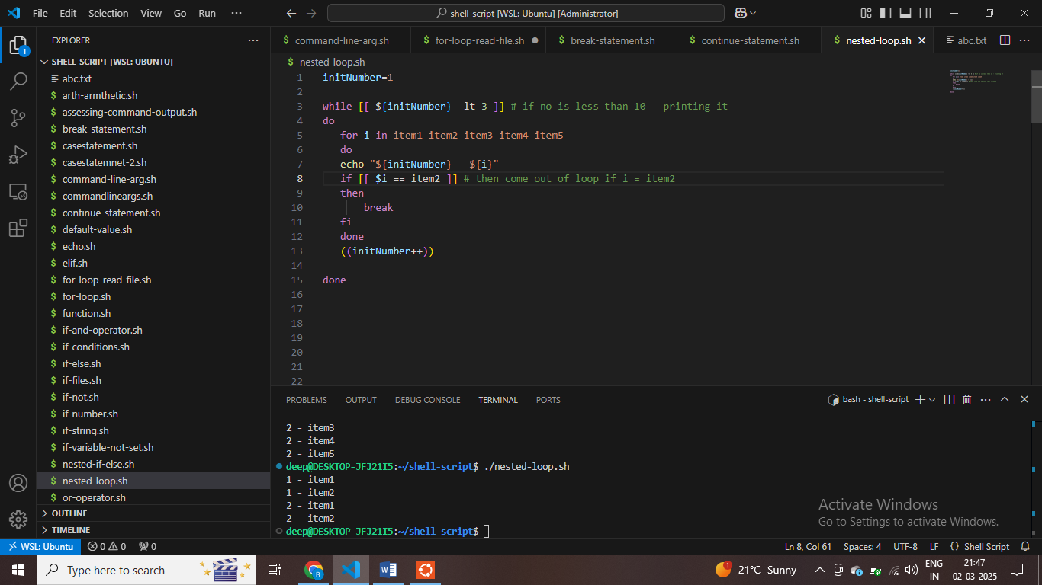

**Level define kar skate hai kis level ka aage loop break karna hai**

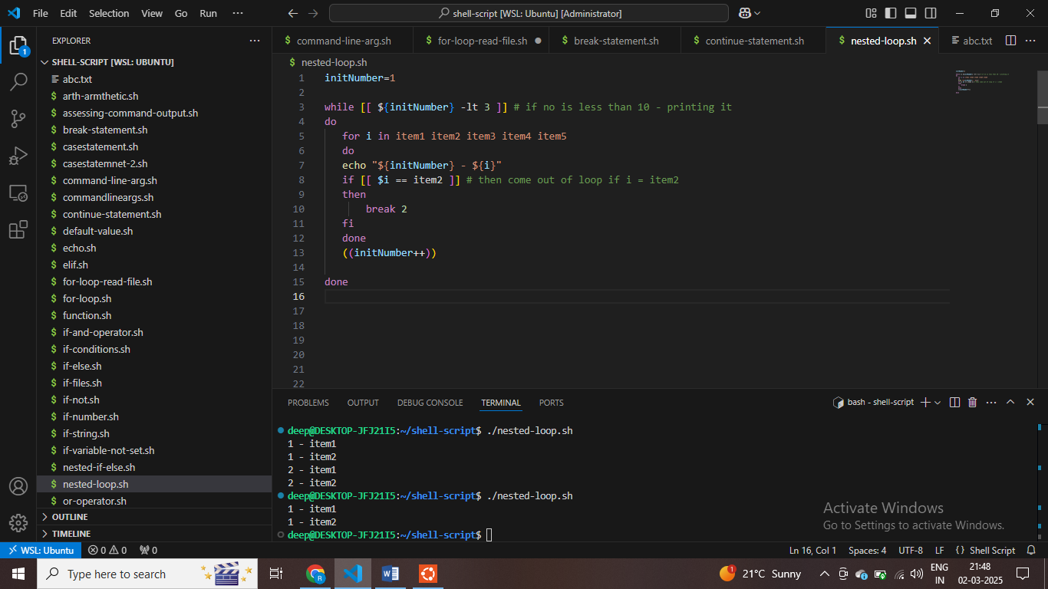

# Shell Script tutorials - 45 - Select in Shell script - Select from Menu in Shellscript

**Users ko ek list dedega –aur user inme se koi ek select karega**

* **Multiple list main se koi ek select kar skte ho**

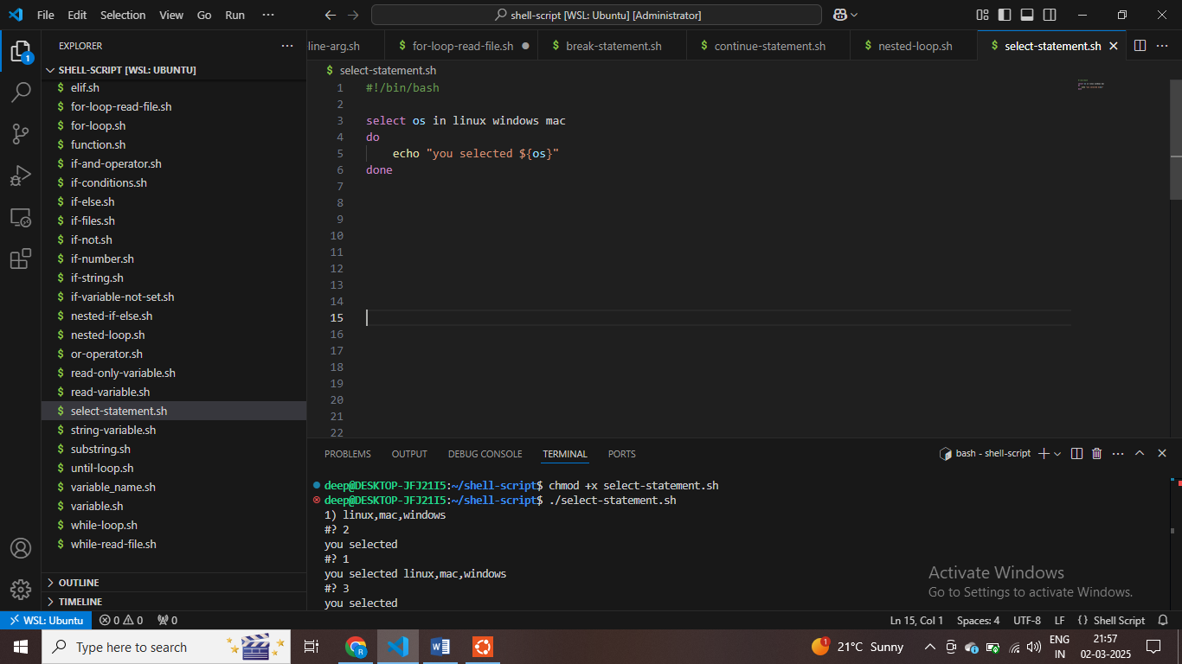

**#selecting single value from multiple-value**

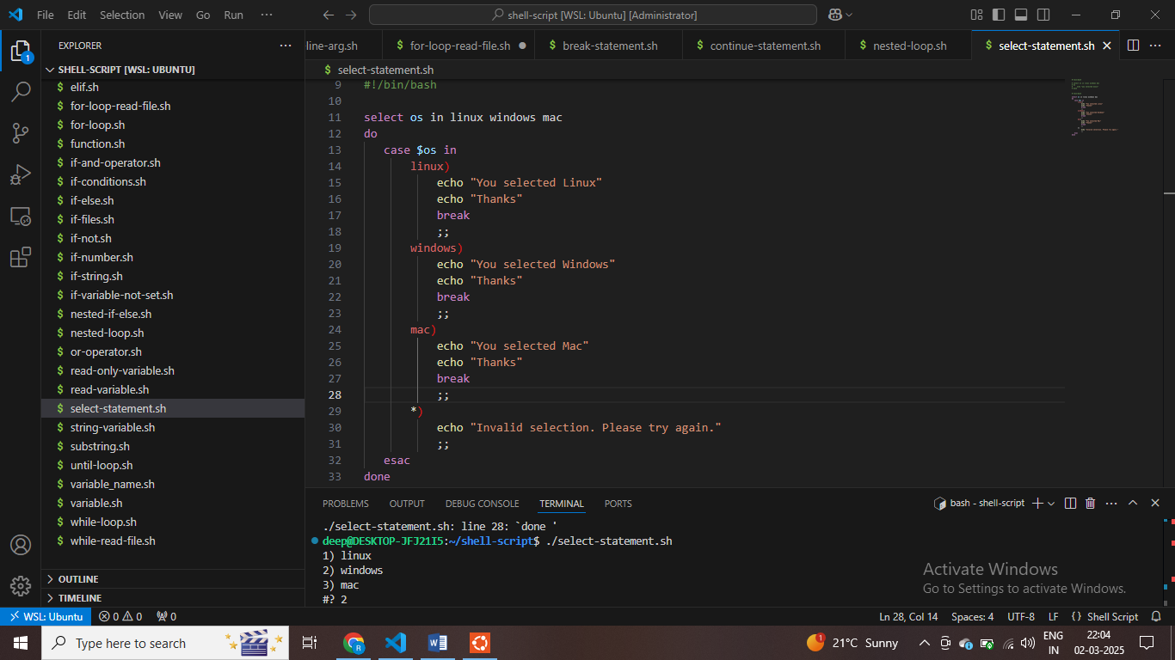

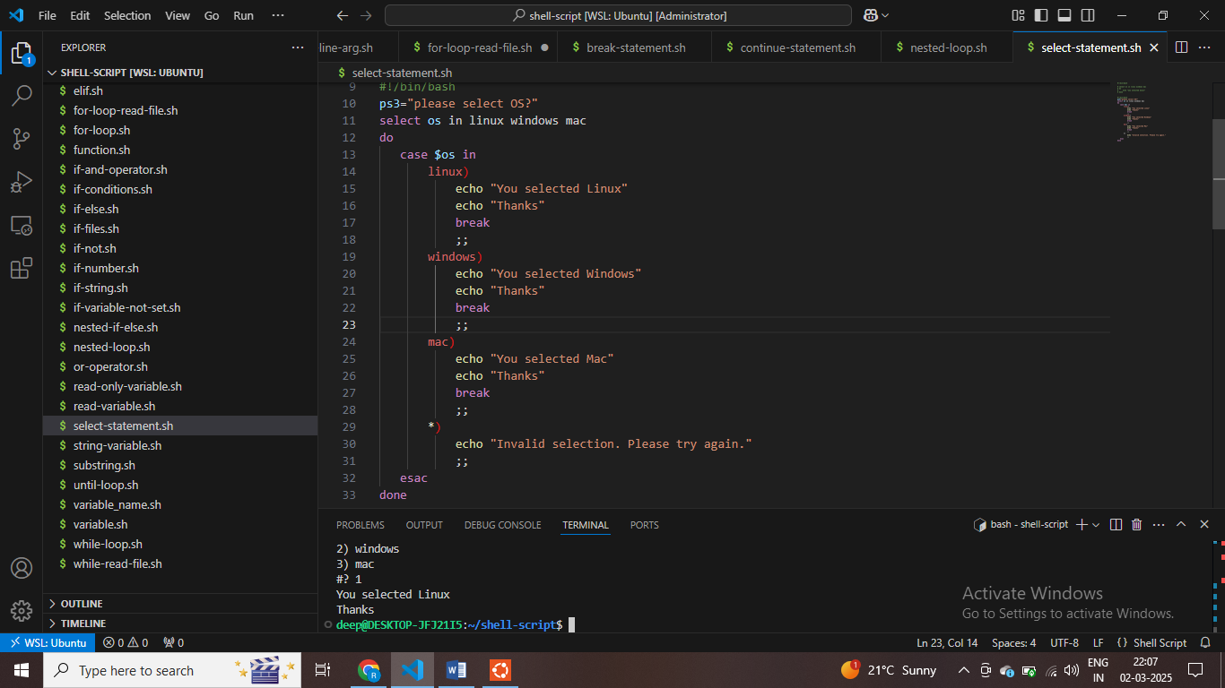

**Shell Script tutorials - 46 - Debug Shellscript - Exit from Shellscript when any Command Gives Error**

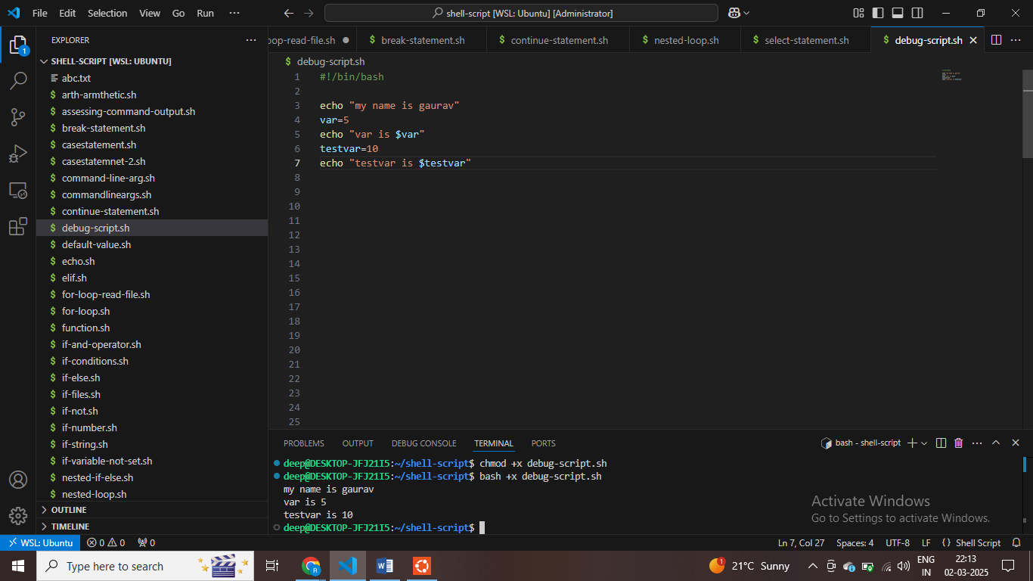

**#open script in bash mode or execute mode**

**Open script in debug mode**

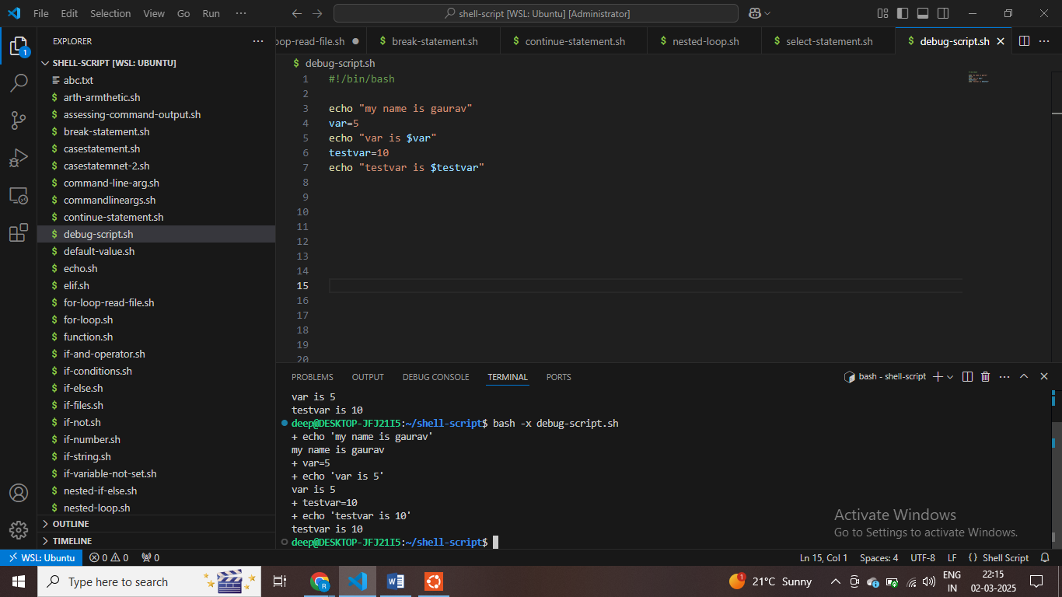

**Bash –x script.sh**

**Bash se debug karte hai**

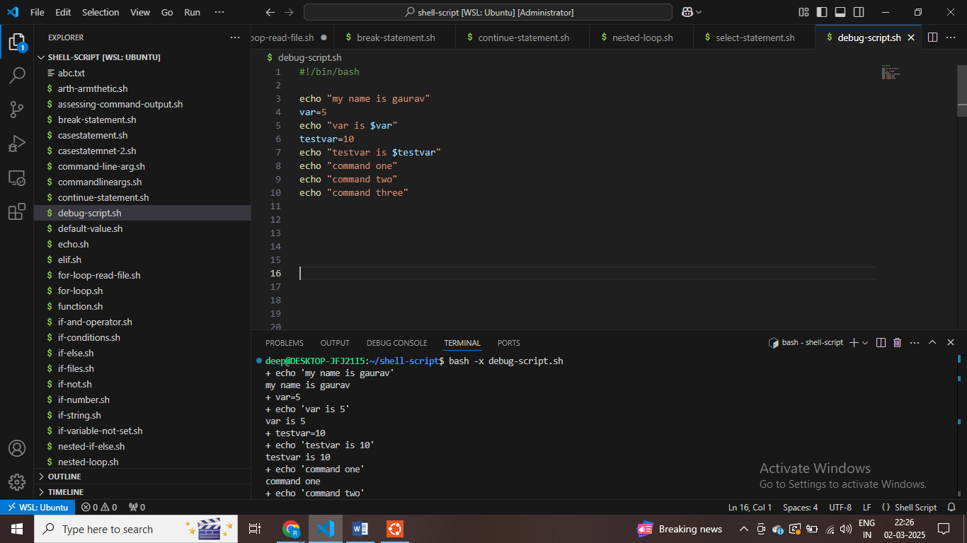

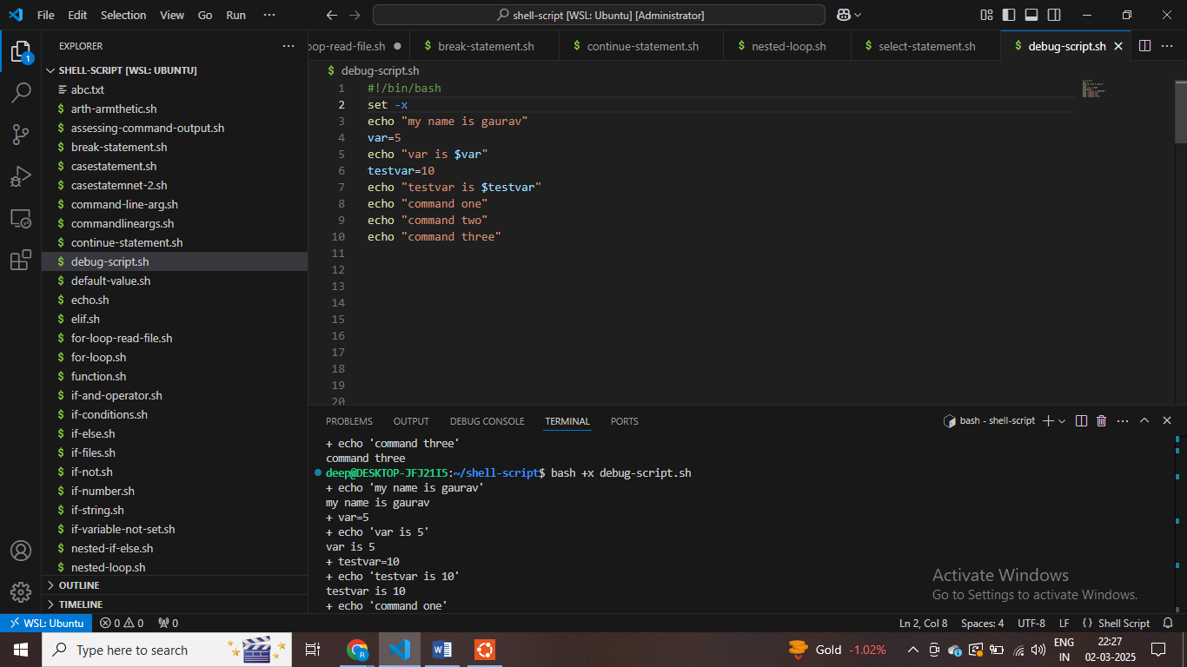

**Set –x refer to debug mode**

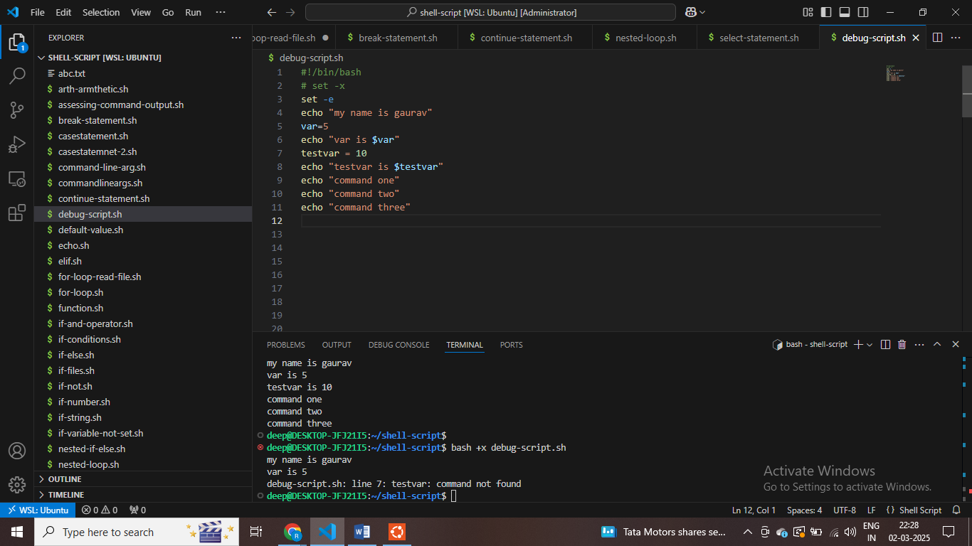

**Set –e for – If we get error at any palce , then it stop working**

